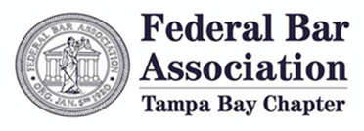

The Tampa Bay Chapter of the Federal Bar Association invites law firms, legal aid organizations, and other supporters of the federal judiciary to become sponsors of our monthly e-newsletters. Sponsorships are administered on an annual basis and can be purchased at the following tiers:

Platinum Sponsor – $1,500.00/year (limited to one (1) sponsor)

Gold Sponsor - $750.00/year (limited to two (2) sponsors)

Silver Sponsor - $500.00/year (limited to three (3) sponsors)

Bronze Sponsor - $250.00/year (limited to five (5) sponsors)

Please express your interest in serving as a sponsor for the 2021-2022 newsletter by completing the following form:

**NEWSLETTER SPONSORSHIP REQUEST FORM**

Name of Sponsor: ___________________________

Sponsor’s Mailing Address: ___________________________

___________________________

___________________________

Sponsor’s Phone Number: ___________________________

Sponsor’s Email: ___________________________

Desired Annual Sponsorship Level (Check One):

Platinum [____] Gold [____] Silver [____] Bronze [____]

Please return this form via email to [erik@johanson.law](mailto:erik@johanson.law) by July 31, 2021. Applications will be processed in the order in which they are received. Sponsorship tiers are available on a first-come first-served basis.