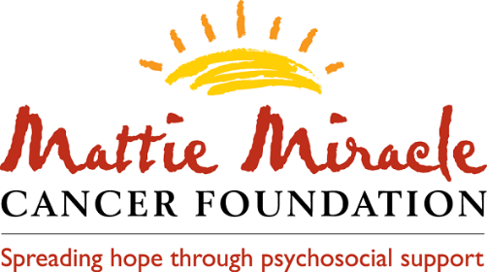
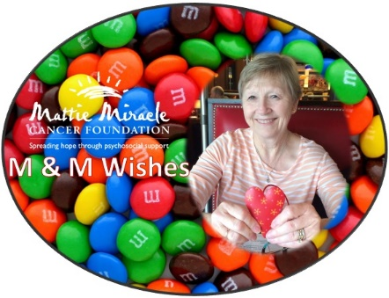

M&M Wishes Grant Application

In 2021, the Mattie Miracle Cancer Foundation established the M&M (“Margy & Mattie”) Wishes Grant in memory of our board member, Margy Jost. Margy was a fierce childhood cancer advocate who devoted her life to helping children with cancer. Margy was passionate about providing grants to families to make their child's wish come true and to help create memories outside of the hospital experience. M&M Wishes offers families a grant up to $1,000 to support their child's wish for a fun family activity, trip, or a wish list item for the child with cancer. Children with cancer must be five years or older, so that they are of the age to generate and select their own Wish. Families can apply for an M&M Wish only once. After submitting your application, you can expect to receive a follow-up email within three weeks.
NOTE: Wishes to go to Disneyland/World, are beyond the scope of M&M Wishes. If you are applying for support to go to Disney, you will need to specify how this $1,000 grant will be used as well as indicate if you are receiving other outside support for this trip.
Please submit your application to Mattie Miracle's President at: vicki@mattiemiracle.com.
All requests must be accompanied by an attached letter of verification from a physician or social worker. Letter should briefly discuss diagnosis, treatment, and need. Thank you.

Email Address: _________________________________________________________________
Child’s First and Last Name: _______________________________________________________
Parent’s First & Last Name: _______________________________________________________
Parent Address: __________________________________________________________
Parent Phone Number: _____________________________________________________
Parent’s First & Last Name: _______________________________________________________
Parent Address: __________________________________________________________
Parent Phone Number: _____________________________________________________
Child’s Age & Birthday: ___________________________________________________________
Child’s Diagnosis: _______________________________________________________________
Date of Diagnosis: _______________________________________________________________

Hospital for Cancer Treatment (include city & state):
______________________________________________________________________________
Name of Physician: ______________________________________________________________

Wish Request Please explain your family's situation including: (a) the impact of your child's diagnosis on the family system, (b) what your child is requesting, and (c) why you are seeking a M&M Wish.

____________________________________________________________________________________________________________________________________________________________________________________________________________________________________________________________________________________________________________________________________________________________________________________________________________________________________________________________________________________________________________________________________________________________________________________________________________________________________________________________________________________________________________________________________________________________________________________________________________
Do you consent for your child's first name/age/diagnosis to be shared with Mattie Miracle supporters (in our newsletters and social media sites)? Please check one (Your response will not influence the support decision).
- Yes, first name, age, and diagnosis
- Yes, first name and diagnosis
- Yes, just diagnosis
- Yes, just first name
- No
Recipients of our funding agree to provide Mattie Miracle feedback about the M&M Wish experience. Please check one.
- Yes
- No

