
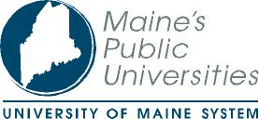
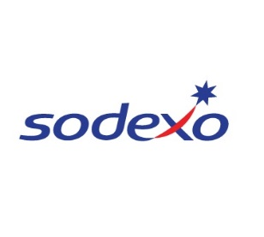

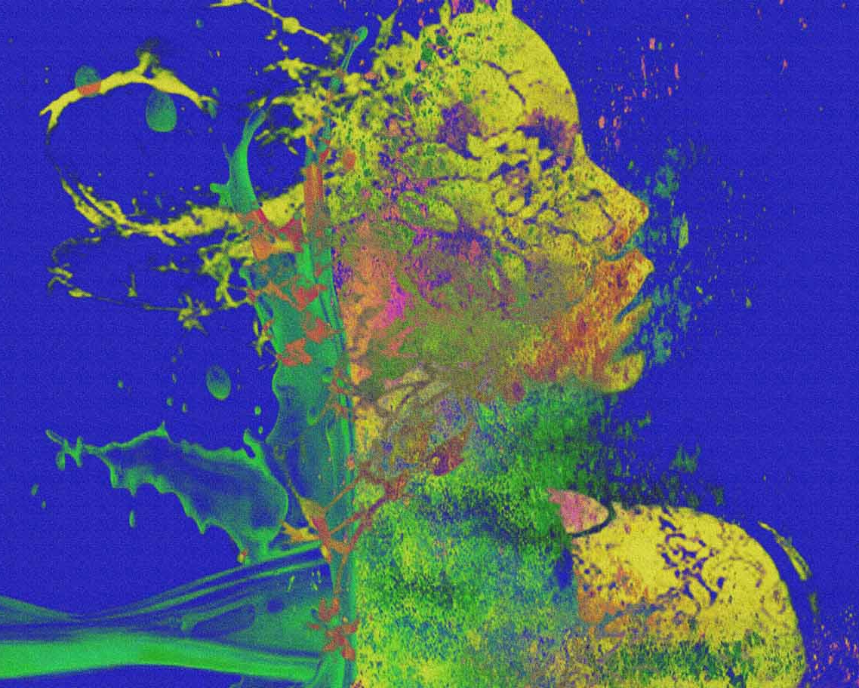
Faculty, Students, Staff and Senior College/OLLI Members!
Please join us for the first annual USM Symposium on Aging!
No matter what your discipline, if you want to learn more about aging and how aging touches all of us in our personal and professional lives, this symposium is for you!

A Call for Student Posters and Art
Students, showcase your research or service learning! Ten abstracts will be selected for poster presentations. Abstracts are due April 3, 2018. Please go to http://www.usmaging.org/student-opportunities for more information.
Students are also invited to submit a brief description of artwork showcasing older adults or focused on aging for consideration of presentation at the USM Symposium on Aging. Artistic submission including drawing, painting, photography, ceramics, sculpture, conceptual art, electronic, and other formats will be accepted for consideration. Electronic copies along with a brief description of the piece should be submitted to usmaging@gmail.com.

About the USM Aging Initiative
The USM Aging Initiative is a multidisciplinary group of USM faculty and staff created to engage faculty, students, staff and Senior College members in learning about the experience of aging in our society; connect those with expertise, experience and ideas to develop new and creative multidisciplinary partnerships to promote aging-related research and scholarship; and promote USM scholarship and research activities in the wider community.

Sponsorship
This event would not be possible without the generous support of the USM Title III Faculty Development Program, the USM School of Nursing, the USM College of Science, Technology & Health, the USM Department of Recreation & Leisure Studies, the Chancellor, University of Maine System, AARP Maine and Sodexo Food Services.
ART: Metamorfosi by Luca Macchiavelli licensed under Creative Commons Attribution-Share Alike 4.0 International license. Retrieved from https://commons.wikimedia.org/wiki/File:Metamorfosi.jpg.

April 27, 2018
8:00 a.m. – 3:00 p.m.
Abromson Center
Portland

To Register
Admission is free but space is limited. Please go to www.usmaging.org/aging-symposium to find out how to register.
USM Symposium on Aging
Symposium Highlights

Reframing Aging
Julie Sweetland, from the Frameworks Institute, will present research findings on how Americans understand “aging” and evidence-based strategies for prompting productive rather than negative frames for talking about aging.

My Mother’s Clothes are Not My Mother
Elizabeth Peavey will present excerpts from her award-winning, one-woman show which explores the frustrations, tenderness, revelations and humor entailed in caring for an aging parent, and its aftermath.

Workshops
Explore opportunities for engaging in multidisciplinary & inter-professional scholarship, research and experiential learning focused on aging.
Hear how our panel members have taken their wisdom, experience and curiosity in new directions after their first half century.
Find out what it feels like to experience dementia by participating in a structured simulation.

