According to 2019 data from the US Census, just over 80% of Lake County workers were employed outside of the county with nearly 40% of those jobs located in Eagle or Summit counties. Chaffee County accounted for only 1.6% of jobs. (US Census On the Map, Lake County, All Jobs)
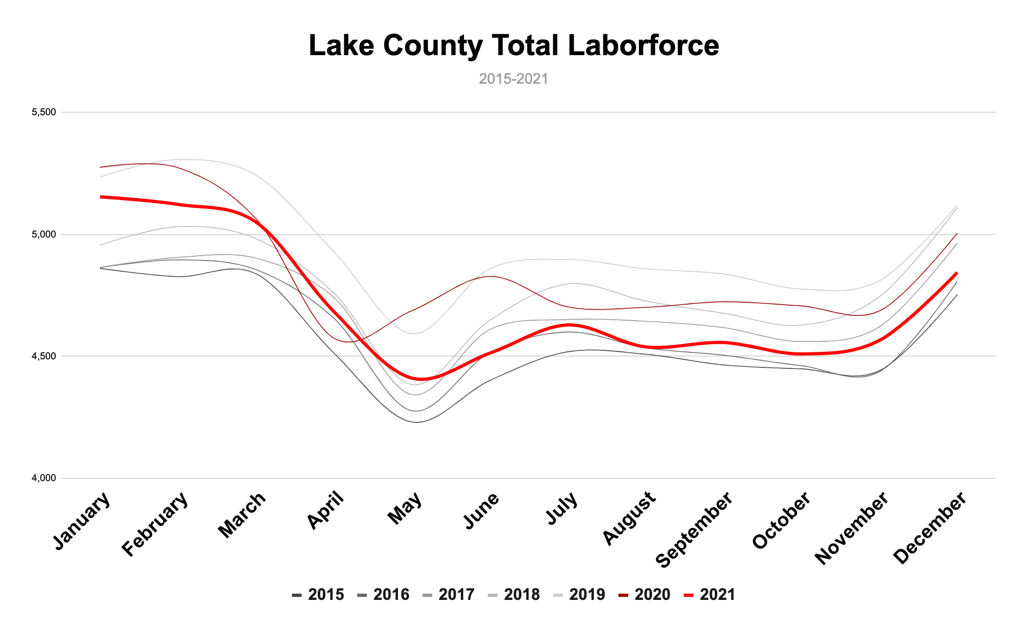
Lake County experienced strong labor force growth between 2015-2018. That growth slowed in 2019, and during the pandemic, the total labor force declined with 277 fewer people in December of 2021 than December of 2019. Labor force is defined as the number of people either employed or unemployed in a community. A person is considered unemployed if they are actively looking for work. Residents not looking for work are not considered part of the total labor force. They may include persons who have child- or dependent-care responsibilities, are retired, or not pursuing employment for any other reason. In order for a person to collect unemployment, they must be actively looking for work. Currently, Lake County has around 3.7% unemployment, which equates to around 181 unemployed persons.

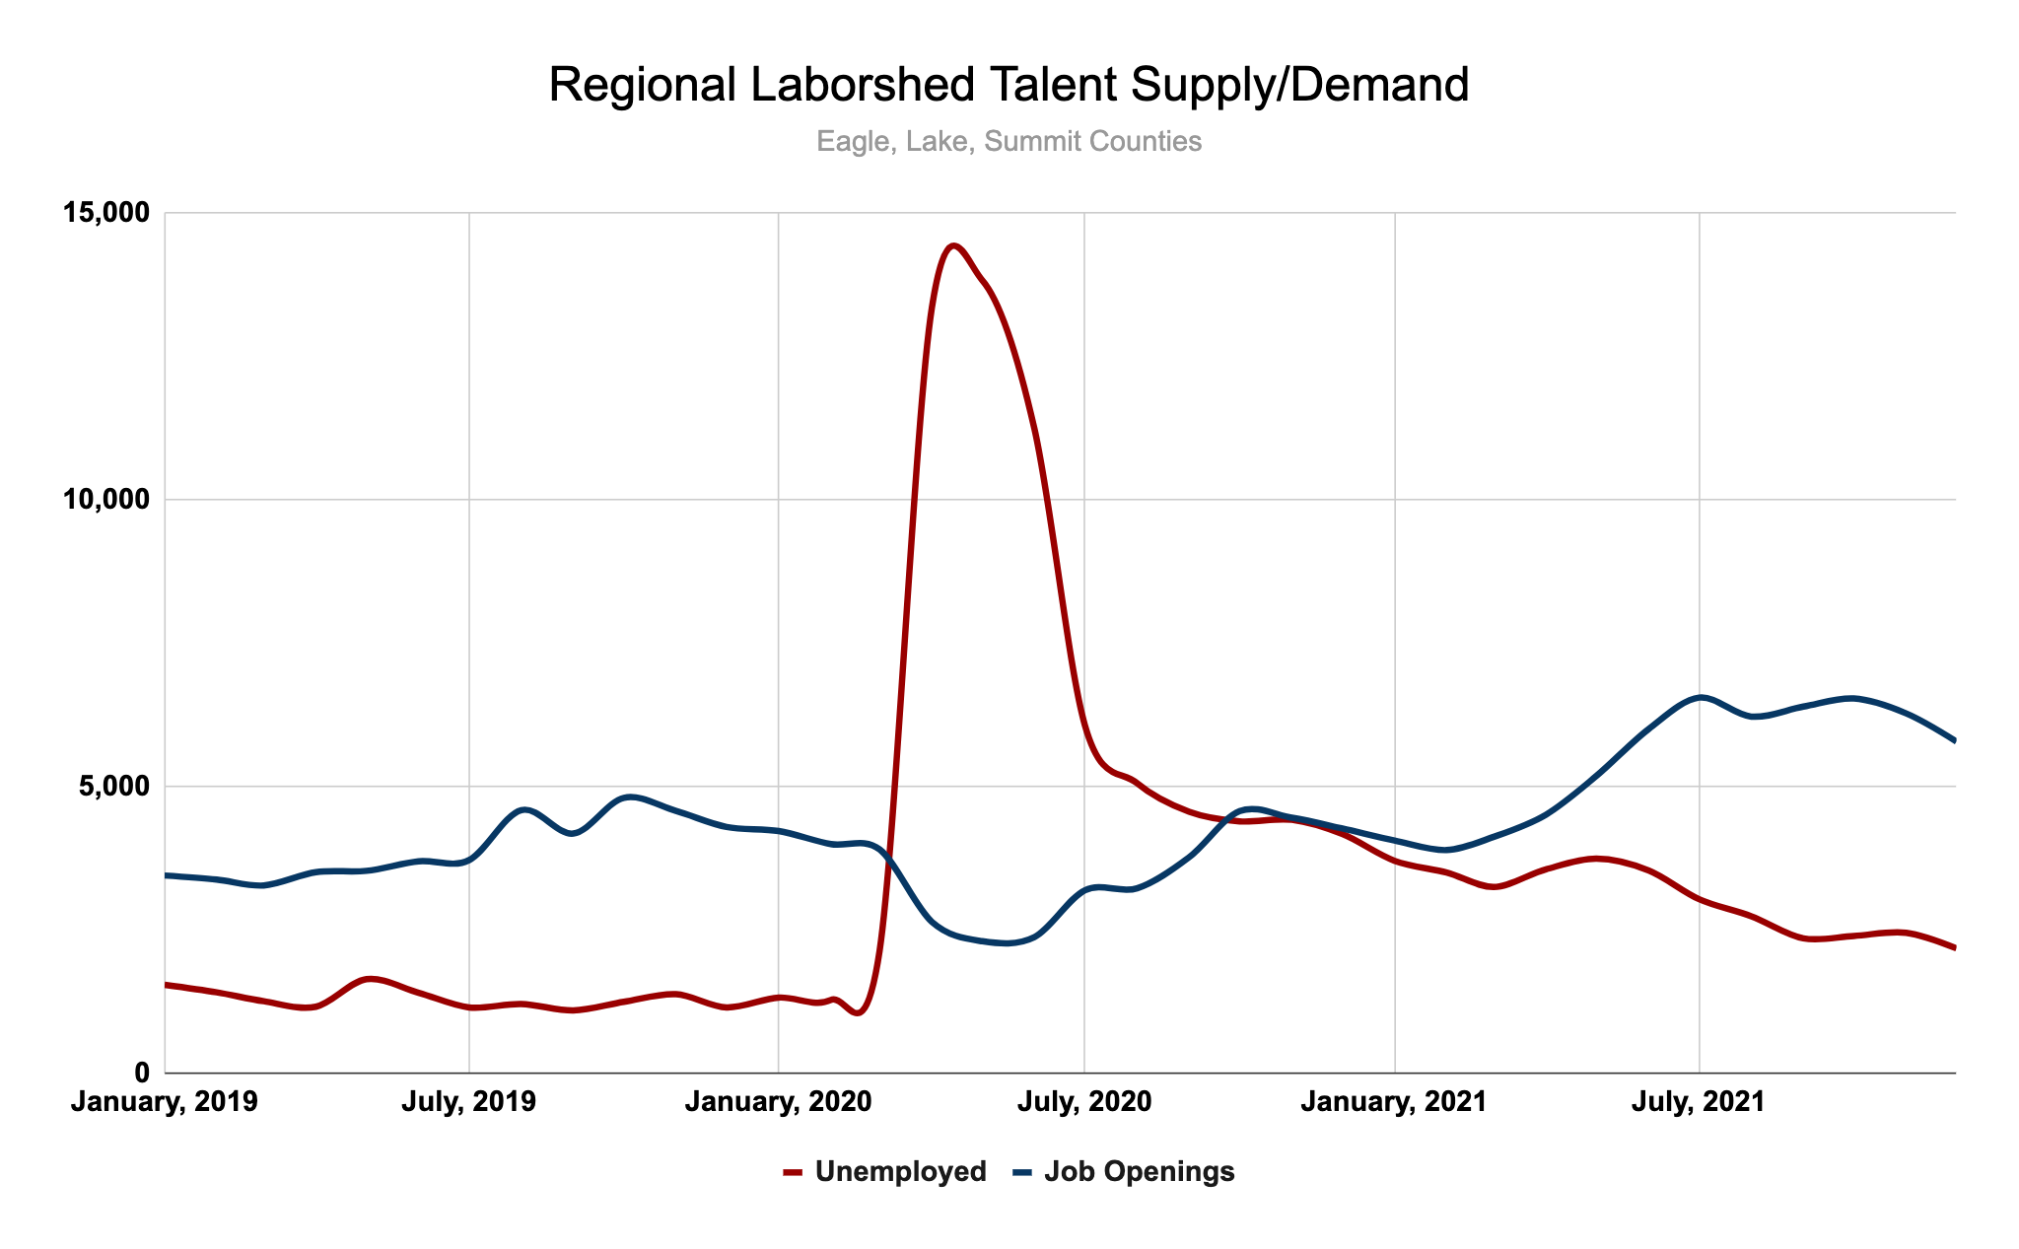
Pre-pandemic, hiring was a challenge in our region and that hallenge has become more acute. The number of jobs has increased while there are fewer workers available to fill positions. In the Eagle/Lake/Summit County laborshed, there are approximately 0.37 workers for each job opening. That is compared to 0.8 in Colorado and 0.6 nationally. Opportunity does exist for Lake County employers able to capture workers currently commuting out-of-county for employment, but hiring will remain tough regionally given the tight supply of labor.

Causes for the tight labor supply range and there is not one simple reason for the current labor shortage. The United States is charting a significant increase in retirements as a result of the pandemic, as well as the Baby Boomer generation aging out of the labor force. Other factors include slowing birth rates and declining male labor force participation. The pandemic also created substantial impacts to women in the labor force, reductions to visa workers numbers, and accelerated trends in part time work.
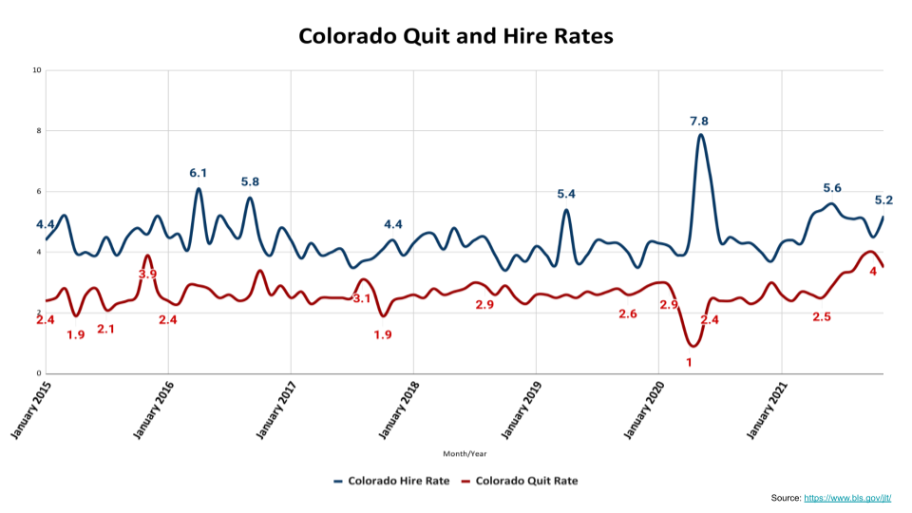
There has been much discussion recently of the “great resignation” seen in today’s labor market. Despite record numbers of quits (25.3 million nationally between July and December of 2021), hiring rates continue to exceed quit rates as workers are finding work that more closely aligns with values. Employers who can find the right balance between compensation, benefits, and culture will have the opportunity to capture talent looking to make a change. Employee retention is also becoming more critical because it will become less likely that new workers are available in our communities to fill vacant positions and because there are more openings than people, workers have a number of jobs to choose from.

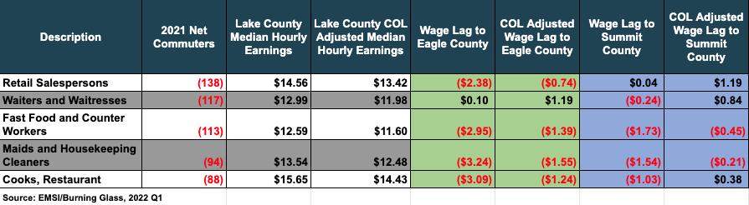
Lake County tends to lag behind Eagle and Summit counties in median wages, but when factored for cost of living that gap becomes smaller. Wage rates have seen significant pressure in the past year as cost of living, inflationary pressures, and competition for workers impact employers. The table below shows the top 5 occupations for outbound workers and the relative wage lag in Lake County compared to Eagle and Summit counties. Restaurants in particular have an opportunity to compete for talent based on wage differences.

The challenges in today's labor market will exist for many years to come and employers that can get creative in navigating shifting demographics will have an edge in attracting and retaining employees.

