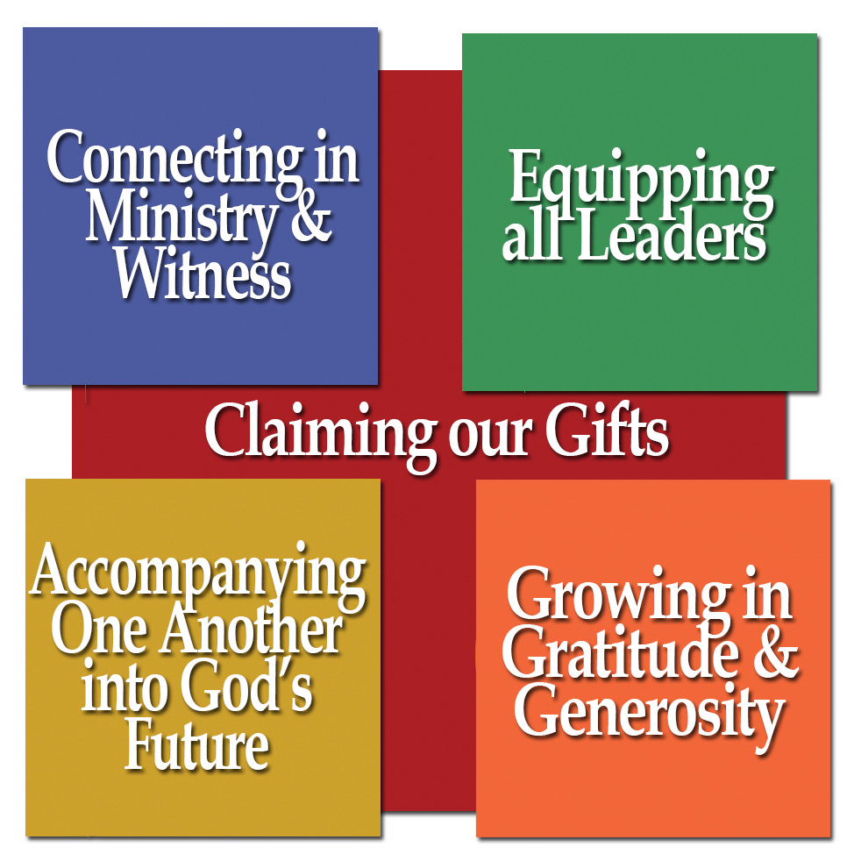
March 2020
For use in your bulletins, newsletters, social media, and worship

Assembly Ambassador Monthly Toolkit
j

Ministry Focus: Ecumenical Life

Thoughts from Bishop Jim:

In what’s often considered a post-denominational age, the notion of ecumenical life may seem old fashioned. After all, aren’t we talking about partnerships between institutional churches? How does that spread the cause of the gospel? The word ecumenical actually comes from the Greek word oikoumenē meaning ‘the (inhabited) earth’. To be ecumenical is to be a church committed to life and collaboration with all God’s people for the sake of the whole world. True, this cooperation finds form through the institutions of our synods, congregations and churchwide expression. Yet ultimately, it’s people – able to see God’s face in others – who put their gifts together in order to participate in something bigger than themselves. That’s worth celebrating!
Mission Moment: St. Christopher’s Highway, Rock Springs, WY

Mount of Olives Lutheran Church does ecumenical work through a shared ministry known as St. Christopher’s Highway—Travelers’ Aid. Together with Episcopal and United Church of Christ congregations throughout southwest Wyoming we serve travelers in need. Travelers are able to call our ministry network of committed volunteers to receive lodging, food, clothing, or transportation. In April 2019, leaders from each of our churches got together and saw a need that was not being met—so, St. Christopher’s came to birth. We follow the model of St. Francis of Assisi, “Preach the gospel at all times, when necessary use words.” There are no strings attached, we are here to serve.

Hymn: ELW 498 United at the Table (Unidos en la Fiesta)

Prayer Petition:
Unifying God, we are grateful for the ministry of our full-communion partners and the unique gifts they offer to our shared witness: The Episcopal Church, United Methodist Church, Moravian Church, United Church of Christ, Reformed Church in America, and Presbyterian Church (USA). Grant wisdom and a spirit of unity in conversations with other siblings in Christ, that we might strengthen our Gospel witness in the world through our partnerships.

Activities and Embodied Prayers:
MARCH 2020

Ecumenical Asset Mapping
Explore what full-communion partner congregations and other ecumenical partners are your community or neighborhood. Highlight them on a map and pray for them during worship. On the map, list any shared ministry or events you do together. Visit their building or their website to learn what ministries they offer to the community.

Pulpit Swap
Invite a full-communion partner pastor to preach/preside during Sunday worship, and have your pastor join them for worship. Another Sunday, join another congregation for worship.

Offering Connections: (to include in the offering portion of worship)

March 1: Your gifts help support 2 ecumenical mission sites: Camino de Vida in Albuquerque (PC-USA)
and Cristo Rey in Denver (Episcopal Church).

March 8: With your support, the Rocky Mountain Synod participates in the Colorado Council of Churches, the New Mexico Conference of Churches, and the Wyoming Interfaith Network.

March 15: Your offerings help support a joint ELCA-Episcopal Campus Ministry at UNC in Greeley, CO.

March 24: In addition to our 6 full-communion partners, the ELCA is in bilateral conversation with 6 other church bodies. This on-going work towards shared ministry is made possible through your support.

March 31: Through your mission support, Bishop Gonia, staff, and synod council are able to be present at ordinations, installations, and annual conferences of our full-communion partners, embodying our call to be the Church Together.

MARCH 2020

Community Conversation and Further Reading:

- A Declaration of Inter-Religious Commitment (2019)
- A Declaration of Ecumenical Commitment (1991)
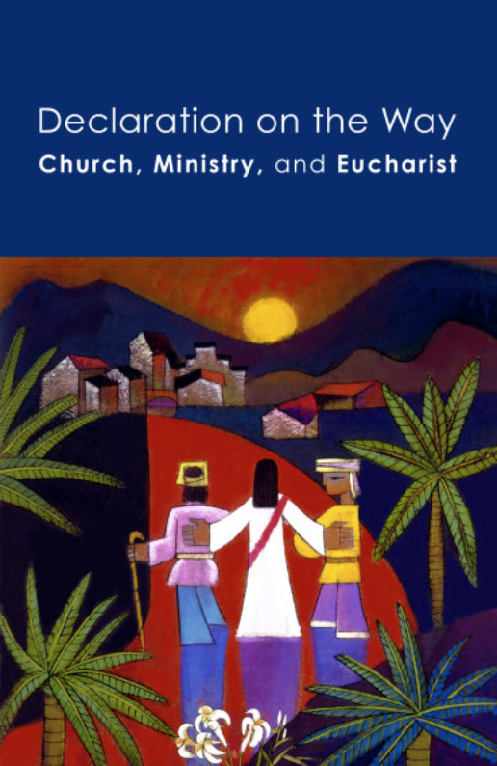
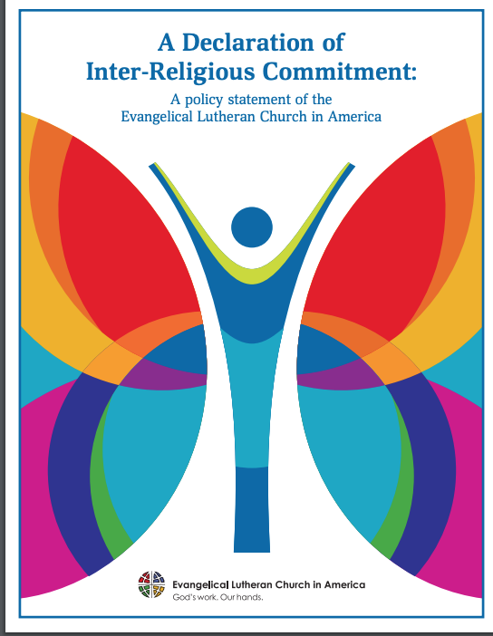
- Declaration on the Way: Church Ministry, and Eucharist

- ELCA Ecumenical and Inter-Religious Relations

