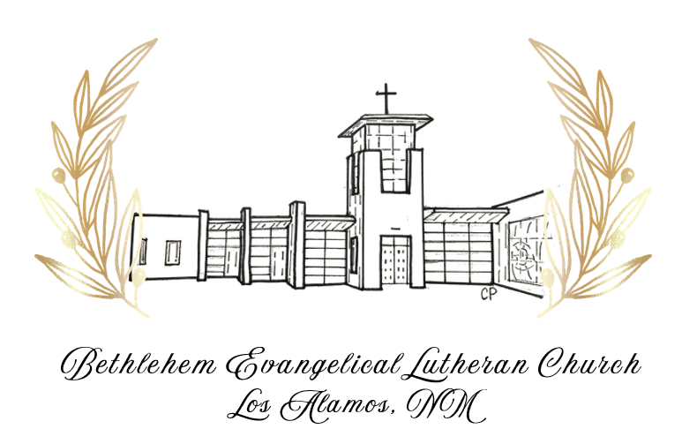

SEPTEMBER 12, 2026
CELEBRATING
75 YEARS

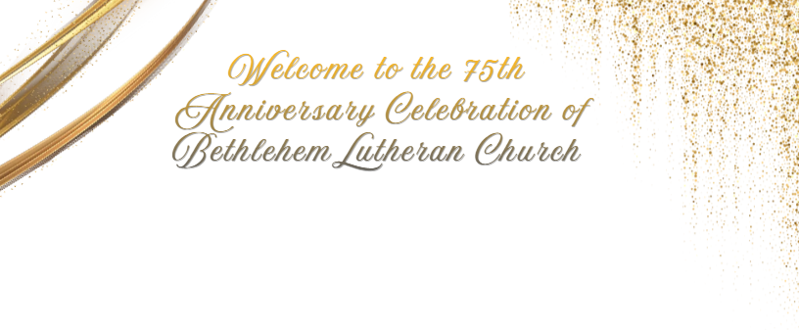


THANK YOU
As we gather to celebrate 75 years of God’s faithfulness in our church, we give thanks for all who serve and support our congregation. We are grateful for the faithful work of the 75th Anniversary Planning Committee, whose dedication made this celebration possible, and for Lane Stevens for sharing music with us this evening. We extend our gratitude to everyone who contributed to this evening’s program. Your willingness to share your gifts enriches our community and honors our shared history.
CELEBRATION COOKBOOK
To celebrate the 75th anniversary, we are asking members to submit some of your favorite recipes.
It has been 25 years since the last cookbook.
Submissions are due by 12/31/2026 and the
cookbook will be available digitally sometime in
2027. Please submit your recipes to:
cookbook@bethluth.com
Our Mission Statement
At Bethlehem we strive to follow the triune God and love all people. We exist to create an environment where we welcome and invite all people to meet Jesus, to find community and to grow in their faith. We embrace and extend the blessings that God continually gives us as we go out in peace and inspire the world with grace.
CHARTER MEMBERS

Mrs. Jeannette Arkin • Mr. Charles D. Blackwell • Mrs. Marjorie T. Blackwell • Mr. Leonard Crogstad • Mrs. Ruth Crogstad • Mrs. Irene A. Davis • Mrs. Barbara Day • Mr. Frederick R. Deines • Mrs. Ruth H. Deines • Mrs. Katherine Drager • Mr. Jules Dufour • Mrs. Mary Dufour • Miss Mae C. Erickson • Mrs. Minnie Esser • Mr. Vincent L. Esser • Mrs. Joyce A. Eyster • Mrs. Ann L. Froistad • Mr. Stanley H. Froistad • Mrs. Norma E. Glassmire • Mr. Alan Gordon • Mrs. Evelyn Gordon • Mr. James K. Gore • Mrs. Margaret Gore • Mr. Allen W. Hasty • Mrs. Jean Hasty • Mrs. Pauline E. (Peterson) Heimbach • Mrs. Mary Henkel • Mr. Richard Henkel • Mr. Carl A. Hercher • Mrs. Ruth E. Hercher • Mr. Reinhardt W. Heuer • Mrs. Reinhardt Heuer • Mrs. Richard W. Hinds • Mr. Alfred G. Holzwarth • Mr. Bruce E. Hoverson • Mr. Edwin C. Hyatt • Mrs. Marian L. Hyatt • Mr. Kenneth S. Jensen • Mrs. Kenneth Jensen • Mr. Allan E. Johnson • Mrs. Ila Johnson • Mr. Nels W. Johnson • Mrs. Nels Johnson • Mr. Stanley G. Johnstone • Mrs. Virginia Johnstone • Mr. Carl Lundquist • Mrs. Elsie Lundquist • Mrs. Jean McKibben • Mrs. Billie Miller • Mr. Wendell L. Miller • Mr. David M. Nelson • Mrs. Ruth Nelson • Mrs. Marian Nelson • Mr. Vincent G. Nelson • Mr. Donald C. Peterson • Mrs. Donald C. Peterson • Mr. Carroll A. Rendell • Mrs. Gladys Rendell • Mrs. Edna Risley • Mr. Ellsworth M. Risley • Mr. Eugene H. Roach • Mrs. Laura Roach • Mrs. Thelma Ross • Mr. Elmer H. Ryman • Mrs. Elma Ryman • Mrs. Louie Sampson • Mr. Sam Sampson • Mr. Christian F. Schroeder, Jr. • Mrs. Jeanette Schroeder • Mr. Oliver R. Simi • Miss Marcia Smith • Mrs. Elma Stahl • Mrs. Helen Stearns • Mr. William M. Stearns • Mrs. Mary L. Tyson • Mr. Robert D. Tyson • Mr. Glenn A. Vogt • Mrs. Margaret Vogt

ROSTERED LEADERS


Pastors
Pastor Charles A. Davis (1950 – 1951)
Pastor Dale L Knudsen (1952 – 1958)
Pastor Gordon O Lindemann (1959 – 1961)
Pastor Raymond H. Tiemeyer (1962 – 1967)
Pastor Paul Parker Anspach, JR. (1967 – 1982)
Associate Pastor Donald Flaxbart (1981 – 1983)
Pastor Calder A. Gibson II (1983 – 1997)
Associate Pastor Robert D. Beck (1990 – 1991)
Pastor Edward L. Thomas (1995 – 2003)
Pastor Bruce A. Kuenzel (2004 – 2016)

Co-Pastor Scott Thalacker (2018 – 2020)
Associate Pastor Nicole’ Raddu Ferry (2012 – 2018)
Co-Pastor Nicole’ Raddu Ferry (2018 – 2021)
Pastor Nicole’ Ferry (2022 – 2024)

Interns
Mike Evans (1977-1978, Lutheran Theological Seminary at Gettysburg)
Gary McCloskey (1978-1979, Lutheran Theological Seminary at Gettysburg)
David Wendell (1979-1980, Lutheran Theological Seminary at Gettysburg)
Bob Louden (1980-1981, Lutheran Theological Seminary at Gettysburg)
Margaret Jill King (1992-1993, Lutheran Theological Southern Seminary)
Ed Thomas (1993-1994, Lutheran Theological Southern Seminary)
Amy Oehlschlaeger (1994-1995, Lutheran Theological Southern Seminary)

Deacons
Deacon Cynthia Biddlecomb, Director of Lay Ministry 2002-2010
Deacon Amy Schmuck, Deacon for Welcome & Lifelong Learning, 2024-Present

Interim Pastors
Rev. Matthew Lepisto, Transition Pastor, 1951-1952
Rev. Jay Spoonheim, Disaster Pastor, 2000-2001; Interim Pastor, 2003; Part-time Associate Pastor, 2010-2011
Rev. Tom Anderson, Interim Pastor, 2003-2004; Part-time Associate Pastor, 2011-2012
Rev. John Bell, Interim Youth & Family Associate Pastor, 2010-2011
Rev. Ben Larzelere, Bridge Pastor, 2016-2017
Rev. Russ Sorensen, Interim Pastor, 2017-2018
Rev. Dr. Kate Schlechter, Associate Bridge Pastor, 2023-2024; Senior Transition Pastor, 2025-Sept. 2026

Youth Directors
John Conrad 1984 – 1986
Gordon Hora 1986 – 1988
Sean & Penny Love 1994 – 2002
Matt Nichols 2003 – 2009
Nicolé Ferry 2010 – 2016

HISTORY OF BELC

A Journey of Faith: 75 Years of Ministry

1950s: A Congregation is Born
- June 1950 – Lutheran Seminarian Paul Jansen arrived to preside at Bethlehem's first worship service attended by 45 people.
- 1950 – Pastor Charles Davis is called to become the Mission Developer, and the congregation is officially established, meeting at the Girl Scout Little House on Trinity Drive.
- April 8, 1951 – Bethlehem Evangelical Lutheran Church is officially established as a United Lutheran Church in America (ULCA) congregation comprising 78 charter members.
- September 1951 – Pastor Matthew Lepisto commuted from Albuquerque to preside at Bethlehem.
- Spring 1952 – Pastor Dale Knudsen accepts the call to BELC.
- November 1953 – Groundbreaking is held for the initial church building.
- June 1954 – The first unit of the church is dedicated. On the same day, a forest fire burns on Sawyer Hill and several members serve as volunteer firefighters. Ronny Henkel is born that day, and Mary Henkel drives herself to the hospital while Dick Henkel fights the fire on the mountain.
- January 1959 – Pastor Gordon Lindemann accepts the call to BELC.

1960s: Growing in Faith
- 1962 – Bethlehem Lutheran, along with the ULCA, merges into the newly formed Lutheran Church in America (LCA).
- 1962 – Pastor Tiemeyer accepts the call to BELC.
- 1963 – The Sunday School Unit is dedicated.
- 1967 – Pastor Anspach accepts the call.
- 1969 – Self Help is formed to aid area residents, with Davi Raju serving as its first director.
- 1969 – The new Sanctuary is dedicated.
- 1969 – The new Pipe Organ is dedicated.

1970s: Expanding Ministry
- 1970 – The parsonage is built.
- 1977 – Intern Mike Evans serves BELC.
- 1978 – Intern Gary McCloskey serves BELC.
- 1979 – Intern David Wendel serves BELC.
- 1979 – Member Gary Horpedahl is ordained and installed in a church in California.

1980s: Building Community
- 1980 – Intern Bob Lowden serves BELC.
- 1982 – Interim Pastor Don Flaxbart serves BELC.
- September 1982 – Pastor Calder Gibson is installed.
- September 1984 – John Conrad serves as Youth Director.
- 1986 – Gordon Hora serves as Youth Director.
- 1986 – Ecumenical services begin with Trinity on the Hill Episcopal Church and Immaculate Heart of Mary Catholic Church.
- 1987 – Pastor Ephraim Mwankenja from Ethiopia spends several months at BELC.
- 1988 – BELC, along with the Lutheran Church in America (LCA), becomes part of the newly formed Evangelical Lutheran Church in America (ELCA).

1990s: Preparing for the Future
- February 1990 – Bob Beck serves as Associate Pastor.
- 1992 – Margaret Jill King serves as intern.
- 1993-1994 – Pastor Ed Thomas serves as intern.
- 1994 – Amy Oehlschlaeger serves as intern.
- 1994 – Sean and Penny Love serve as Youth Directors for Bethlehem and Trinity on the Hill churches.
- 1995 – Pastor Ed Thomas is called as Pastor at BELC.
- 1997 – Pastor Calder Gibson retires after 15 years of ministry, and Pastor Thomas assumes the role of Senior Pastor.
- 1999 – Ron Augustson is called as Director of Volunteer Ministries.
- 1999 – The Place of Grace Capital Campaign begins to add seating to the Sanctuary, a Gathering Space, kitchen, and Sunday School rooms. Ultimately, $1.7 million is raised.

2000s: Resilience and Renewal
- May 2000 – The Cerro Grande Fire scorches the church building and parsonage and destroys the homes of 14 Bethlehem members.
- May 2000 – Pastor Jay Spoonheim serves alongside Pastor Thomas as Bethlehem's "Disaster Pastor" following the trauma of the fire.
- 2001 – Stephen Ministry begins.
- 2001 – BELC serves at the Lutheran Navajo Mission School in Arizona, teaching science.
- May 2002 – Deacon Cynthia Biddlecomb is installed at BELC.
- May 2002 – Phase I of the building project, including the Sunday School wing, kitchen, and Fellowship Hall, is completed and dedicated.
- 2003 – Pastor Tom Anderson is installed as Intentional Interim Pastor.
- 2003 – Matt Nichols is installed as Youth and Family Director.
- 2004 – A "Rotation Model" of Sunday School is implemented, including a movie room, art room, storytelling tent room, computer room, science room, and cooking rotation. Students rotate weekly to learn Bible stories in a variety of settings.
- January 30, 2005 – Phase II of the building project, including expanded Sanctuary seating and the addition of the Gathering Space, is completed and dedicated.
- January 2005 – Pastor Bruce Kuenzel is installed at BELC.

2010s: New Ministries, New Opportunities
- 2010 – Pastor John Bell is installed as Interim Youth and Family Pastor.
- 2011 – Pastor Tom Anderson is installed as Part-Time Associate Pastor.
- 2011 – The I.O.T.A. Praise Band is created.
- 2012 – Pastor Nicolé Ferry is installed as Associate Pastor at BELC.
- 2013 – The Columbarium is installed and dedicated.
- 2015 – Building Kindness, later known as Somos Amigos and eventually Mesa to Mesa, is launched by Bethlehem to provide free minor home repairs through volunteer service.
- 2016 – Pastor Ben Lazerlere is installed as Bridge Pastor.
- 2017 – Pastor Russ Sorenson is installed as Interim Pastor.
- July 29, 2018 – Pastor Scott Thalacker is installed as Co-Pastor alongside Pastor Nicolé Ferry.
- January 5, 2019 – The Sanctuary roof collapses following a heavy snowfall.
- 2019 – The Raise the Roof Capital Campaign begins to repair the roof and expand ministry technology.

2020s: Faith Through Change
- March 2020 – During the COVID-19 pandemic, all community gatherings, including worship services, are suspended under mandatory closures. BELC staff and the Audio-Visual Team quickly implement virtual Zoom-based worship services.
- 2020 – Outdoor worship services begin when public health conditions allow.
- 2021 – The Pipe Organ is refurbished.
- Spring 2023 – Pastor Kate Schlechter is installed as Bridge Pastor to serve alongside Pastor Nicolé Ferry.
- April 2023 – The Table, an alternative worship service designed for families, is introduced.
- February 2024 – Future Search planning begins to develop a new vision for BELC.
- March 23, 2024 – Deacon Amy Schmuck is installed as Deacon for Welcome & Lifelong Learning at BELC, serving alongside Pastor Ferry.
- March 2025 – Pastor Kate Schlechter is installed as Senior Transition Pastor.
- 2026 – Bethlehem celebrates 75 Years of Ministry, giving thanks for generations of faithful members, leaders, and community partners who have shaped the congregation's mission and ministry.

And the Story Continues...
Giving thanks for the past, celebrating the present, and looking forward in faith to all God has yet in store for Bethlehem.

HISTORY OF LOS ALAMOS

Los Alamos: A Community Shaped by Science,
Service, and Resilience

1940s: The Secret City Emerges
- 1943 – The secret city of Los Alamos is established for the Manhattan Project under the direction of Robert J. Oppenheimer and General Leslie Groves.
- 1945 – World War II comes to an end.
- 1945 – Norris Bradbury becomes Director of Los Alamos Laboratory.
- 1949 – Los Alamos County is officially created.

1950s: From Secret City to Community
- March 1951 – The Baptist Church dedicates its building.
- April 1951 – The Laboratory hosts an open house featuring the new Van de Graaff generator, an electrostatic machine that uses a moving belt to build a large amount of static electricity on a metal dome.
- May 1951 – The Catholic Church moves its building to Canyon Road.
- September 1951 – The Methodist Church is chartered.
- January 1952 – Los Alamos Hospital is dedicated.
- August 1952 – A 4.0 earthquake occurs in Los Alamos. Many residents initially believe it is a routine test "shot."
- May 1954 – The Atomic Energy Commission's Personnel Security Board denies Robert Oppenheimer a security clearance.
- June 1956 – The Laboratory announces that a research team has "captured" the neutrino, one of nature's smallest atomic particles and a possible key to understanding the universe.
- 1957 – The guard gates come down and Los Alamos becomes an open city.
- December 25, 1957 – Sputnik II soars across the skies of the western United States on Christmas Day.
- 1960 – Bethlehem member Joseph McKibben invents an artificial muscle to assist people with paralyzed limbs. He developed the device in hopes of helping his daughter Karen, who was affected by polio.

1960s: A Growing Town
- 1962 – President John F. Kennedy visits Los Alamos.
- 1962 – The Los Alamos Chamber of Commerce is organized.
- 1962 – The Los Alamos Monitor newspaper begins publication.
- 1963 – Los Alamos Bank opens for business.
- 1963 – The Los Alamos Inn opens, offering 84 rooms and becoming the town's first motel.
- 1963 – A museum highlighting the history and development of the Laboratory opens. It would later become the Bradbury Science Museum.
- 1966 – Government housing and environmental buildings are offered for sale to residents who had previously rented them from the federal government. Monthly rents range from $67 to $185. Top Laboratory salaries are approximately $12,000 annually, while many other residents earn around $5,000 per year. Poverty is considered virtually unknown in the community.

1970s: Expansion and Change
- 1970 – Harold Agnew becomes Director of Los Alamos Laboratory.
- 1970 – Census data shows Los Alamos has the highest home values in New Mexico at approximately $23,500.
- 1970 – A new Golf Club building, complete with dining facilities, is completed.
- May 1972 – Plans for the La Senda development are approved.
- 1974 – Los Alamos High School receives the Bellamy Flag Honor for academic achievement. The award includes a flag that has flown over the United States Capitol and honors Francis Bellamy, author of the Pledge of Allegiance.
- October 1974 – Ownership of Fuller Lodge is transferred from the federal government to Los Alamos County.
- December 1974 – The Senior Center opens in Fuller Lodge.
- November 1975 – Development plans for North Mesa are approved.
- June 1977 – The La Mesa Fire burns 15,444 acres of Bandelier National Monument and Laboratory property, reaching K and S Sites where chemical explosives are tested.
- 1977 – Jurisdiction of the Laboratory transfers from the Atomic Energy Commission to the newly established U.S. Department of Energy.
- 1979 – Donald Kerr becomes Director of Los Alamos Laboratory.

1980s: A Maturing Community
- 1980s – Townsite is home to both Safeway and Gibson's Discount Store. Safeway is later acquired by Furr's, and Gibson's closes before the end of the decade.
- 1980s – Sombrillo Nursing Facility opens.
- 1980s – The White Rock Branch Library opens.
- 1986 – Sig Hecker becomes Director of Los Alamos Laboratory.
- 1987 – Approximately 50 inches of snow fall on Los Alamos, bringing much of the community to a standstill.
- 1988 – The Larry R. Walkup Aquatic Center is built.

1990s: Milestones and Challenges
- 1993 – President Bill Clinton visits Los Alamos.
- 1993 – Los Alamos National Laboratory celebrates its 50th Anniversary.
- 1995 – The Peggy Sue Bridge is demolished.
- 1996 – The Dome Fire destroys 16,589 acres of Bandelier National Monument and Santa Fe National Forest land.
- March 1998 – The Betty Ehart Senior Center opens.
- 1998 – Two roundabouts are constructed: one at Diamond Drive and San Ildefonso Road, and another along the new Main Street corridor near C.B. Fox.

2000s: Fire, Recovery, and Renewal
- May 2000 – The Cerro Grande Fire burns more than 58,000 acres, becoming the largest wildfire in New Mexico history at the time. Approximately 400 homes are destroyed, and residents of Los Alamos and White Rock are evacuated for several days.
- 2001 – High Society, Los Alamos's only movie theater, closes.
- 2001 – The community continues recovering from the Cerro Grande Fire. A federal investigation places responsibility on the National Park Service and prompts a review of national wildfire prevention policies.
- 2001 – Los Alamos Community Winds is formally established for amateur and professional musicians.
- 2004 – The Juvenile Justice Advisory Board is created to provide prevention, intervention, and support services for local youth and families.
- October 1, 2007 – Atomic City Transit begins operation, providing free public transportation throughout Los Alamos County.
- 2008 – Ownership of Los Alamos Airport is transferred to Los Alamos County.

2010s: Investing in the Future
- 2010 – Construction of the Los Alamos Justice Center and County Courthouse represents a major civic infrastructure investment.
- June 26, 2011 – The Las Conchas Fire begins and rapidly grows to more than 150,000 acres.
- 2013 – Clay and Dorothy Perkins purchase Master Cottage #1 and donate it to the Los Alamos Historical Society, which later establishes the Harold Agnew Cold War Gallery.
- 2014 – Ashley Pond undergoes major renovations, including construction of an event stage for community concerts and gatherings.

- April 22, 2015 – The Pajarito Environmental Education Center opens to the public on Earth Day.
- 2015 – The White Rock Library opens in a new, larger facility along State Road 4.

2020s: Resilience and Reflection
- 2020 – The COVID-19 pandemic changes daily life throughout Los Alamos and around the world.
- April 30, 2020 – C.B. Fox closes its doors after 40 years of serving the community.
- June 9, 2020 – The Reel Deal Theater closes after serving Los Alamos for 17 years.
- 2022 – The Cerro Pelado Fire in the Jemez Mountains places Los Alamos on heightened alert.
- 2023 – Christopher Nolan's film Oppenheimer is released, bringing renewed international attention to Los Alamos and its role in history.
- 2026 – The Mitchell Fire, near Bethlehem Lutheran Church, is quickly contained and extinguished.

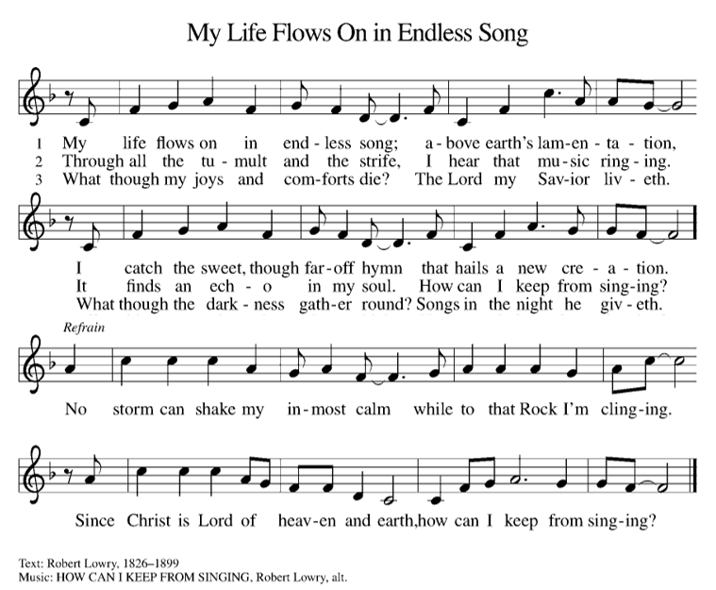
HYMN SING SONGS
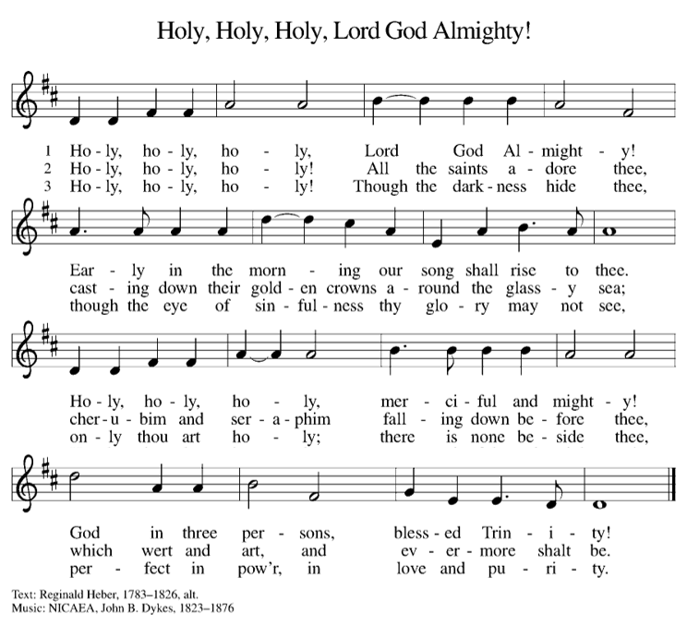
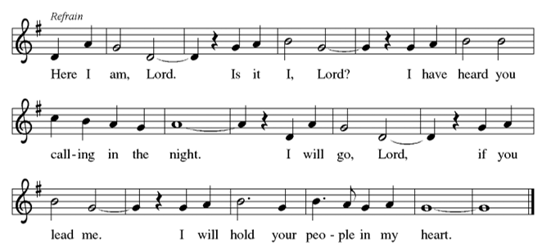
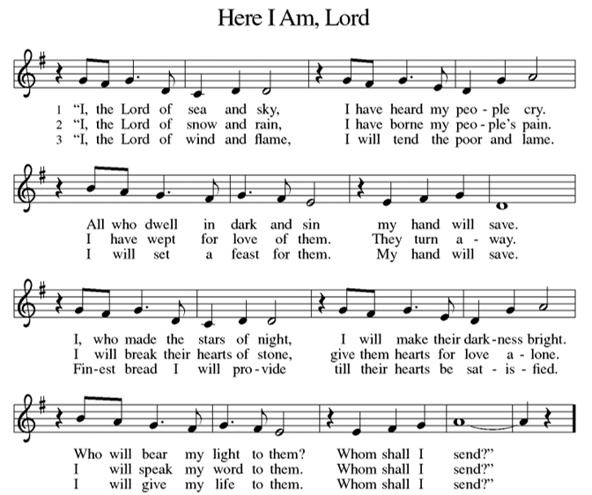
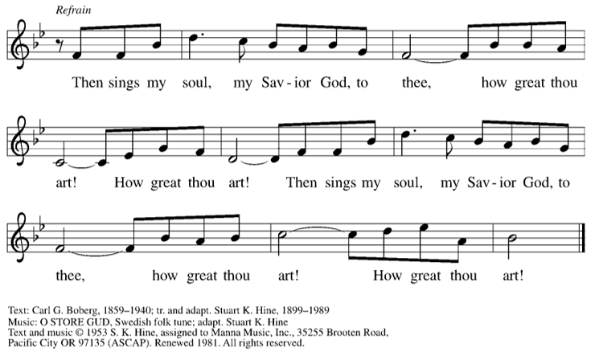
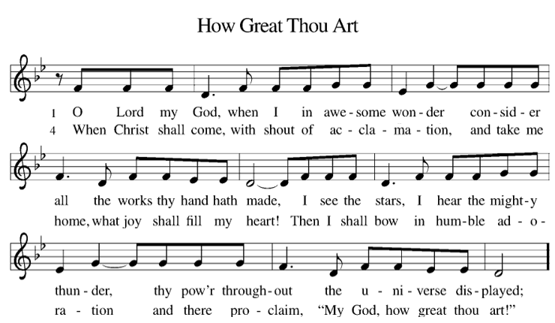

DINNER
VIDEO MONTAGE & REFLECTION
PROGRAM
DOORS OPEN
5:30 PM
7:00 PM
HYMN SING
7:30 PM
DESSERT
CLOSING REMARKS
5:00 PM
8:00 PM

