OUR MISSION:
Together we proclaim and embody
God’s unconditional love for the sake of the world

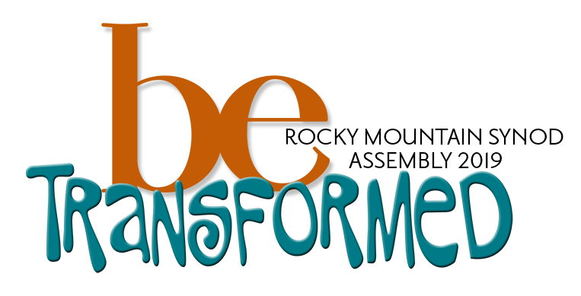

2019 Rocky Mountain Synod
Voting Member Information Packet

EMBASSY SUITES • ALBUQERQUE, NM
rmselca.org/assembly

Beloved in Christ,

As the ELCA Rocky Mountain Synod we’ve been focused this last year on what it means to be Christ’s Church for the Life of the World. Our attention now turns to what animates our witness and ministry as Christ’s Church by exploring the Spirit’s work within us – individually and communally. Under the theme “Be Transformed” our 2019 Synod Assembly will consider the changes that take place in our hearts, minds, and very being as God’s love in Jesus takes hold of us. We are pleased that Father Richard Rohr (Center for Action and Contemplation) has agreed to be with us for this journey of shared discovery.

It is our hope that our assembly voting members represent the full breadth of our synod. We ask that you encourage new leaders to participate in our life together, especially our youth and young adult members. A youth housing option will be available again this year. Childcare and translation services will be provided as needed to support those who may not otherwise be able to attend.
We look forward to seeing you in Albuquerque,

In faith,
Bishop Jim Gonia
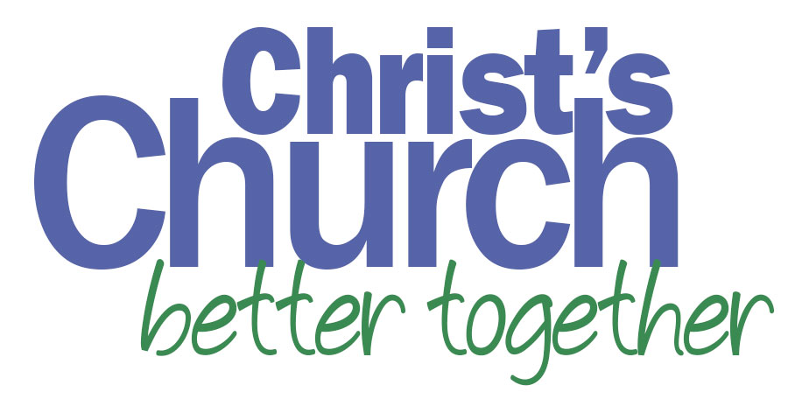

What’s new for 2019?
Keynote Speaker: Father Richard Rohr
Fr. Richard Rohr is a globally recognized ecumenical teacher bearing witness to the universal awakening within Christian mysticism and the Perennial Tradition. He is a Franciscan priest of the New Mexico Province and founder of the Center for Action and Contemplation in Albuquerque, New Mexico. Fr. Richard’s teaching is grounded in the Franciscan alternative orthodoxy—practices of contemplation and self-emptying, expressing itself in radical compassion, particularly for the socially marginalized. Fr. Richard is academic Dean of the Living School for Action and Contemplation. Drawing upon Christianity’s place within the Perennial Tradition, the mission of the Living School is to produce compassionate and powerfully learned individuals who will work for positive change in the world based on awareness of our common union with God and all beings.
Off-site Excursions and On-site Immersions
In light of our assembly theme of “Be Transformed”, voting members and visitors will be invited to select one topic or conversation for deeper learning and engagement. Sessions will be 2-3 hours of experiential learning. Off-site excursions will include: Campus Ministry, Camino de Vida, a local hike, Hispanic Cultural Center, Indian Pueblo Cultural Center, and a Native American Comic Book store. On-site immersions topics include: Leadership development, Worship and Arts, Dismantling the Doctrine of Discovery, Generosity, and Anti-Racism. Participants will select their excursion/immersion when registering for the assembly.
Optional Assembly T-shirts
Proclaim our commitment to our neighbor with this optional assembly t-shirt benefiting ELCA World Hunger. T-shirts must be pre-ordered with assembly registration. Cost: $15

Assembly Location & Travel Information
Location
Embassy Suites
1000 Woodward Place NE
Albuquerque, NM 87102

Transportation
The hotel does not provide a shuttle service. For those traveling by plane, an Uber or Lyft from the airport is around $8.
Date and Time
The assembly will begin around 2 p.m. on Friday, May 3 and end around 10:00am on Sunday, May 5. Following the close of the assembly, attendees will be invited to join area congregations for Sunday worship.
Assembly Registration Fee includes program costs, materials, three meals, and breaks. The Registration Fee does not include the hotel.
Voting Member: $300
Visitor with Meals: $250
Visitor without Meals: $125
Exhibitor with Meals: $175
Exhibitor without Meals: $50
Youth Visitor (includes hotel): $150
New this year: Local visitors can join Saturday for an afternoon excursion, dinner and worship: $50

Please note: Assembly Registration fee is due ten (10) days prior to assembly (April 23rd). Registration can be paid online or via check to the Rocky Mountain Synod.

You will make your own hotel reservation at the Embassy Suites.
The link will be posted by Februrary 1: www.rmselca.org/assembly
Single Room: $119
Double Room: $129
Triple: $139
Room rate includes breakfast and an evening reception. All rooms are 2-room suites with a pull-out couch.
Hotel Reservation deadline is April 12
To guarantee our group rate, you must reserve your hotel by April 12. After this date, rooms may still be available, but we cannot guarantee the group rate. If needed, there will be additional rooms reserved at the Sheraton, with complimentary shuttle service provided.
Scholarships and Travel Assistance
We are Christ’s Church, Better Together! Which means we are not complete unless all are gathered around the table. Scholarships are available to those who need financial assistance. The online request form can be found here: www.rmselca.org/assembly Scholarship request deadline is March 15. Requests after this date will be considered as funds are available.
Travel equalization will once again be available. The intent of travel equalization is to off-set some of the financial burden of those who travel long distances. With the Albuquerque location, we will have a higher than usual number of attendees traveling a longer distance. Travel equalization will be available to those who travel more than 1000 miles round trip. Funds will be offered for miles over 1000, or a portion of your airfare. Travel equalization will be disbursed after the assembly, based on funds available. If you have any questions, please contact Deniese Estrada: 303-777-6700.
Acting as the Church Together, there will be an option at registration to donate a small amount to Assembly Scholarships if your congregation is able.

Important Deadlines
February 4: Online Registration Opens
February 22: Exhibitor Request Deadline
An online request form will be available February 4
February 22: Resolution and Memorial Intent Deadline
If you are planning to submit a resolution or memorial, please submit an online intent form to help with our planning.
March 15: Priority Deadline for Scholarship Requests
Scholarship requests after this date will be considered as funds are available.
March 22: Resolutions and nominations for Synod Secretary due
March 22: Ministry Booklet Pages Deadline
The on-line submission form for exhibitors and ministry booklet pages will be available early February.
April 12: Hotel Reservation deadline
April 23: Registration Fee Due

Voting Member Information
The voting members of the assembly must be members of the congregation and are determined as follows:
A. Congregations are allowed 2 lay voting members, 1 male and 1 female. If a congregation is not able to find both a male and female, contact Janice Ladd-Horkey at the Office of the Bishop for permission to send 2 of the same gender: jladd-horkey@rmselca.org
B. In addition, based upon baptized membership records for the previous year (2017)
(1) Congregations having membership of 650 to 1,199 baptized members shall be allowed one additional lay voting member (male or female).
(2) Congregations having membership of 1,200 or more baptized members shall be allowed two additional lay voting members (one male and one female).
. In the selection of voting members, congregations are urged to be aware of the matter of inclusiveness of persons of color and/or persons whose primary language is other than English.
D. All Ministers of Word and Sacrament (pastors) and Ministers of Word and Service (deacons) under call or on leave from call on the roster of the Rocky Mountain Synod are voting members.
G. All retired ordained ministers on the roster of this synod who are currently serving as interim pastors who are in attendance at the assembly are voting members.

H. Youth/Young Adult Voting Members
It is the goal of this synod that at least 10% of the voting members of the Synod Assembly, Synod Council, committees, and organizational units of this synod be youth and young adults. For purposes of the constitution, bylaws, and continuing resolutions of this synod, the term “youth” means a voting member of a congregation who has not reached the age of 18 at the time of election or appointment for service. The term “young adult” means a voting member of a congregation between the ages of 18 and 30 at the time of election or appointment for service. A youth or young adult voting member is NOT an additional voting member, but rather would be one of the voting members allotted to your congregation.

Information to assist you and your congregation in inviting, selecting and supporting your youth and young adult voting members for the upcoming Rocky Mountain Synod Assembly:

    - A youth or young adult attending the Assembly, as a voting member from your congregation, will sit with the members of your congregation and fully participate in the assembly schedule.

    - It is our hope that each youth/young adult voting member attending the assembly would have an adult mentor––someone who is also a voting member from your congregation and has previously attended an Assembly. This adult's role is to support the youth during the event, answer questions, explain the business at hand, and offer encouragement for full participation.

    - Make sure ALL of your congregation's voting members have copies of the schedule, reports and documents. If possible bring the congregation's voting members together before the Assembly to review the schedule, resolutions and documents which are posted at www.rmselca.org/assembly

    - Set a date for your voting members to present a report to the congregation following the Assembly. Include your youth and young adult members!

    - Youth who are 17 and younger are the legal responsibility of the congregation. Permission and medical forms and all other critical documents for responsible and safe participation are the responsibility of the congregation. Sample forms, covenants, and guidelines for appropriate adult/youth interaction may be requested from the Office of the Bishop. Youth are the responsibility of the congregation during the regular business hours of the assembly, unless youth-specific events are noted in the agenda. For youth participating in the youth housing option, designated caring adults will serve as overnight leaders.

Resolutions and Memorials
Although both memorials and resolutions are requests by a synod for action, they are intended to address different issues and are processed differently.
Memorials address broad policy issues and are passed by Synod Assemblies for consideration by the Churchwide Assembly.
On the other hand, resolutions are requests from individual synods to the Church Council or units or offices of the Churchwide organization OR requests from the Synod Assembly to Synod Council, Office of the Bishop, or synodical boards or committees. As a practical matter, resolutions have a more narrow focus than memorials because they are requests for consideration or action by individual units or offices of the Church Council or Synod Council.
To assist with our planning, please submit a resolution intent form on the RMS website. This does not take the place of an official resolution submission.

2019 Rocky Mountain Synod Assembly Elections

At this assembly, we will be electing a Synod Secretary. The Secretary is a member of the Synod Council for a 4-year term. To be considered for election, a nomination form must be received by March 22. The nomination form will be available on the website January 1. The form should be completed by the person wishing to serve in that position. Completed nomination forms should be submitted to Janice Ladd-Horkey: jladd-horkey@rmselca.org Nominations will also be received from the floor of the assembly on May 3.

Church Together Ambassadors
Part of your on-going leadership as an assembly voting member will be to serve as a Church Together Ambassador for the next year. What does this mean?
- You will serve as an advocate of our shared life and witness as the Evangelical Lutheran Church in America until we meet in Assembly in 2020.
- Specifically you will receive monthly materials containing stories and insights about why our life as church together matters; these materials will highlight ministries of our congregations, partners, synod and wider church. Each month will focus on a specific aspect of our life as church together.
- In coordination with your pastor/deacon and congregational leadership, you will make sure that these stories and insights are shared with your congregation, ideally in worship, but also through other communication channels, through faith formation opportunities, etc.
- You will seek ways to share the stories of your congregation’s ministry and witness with the rest of us as you network with other Church Together Ambassadors in exploring additional avenues for passing along the energy and enthusiasm generated when we gather in Assembly.
- Questions or suggestions can be directed to Deacon Erin Power, Assistant to the Bishop for Synodical Life.

Assembly Weekend Worship Resources
Our 2019 Assembly will once again take place Friday-Sunday. We will be providing worship resources for congregations and ministries to use during assembly weekend. Congregations are invited to use this shared resource to worship as the Church Together while voting members, pastors, and deacons are gathered at assembly. More information will be made available soon.

