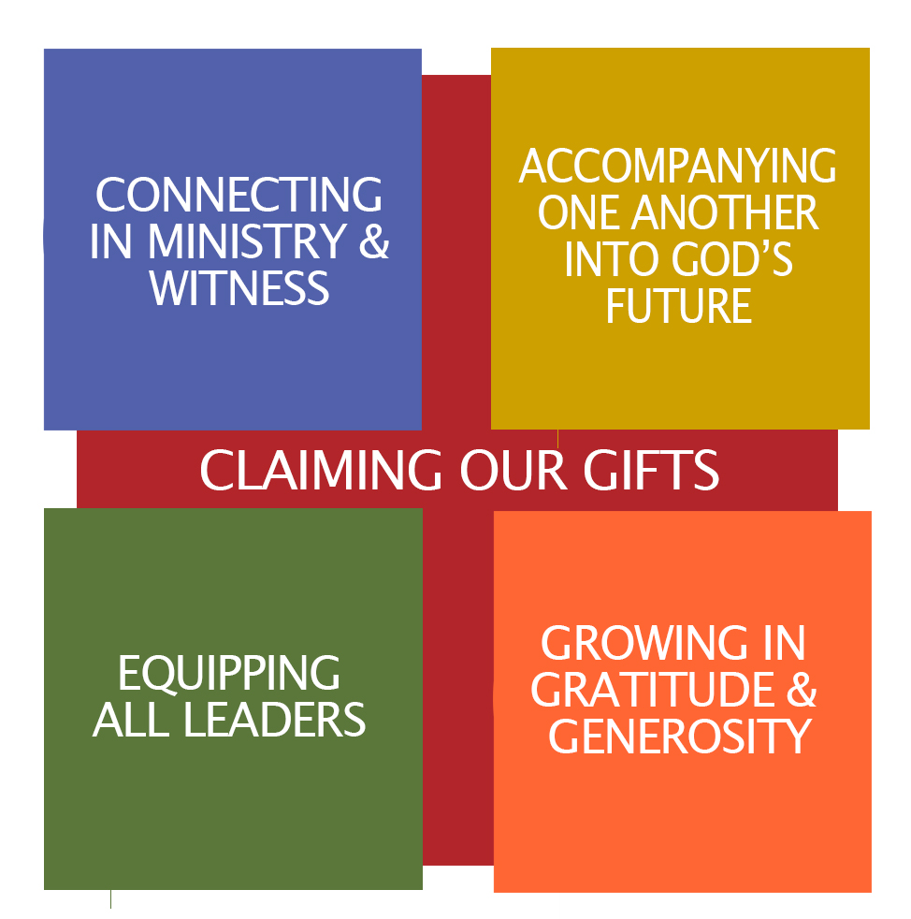
MAY 2019
For use in your bulletins, newsletters, social media, and worship

Assembly Ambassador Monthly Toolkit
j

Ministry Focus: Faith Formation

Thoughts from Bishop Jim:
When I offer my teaching on Claiming Our Gifts, I like to remind folks that we are not the type of Christians who believe that there is an “arrival point” in the life of faith. Rather we are people committed to lifelong growth as disciples, recognizing that there is ALWAYS something new to learn and experience about the God we meet in Jesus! Luther himself was passionate about providing tools for lifelong learning, offering everything from the Small Catechism to Table Talks. While our particular practices for faith formation may change over time - intergenerational models are popular now, for example - our hunger for Spirit-inspired faith discovery will always be part and parcel of our DNA as the ELCA.

Mission Moment: Faith Lutheran Golden
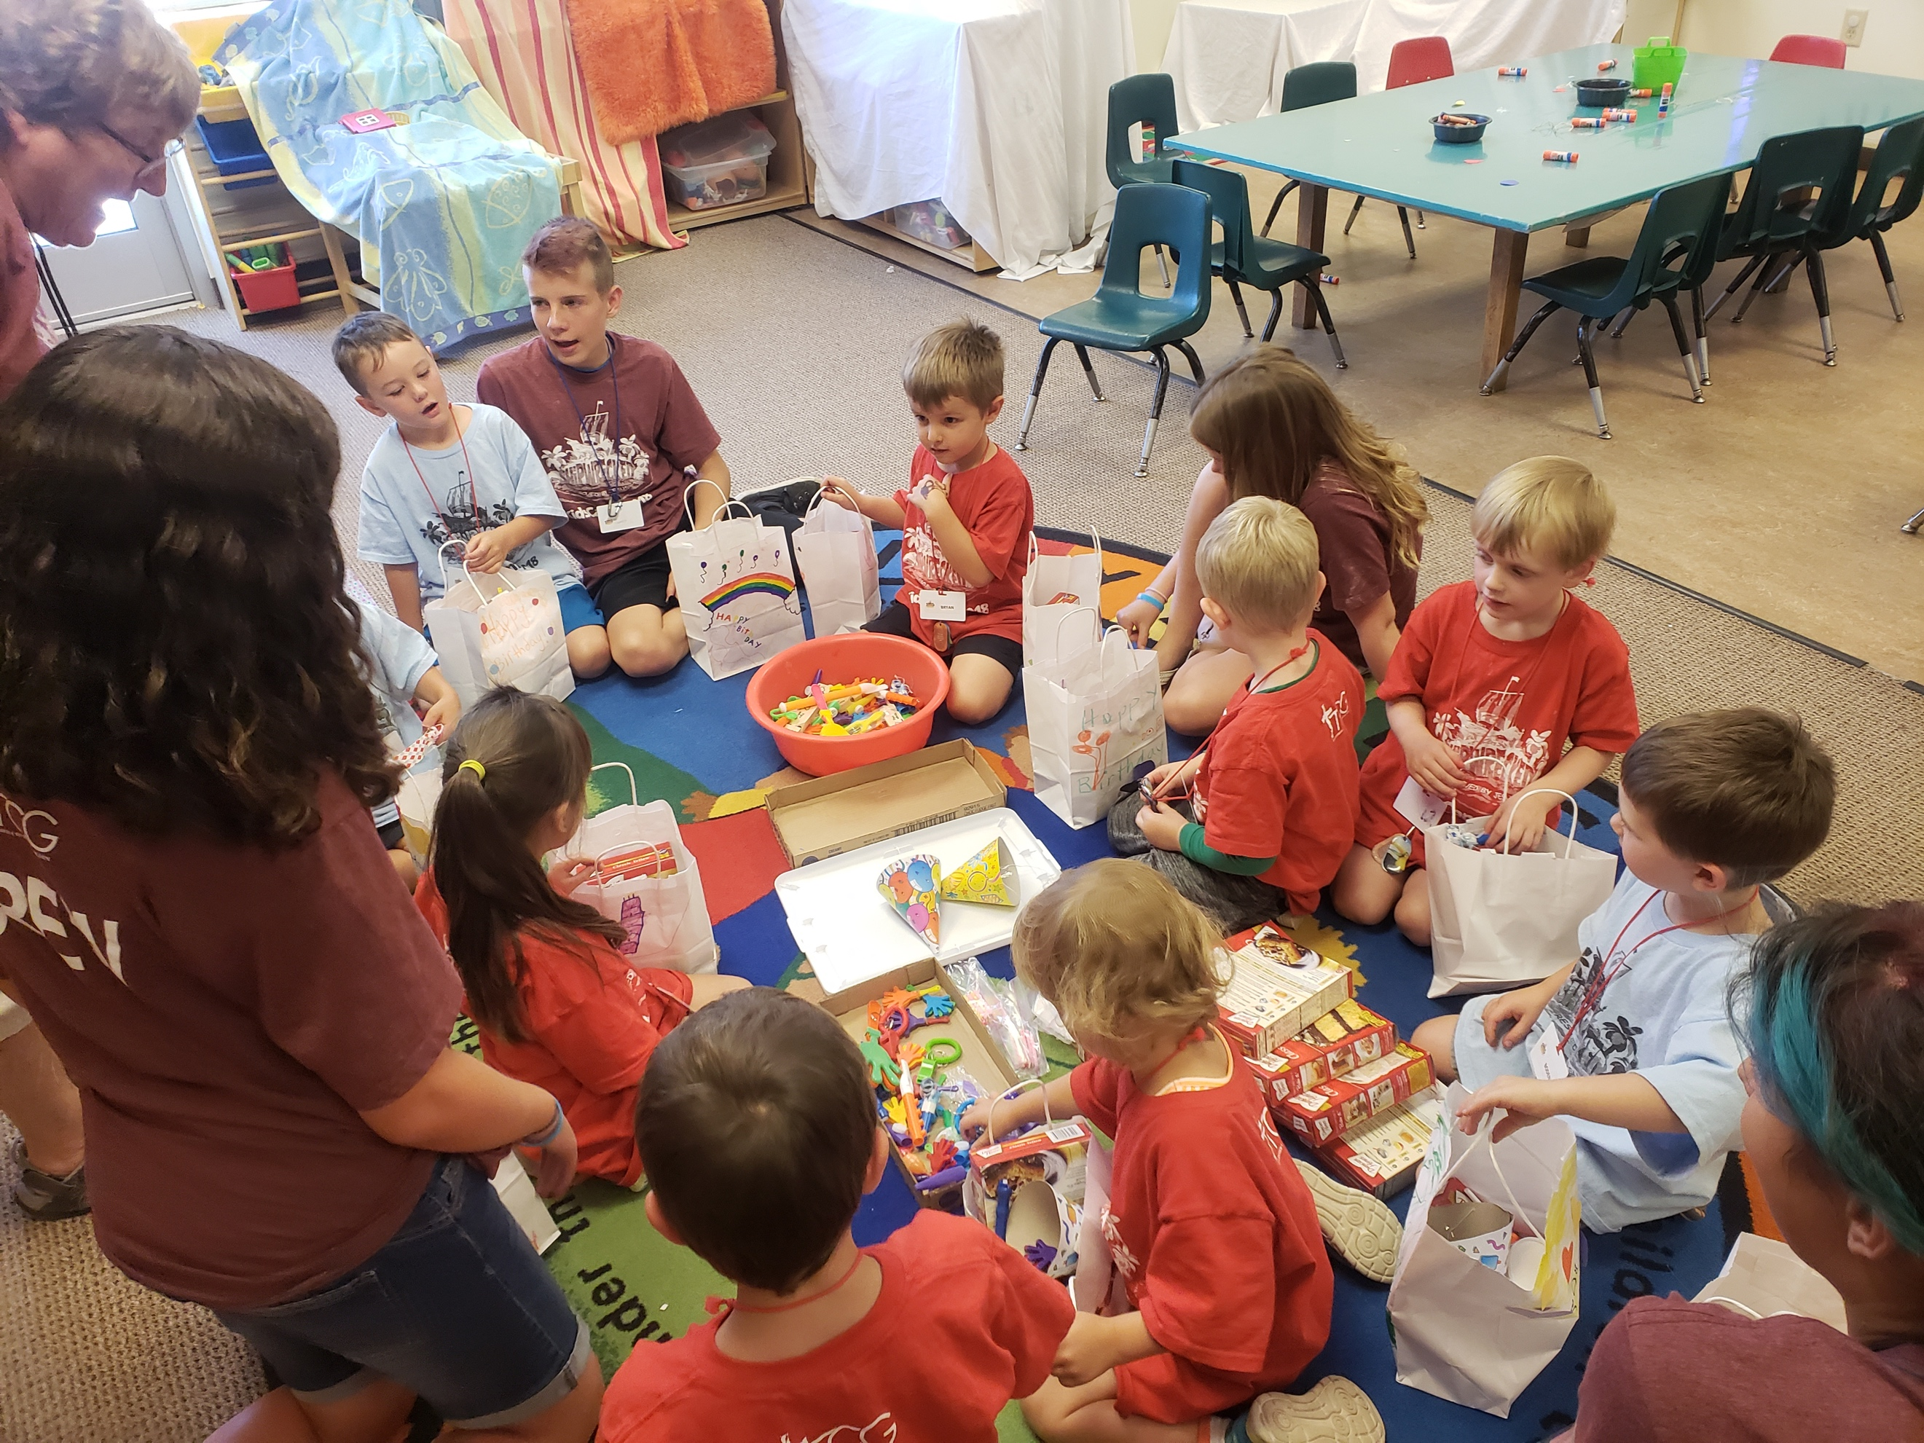
FAITH Lutheran has had a Vacation Bible School program for many years. Years ago, we started having conversations around why we do VBS and how do we help kids live into the mission of FAITH, which is Changing Lives Through the Power of Jesus, so that they can go out into our world and be the hands, feet, and voice of Jesus. One answer is that we want to always share the love of Jesus with kids and help them know how much they are loved by an amazing God. In this process, we changed the name of VBS to Kids Camp. It sounds a little different, but that’s just what we wanted to do with Kids Camp…make a difference.

Through our youth group’s relationship with Joshua Station, an organization that provides a two-year transitional housing program for people experiencing homelessness, we dreamed of including Joshua Station kids in Kids Camp. We now rent vans to transport kids at Joshua Station to and from Kids Camp. We even have some volunteers from there each year! It’s a great and growing relationship we love.
None of this could be done without the tremendous support and outpouring of love from the community of Faith Lutheran Church. This is an intergenerational event with people ages 12 to 85 working in the weekalleading up to and during the week of camp. We have grown from serving about 45 kids each summer to almost 300. The kids love the stories, games and projects, but they also love learning that they can share the love of Jesus with others and make a difference in their world.
The best part of all of this is that we do this in partnership with other churches in Golden! We have developed relationships that encourage congregations to support one another across denominational lines and work together to be the hands, feet and voice of Jesus in Golden.

Mission Moment Image:
Kids Camp kids put together Birthday Bags for the JeffCo Action Center, one of the many hands-on projects the kids do during their week.

Hymn: ELW 661: I Love to Tell the Story

Prayer Petition:
We pray for staff and volunteers across this church preparing for Vacation Bible Schools and Day Camps. Grant them patience in planning and joy in playing. We pray for all outdoor ministries, especially Rainbow Trail and Sky Ranch, preparing to welcome our youth and young adults. We pray for the youth who will attend camp this summer, that they may experience the love of God through these ministries.
MAY 2019

Embodied Prayers:
Chalk Blessing:
With a piece of chalk, decorate the sidewalk and entrance to your building; offer this or a similar blessing:
May the feet that walk in and out of these doors this summer know that the love of God goes with them, the love of this community envelops them, and the presence of Christ sustains and renews them. Amen.
Post a picture with the hashtag #HolyChaosWelcomeHere and tag the Rocky Mountain Synod!

Soil
With the dirt and seeds provided at Synod Assembly, plant a flower in your garden or flower pot with dirt from Sky Ranch and Rainbow Trail. With those gathered, pray together:
God of creation, bless this soil. Add its richness to our ground and remind us of the growth that happens as our youth travel to summer camp, our counselors bring camp to congregations and ministries, and all are nourished by the blessing of time in your beautiful outdoors in mountain, plain, and stream. Amen.

Offering Connections (to include in the offering portion of worship)

May 5: Your gifts help support our 2 outdoor ministry sites, Rainbow Trail and Sky Ranch
May 12: Every 3 years, over 30,000 youth and adults gather for the ELCA Youth Gathering. Your
offerings help support the staff who work to organize this event!

May 19: Your generosity has made possible the Rocky Mountain Synod Youth Council. Thank you for
supporting and equipping our youth and young adults!

May 26: Our ELCA Churchwide Office produce resources for adult faith formation and Bible studies,
made possible through your regular offerings.

Community Conversations:

Read one or more of the following texts:
2 Timothy 1: 3-14
Romans 12:1-3
Deuteronomy 6:5-9

Video
Watch a clip sharing one story of the impact of Rainbow Trail Lutheran Camp: https://vimeo.com/220492801 (start at around 1:00 and watch until 5:30)
MAY 2019

Community Questions:
- Did you go to camp or attend VBS as a youth? What do you remember? What foods, smells, songs, or activities bring you back to those memories?
- What other places, people, or events shaped your faith as a youth or adult?
- If you were heading to camp next week, what is the first thing you would do?
- How have you seen camp, Vacation Bible School, or day camp shape the youth and young adults in your congregation?

Pray:
Close with a prayer of gratitude for the memories and gifts from camp, Vacation Bible School, and day camp. Pray for camp staff and campers.

Just for Fun:
Brew and serve Rainbow Trail or Sky Ranch coffee. Serve camp snacks like trail mix or s’mores.

