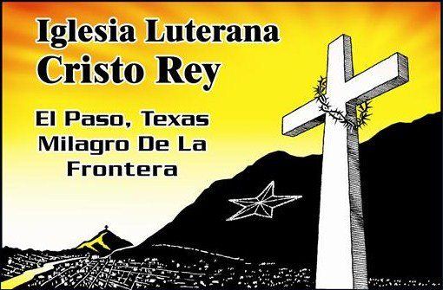
Iglesia Luterana Cristo Rey
1010 East Yandell Drive EL Paso TX 79902 Office: 915.544.6545 Fax: 532.0524

Hello!
My name is Michael Dickson, and I’ll be serving as the new program coordinator for the Border Immersion and After School programs at Iglesia Luterana Cristo Rey in El Paso, Texas. I’ll be the contact person for all volunteers and sponsors helping with the After School Program, all groups coming down to visit us on the border, and for all of our community partners who help schedule and structure the border immersions. These groups of youth and adults come here to learn and to be challenged, to get to know and feel more deeply the complexities and human realities of border life and immigration. I get the opportunity to help guide them with Pastora Rose Mary as they try to walk alongside this community, and we can’t do that without your help.
I’m sending you this message because you are part of the network that makes these programs possible, whether it be through your solidarity in and with the El Paso border community, your involvement in border immersion programming, or the engaged, open, and compassionate participants and volunteers you send us. Thank you for the support, and I invite you to reach out and continue to be in solidarity with us any way you can. Please continue to use your voices to share Cristo Rey’s story.
I grew up in North Carolina, and I’ve spent my whole life living and working in the Lutheran Church and playing with and teaching children. The theme of community is absolutely central for my life – and as most of the communities I’ve been a part of have been mostly children and church people – it felt like a natural step for me to come work in community with the kids in and around Cristo Rey.
I received a degree in English and Mass Communication from the University of North Carolina in 2014, but my real education came later. The year after I finished my degree, I had the incredible opportunity to move to Jerusalem through the Young Adults in Global Mission program, where I lived and worked in the Arab Lutheran Church of Palestine and Israel, trying to open myself to human community in places some humans are afraid to go. I learned more about community and the power of the church – and I even got to play and learn Arabic from small children. There I walked alongside that community, and there they showed me what it really means to serve, to be a peacemaker. Learning from their example and from the painful divisions of the Holy Land today, I made a commitment to an ideal of mission and service that is not about changing or fixing but about relationships and reconciliation. That is why I am here today.
Please don’t hesitate to reach out and connect with us here at Cristo Rey. I look forward to being in contact, and I hope we all can grow more deeply together in community this year. Peace be with y’all!
Michael Dickson
Iglesia Luterana Cristo Rey
borderimmersion@gmail.com Office: (915) 544-6545 Cell: (919) 230-0736
http://borderimmersion.wix.com/elpaso

