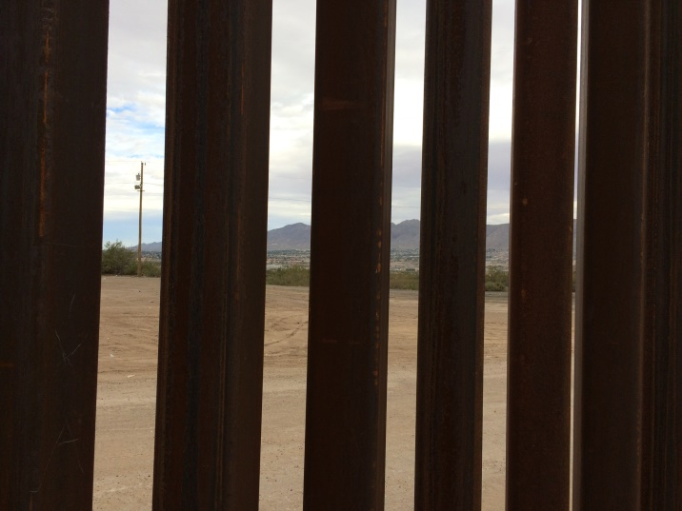
Looking In or Looking Out

Your Rocky Mountain Synod Council recently had the opportunity to hold our Fall Council meeting at Iglesia Cristo Rey in El Paso, TX. As part of the weekend experience, we participated in a Border Immersion Experience. This eye-opening weekend helped everyone to understand the context of being Church on the border and will help Council members to make more informed decision on behalf of us all.
We visited with the Border Patrol to learn their views of how they believe they are keeping the US secure. We spent time and shared a meal with an immigrant family living in a colonias on the outskirts of El Paso where they daily fear deportation, hearing stories of rattlesnakes invading their home and rain pouring in through holes in the roof. We visited a clinic in Juarez and met a saint doctoring the people of Juarez who have no access to health care. We met two women who have created a mission serving those in Juarez and shared that they have no desire to move to the US because their mission is in Mexico.
There was also time to visit the downtown Juarez plaza where people continue their daily lives in Mexico. The markets were open, there was street dancing, bands and singers, and human statues gave candy to the children for a few pennies.
Reuben Garcia of Annunciation House, where refugees are greeted after leaving a detention center, talked about his view of the border. His words to us struck a chord in my heart. “The migration of people has been taking place for centuries. This is a social issue and the US government is attempting to solve a social issue with a political solution by building a wall.” During a recent Sunday Forum, we learned that over 35 million immigrants came to the US between the late 1800’s and 1920. These are our ancestors from Norway, Sweden, Germany, Ireland. Were they greeted by a wall? When I stood at the fence (wall) which is heavy iron and at least 20 feet tall, I couldn’t help but wonder where Jesus would be standing – looking in our looking out.
Earline Bohling, Vice President
Rocky Mountain Synod

