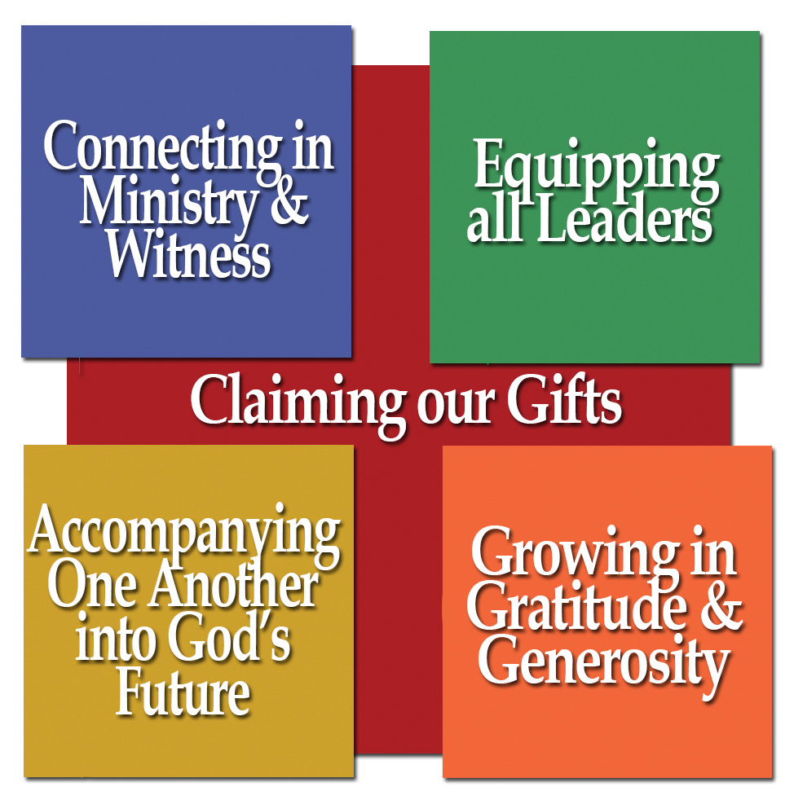
JULY 2019
For use in your bulletins, newsletters, social media, and worship

Assembly Ambassador Monthly Toolkit
j

Ministry Focus: Congregational Life

Thoughts from Bishop Jim:
Our regular gathering as the people of God around Word and Sacrament is central to our understanding of church and one of the marks of our ELCA DNA is our regular gathering as the people of God around Word and Sacrament. As ELCA Christians, we have a dynamic understanding of God’s living Word continually launched into our lives through our engagement with the Scriptures and the ministry of preaching. We are people for whom baptismal promises provide daily renewal and perspective. We are people eager to gather at a meal of life in which Jesus offers himself to all. These amazing gifts don’t belong just to us, but are offered to the world through us. As Word and Sacrament communities, our congregations are the primary means by which these gifts of grace are made accessible. Thanks be to God for the faithfulness and variety of our Rocky Mountain Synod congregations!

Mission Moment: Worship Labs at Risen Lord, Conifer, CO
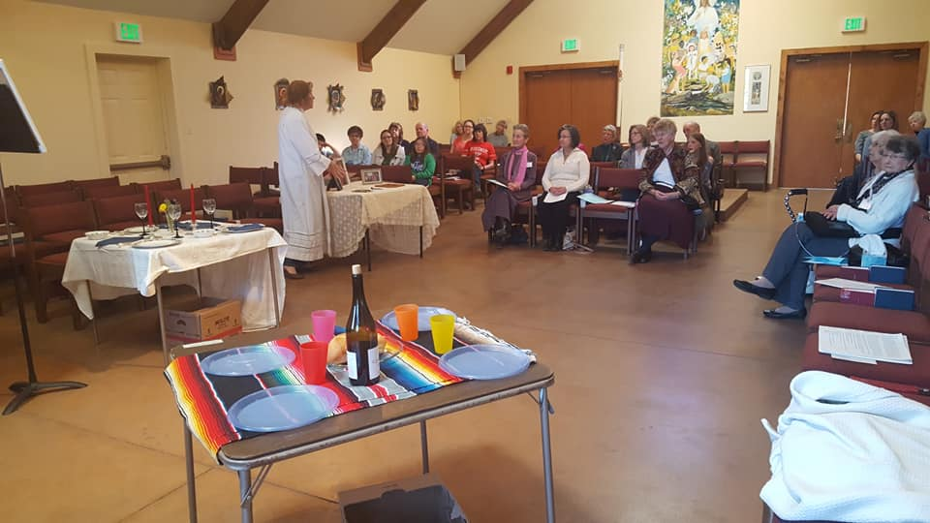
On Sunday April 7, 2019, the body of Christ that is Risen Lord Lutheran Church gathered for worship, but not just any worship. The community was surprised when the worship space held three empty card tables, each with a box of supplies. In place of a sermon, were asked to choose a table and together unpack the supplies in their box and to determine what the items on their table meant to them. One table was outfitted with picnic dishes and items on a colorful blanket. Another with crystal glasses, cloth napkins, and fancy dishes on a lace table cloth. And the third, dressed with a simple white cloth, held a small cross and framed pictures of beloved family members who have died.
The Lord’s Supper. Eucharist. Communion. The conversation was rich and lively as the community discussed these different images of the Lord’s Table, and what it meant to them. This is Worship Lab at Risen Lord in Conifer, a small, generationally diverse community in the foothills southwest of Denver. Because we value being together, and all ages, and faith formation, we took the bold step of bringing traditional confirmation class themes into worship, and exploring what they mean with the whole community in a hands-on, experiential way. It is our version of Church, Better Together.
Mission Moment Image: Deacon Mary Black and the community of Risen Lord preparing for a Worship Lab around the topic of communion.
Hymn: ELW 656: Blest Be the Tie That Binds
Prayer Petition:
Living God, you have called us be the conduits for grace and healing in this community. Unleash your creative spirit among those gathered, that we may be witnesses of your transforming love for the sake of the world. Give wisdom to those called to lead your church and be with those discerning a call to congregational leadership.
JULY 2019

Activities and Embodied Prayers
Creating your story
Tell the story of your congregation! Using a large roll of butcher paper, create a timeline that includes the dates your congregation has existed. Add stories, details, and pictures from your archives. Invite people to add their own stories and pictures from the recent history. During fellowship before or after worship, offer a conversation prompt: What is a favorite memory you have of this congregation? What is a gift of this congregation? What dreams do you have for this community? Share these stories in worship

Hospitality audit
Reflecting on your community and physical space on a regular basis can be a helpful practice. One tool is a hospitality audit. Walk around your space as if you were a visitor. What do you see? What is your experience? Are you welcoming new people into your community in the way you intend? Is your community accessible to new people? One example of a hospitality audit can be found here.

Praying for our partners in ministry
Find out what other faith communities are present in your community. Join them for worship to learn more about them or consider a pulpit swap. Visit their websites to see what ministries they are engaged in. Pray for those communities and their ministries in worship.

Creating a Rocky Mountain Synod Innovation Toolkit
What ministry, program, or idea for worship is working well in your community? Write a short description of your ministry, including a “how-to” guide for others who might want to try this new idea. Send it to Deacon Erin for the creation of an Innovation Toolkit, a book of new ideas and creative practices to spark our collective imagination as a synod!

Offering Connections (to include in the offering portion of worship)

July 7: With your support, the Office of the Bishop accompanies congregations and leaders in
transition. In 2018 we celebrated 6 ordinations and the installations of 28 leaders!
July 14: A portion of this offering will be used to strengthen congregational leaders through the Rocky
Mountain Synod Excellence in Leadership ministry.

July 21: This offering supports the creation of resources by our churchwide organization to support
congregational leaders (www.elca.org/resources)
July 28: Your gifts help congregations, candidacy committees, and seminaries partner together to
equip new pastors and deacons to serve in all expressions of our church.
JULY 2019

Community Conversations: Claiming our Gifts

Video and Discussion
The Rocky Mountain Synod Strategic Plan is centered around 5 focus areas: Claiming our Gifts, Connecting in Ministry and Witness, Equipping All Leaders, Accompanying One Another into God’s Future, and Growing in Gratitude and Generosity. At the recent synod assembly, leaders shared stories of how those priorities were being embodied in ministries across the RMS. Select one or more of the videos to watch together:
- Claiming our Gifts: Rev. Christine Higueria-Street
- Connecting in Ministry & Witness: Tina Kvitek
- Equipping All Leaders: Rev. Kim Gonia
- Accompanying One Another into God’s Future: Rev. Brigette Weier
- Accompanying One Another into God’s Future: Ihoby Rakotomalala
- Growing in Gratitude & Generosity: Rev. Brenda Frelsi & Rev. Joel Rothe
Community Questions:
- What did you notice in the stories shared? What surprised you?
- How is your community embodying that ministry priority? (How are you equipping leaders or growing in gratitude?)
- How do you see these priorities connected to our call to live as followers of Jesus?
- What other priorities would you include as commitments of your community’s witness?

Pray:
Close by naming the gifts of your community, current challenges, and new possibilities. Offer prayers of gratitude for the ministries of your community and prayers for wisdom in exploring new ministries.

Just for Fun:
Hand out gift-wrap bows and ribbon, inviting people to place a bow on something that signifies a gift of your community. Add a short note of explanation next to the bow, or encourage members to guess what that gift is about!

