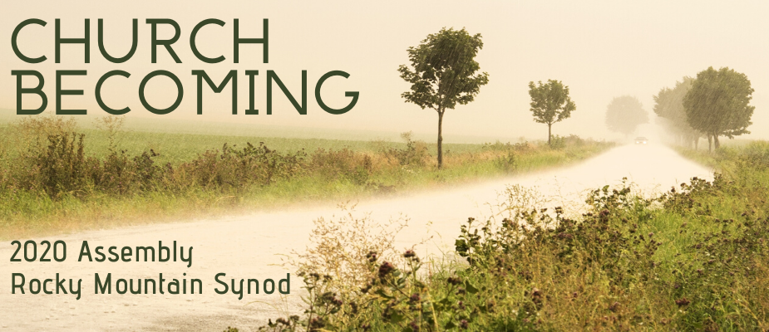

2020 Rocky Mountain Synod
Voting Member Information Packet
rmselca.org/assembly
OUR MISSION:
Together we proclaim and embody
God’s unconditional love for the sake of the world

Beloved in Christ,

This past year invited us to Be Transformed. Father Richard Rohr pointed to the renewing of our minds as key to transformation, releasing us from our either-or thinking to live within God’s both-and perspective.

Our ongoing transformation is essential to become the church God desires. While never perfect or complete, we can recognize blind spots and open ourselves to the Spirit’s work. This renewal makes us a Church Becoming.

Church becoming requires exploration, experimentation, and innovation. Experimenting gathering in five locations simultaneously is inviting us to explore how technology allows us to gather in new ways across our vast geography. This regional assembly format will allow for us to explore “church in context”, featuring local ministry partners and contextual learning determined by leadership in each location.

The business matters of our assembly will take place via zoom. There will be opportunities for conversation about our budget, constitution changes, and resolutions prior to the official assembly. While we will receive resolutions, we are asking to defer memorials until 2021, as memorials will not be addressed until the next churchwide assembly in 2022.

It is our hope that our assembly voting members represent the full breadth of our synod. We ask that you encourage new leaders to participate in our life together, especially our youth and young adult members. In addition to voting members, additional members of your community are invited to participate in the assembly immersion on Saturday afternoon.
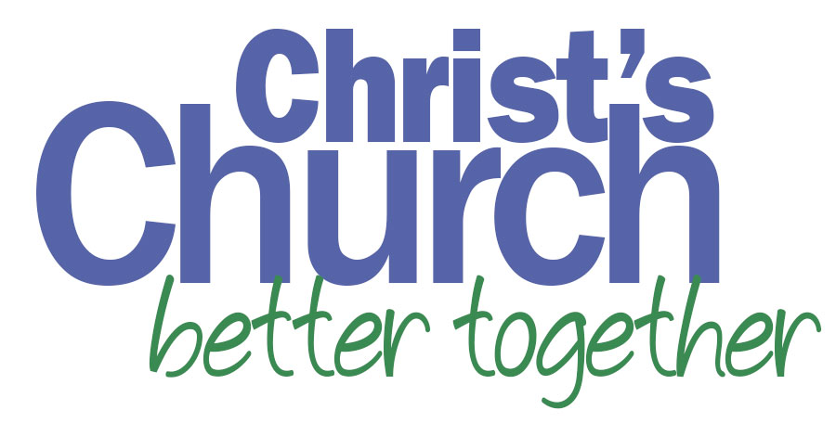
In faith,
Bishop Jim Gonia

What’s new for 2020?
Keynote Speaker: Rev. Jason Chesnut
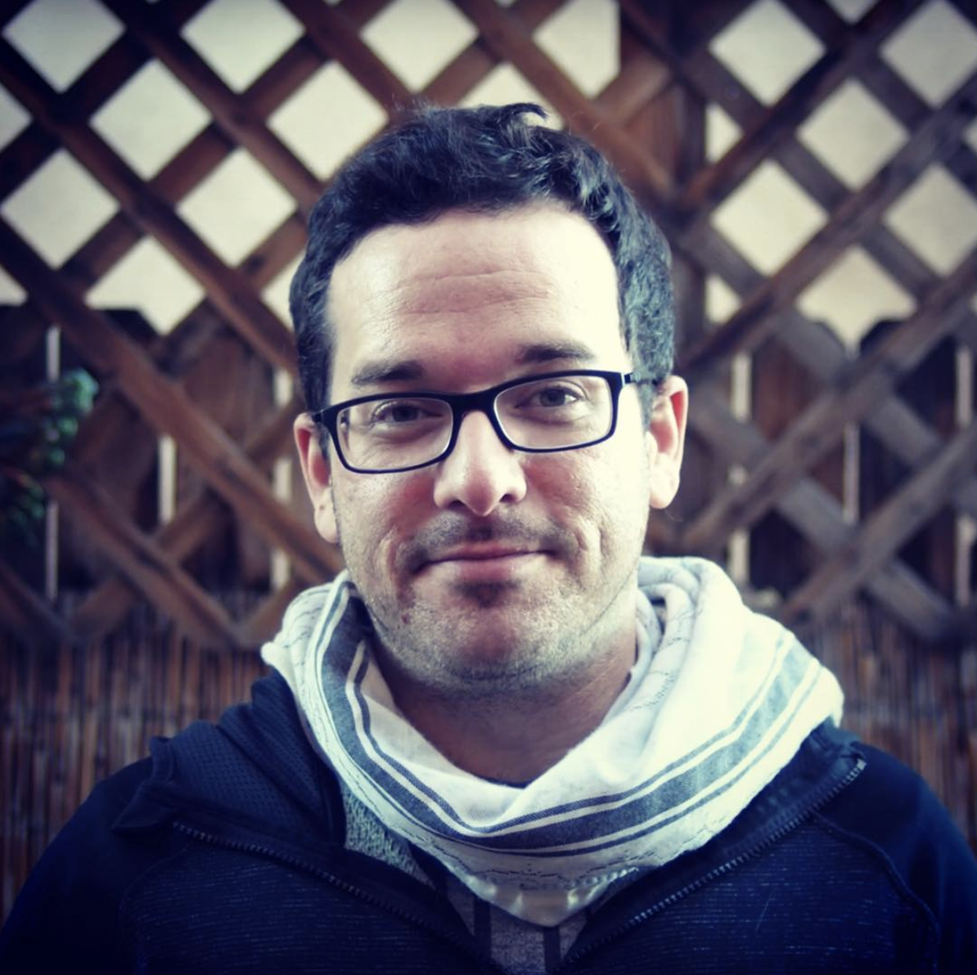
The Rev. Jason Chesnut, ordained in the ELCA, created and developed The Slate Project, an innovative Christian worshiping community that gathers both online and face-to-face in Baltimore, Maryland. He is a videographer, mission developer, and ABS-certified biblical storyteller who recently founded ANKOSfilms, a company dedicated to (a) (n)ew (k)ind (o)f (s)torytelling. A native of San Marcos, Texas, Jason graduated from Texas Lutheran University and the Lutheran School of Theology at Chicago.
Women’s Ordination Anniversaries
In 2019 and 2020, we celebrate the 50th anniversary of the ordination of women into Word & Sacrament Ministry and the 40th anniversary of the ordination of women of color in our predecessor church bodies. Our Friday evening worship will celebrate the gifts of our female/femme Word & Sacrament Ministers.
Assembly Immersions
Saturday afternoon will be an opportunity for contextual learning. Each location is developing local programming. This afternoon of worship and learning is open to area congregations.
- Wyoming/North Colorado: Church as Community Leaders in Disaster
- Boulder-Broomfield/Metro East/Metro West Metro: Excellence in Leadership
- Metro South/Southeast Colorado: Community Violence
- North New Mexico/Border: Narrative and Identity
- Utah/Metro West Mountain: Emerging Communities
Assembly Format
Assembly this year will take place in 5 regional locations, focusing on the church in context. Programming will happen both in the local context and as the church together via Zoom meetings:
- RMS staff, synod council, and assembly guests and exhibitors will be strategically dispersed throughout the 5 locations.
- There will be an opportunity to discuss assembly business items such as the budget or resolutions via zoom meetings prior to the assembly. Recordings of these meetings will be posted on the website.
- Worship and morning prayer will take place in the local context; business and keynote addresses will be streamed to each location via zoom.
Assembly Program and Location Details
Wyoming and North Colorado Conferences
Ascension Lutheran Church, Cheyenne, WY
Featured Guest: Representative from Lutheran Disaster Response
Featured Ministry: NEEDS, Inc. and ELCA World Hunger
Immersion Theme: Church as Community Leaders in Disaster
Partner Ministries: Lutheran Disaster Response, World Hunger, Lutheran Advocacy Ministry-
CO, Sky Ranch, and others TBD.

Boulder-Broomfield, Metro East, and Metro West Metro Conferences
Cross of Christ Lutheran Church, Broomfield, CO
Featured Guest: Tara McConnell, live painting/interactive art
Featured Ministry: Anchor House and Lutheran Family Services
Immersion Theme: Excellence in Leadership
Partner Ministries: Lutheran Family Services, Campus Ministry, Mission Investment Fund,
Interfaith Alliance, Healthy Leaders Team, and other TBD.

Metro South and Southeast Colorado Conferences
Trinity Lutheran Church, Monument, CO
Featured Guests: Adrian Miller (Colorado Council of Churches), Desta Goehner (California
Lutheran University)
Featured Ministry: Second Wind, Sources of Strength
Summit Theme: Community Violence
Partner Ministries: Colorado Council of Churches, California Lutheran University, Portico
Benefit Services, Rainbow Trail, Second Wind, ELCA Foundation

North New Mexico and Border Conferences
Cross of Hope Lutheran Church, Albuquerque, NM
Featured Guest: Bishop Jim Gonia
Featured Ministry: Lutheran Advocacy Ministry-NM
Immersion Theme: Narrative and Identity
Partner Ministries: Border Servant Corps, Campus Ministry, LAM-NM, Global Mission, New
Mexico Conference of Churches, and others TBD
Utah and Metro West Mountain Conferences
Ascension Church, Price, UT
Featured Guest: Rev. Jason Chesnut
Featured Ministry: Rejoicing Spirits
Immersion Theme: Emerging Communities
Partner Ministries: Campus Ministry, Rejoicing Spirits, Pacific Lutheran Theological Seminary,
Educate, Equip, Enact, RMS Candidacy, others TBD

Assembly Schedule (Tentative)
Friday, May 1
9:00-12:00pm Pre-assembly gatherings as requested
11:30-1:00pm Registration
Lunch available as you arrive
1:00pm Opening of Assembly (begins in each local context)
1:15pm Plenary 1: Opening Business (via Zoom)
3:00pm Break/Local Impact Project/Exhibitors
3:45pm Plenary 2: Continued Assembly Business (via Zoom)
5:30pm Dinner
6:45pm Evening Worship: Celebrating Women's Ordination (local context)
Saturday, May 2
8:15am Morning Hymn Sing (local context)
8:30am Morning Prayer with local ministry partner (local context)
9:00am Plenary 3: Continued Assembly Business (via Zoom)
10:00am Break
10:30am Plenary 4: Closing Assembly Business (via Zoom)
12:00pm Lunch
1:00pm Worship (local context)
2:00-4:30pm Immersion (local context)
4:30-5:00pm: Closing Reflections and closing prayer (via Zoom)

Assembly Registration and Hotel
Assembly Registration Fee includes program costs, materials, three meals, and breaks. The Registration Fee does not include the hotel.
Voting Member: $225
Visitor: $175
Exhibitor: $125
Retired Rostered Voting Member: $100
Assembly Immersion Visitor: $25

Please note: Assembly Registration fee is due ten (10) days prior to assembly (April 21st). Registration can be paid online or via check to the Rocky Mountain Synod. Credit card payments will include an additional $12 processing fee per registration.
Room blocks are held for each location under Rocky Mountain Synod.
The reservation links will be posted by February 1: www.rmselca.org/assembly
South Colorado Location
Fairfield Inn & Suites
15275 Struthers Road
Colorado Springs, CO 80921
$129/night (includes breakfast)
Reservation Deadline: March 18
Price
Holiday Inn Express
925 Westwood Blvd
Price, UT 84501
$110/night (breakfast included)
$130/night for suite
Reservation deadline: April 15
North Metro Location
Hampton Inn & Suites
5030 W 88th Pl
Westminster, CO 80031
Cheyenne
Little America
2800 W Lincoln Way
Cheyenne, WY 82009
1-800-235-6396
$114/night (breakfast not included)
Reservation Deadline: April 2
Albuquerque
Courtyard by Marriott
5151 Journal Center Blvd NE
Albuquerque, NM 87109
$123/night (breakfast included)
Reservation deadline: April 3
Scholarships and Travel Assistance
We are Christ’s Church, Better Together! Which means we are not complete unless all are gathered around the table. Scholarships are available to those who need financial assistance. The online request form can be found here: www.rmselca.org/assembly Scholarship request deadline is March 16. Requests after this date will be considered as funds are available.
Acting as the Church Together, there will be an option at registration to donate a small amount to Assembly Scholarships if your congregation is able.

Important Deadlines
February 3: Online Registration Opens
February 21: Exhibitor Request Deadline
An online request form will be available February 3. Exhibitors must also register for the assembly
February 21: Resolution and Memorial Intent Deadline
If you are planning to submit a resolution please submit an online intent form to help with our planning. This does not substitute for formally submitting a resolution.
March 16: Priority Deadline for Scholarship Requests
Scholarship requests after this date will be considered as funds are available. An online request form will be on the website.
March 20: Resolutions and Nominations due
Forms for resolutions and nominations can be found on the website.
March 20: Ministry Booklet Pages Deadline
The on-line submission form for exhibitors and ministry booklet pages will be available early February.
April 5: Registration Deadline
April 23: Registration Fee Due

Voting Member Information
The voting members of the assembly must be members of the congregation and are determined as follows:
A. Congregations are allowed 2 lay voting members, 1 male and 1 female. If a congregation is not able to find both a male and female, contact Kristen Lee at the Office of the Bishop to request permission from Bishop Gonia to send 2 of the same gender: klee@rmselca.org
B. In addition, based upon baptized membership records for the previous year (2019)
(1) Congregations having membership of 650 to 1,199 baptized members shall be allowed one additional lay voting member (male or female).
(2) Congregations having membership of 1,200 or more baptized members shall be allowed two additional lay voting members (one male and one female).
. In the selection of voting members, congregations are urged to be aware of the matter of inclusiveness of persons of color and/or persons whose primary language is other than English.
D. All Ministers of Word and Sacrament (pastors) and Ministers of Word and Service (deacons) under call or on leave from call on the roster of the Rocky Mountain Synod are voting members.
G. All retired ordained ministers on the roster of this synod who are currently serving as interim pastors who are in attendance at the assembly are voting members.

H. Youth/Young Adult Voting Members
It is the goal of this synod that at least 10% of the voting members of the Synod Assembly, Synod Council, committees, and organizational units of this synod be youth and young adults. For purposes of the constitution, bylaws, and continuing resolutions of this synod, the term “youth” means a voting member of a congregation who has not reached the age of 18 at the time of election or appointment for service. The term “young adult” means a voting member of a congregation between the ages of 18 and 30 at the time of election or appointment for service. A youth or young adult voting member is NOT an additional voting member, but rather would be one of the voting members allotted to your congregation.

Information to assist you and your congregation in inviting, selecting and supporting your youth and young adult voting members for the upcoming Rocky Mountain Synod Assembly:

    - A youth or young adult attending the Assembly, as a voting member from your congregation, will sit with the members of your congregation and fully participate in the assembly schedule.

    - It is our hope that each youth/young adult voting member attending the assembly would have an adult mentor––someone who is also a voting member from your congregation and has previously attended an Assembly. This adult's role is to support the youth during the event, answer questions, explain the business at hand, and offer encouragement for full participation.

    - Make sure ALL of your congregation's voting members have copies of the schedule, reports and documents. If possible bring the congregation's voting members together before the Assembly to review the schedule, resolutions and documents which are posted at www.rmselca.org/assembly

    - Set a date for your voting members to present a report to the congregation following the Assembly. Include your youth and young adult members!

    - Youth who are 17 and younger are the legal responsibility of the congregation. Permission and medical forms and all other critical documents for responsible and safe participation are the responsibility of the congregation. Sample forms, covenants, and guidelines for appropriate adult/youth interaction may be requested from the Office of the Bishop. Youth are the responsibility of the congregation during the regular business hours of the assembly, unless youth-specific events are noted in the agenda.

Resolutions and Memorials
Although both memorials and resolutions are requests by a synod for action, they are intended to address different issues and are processed differently. Memorials address broad policy issues and are passed by Synod Assemblies for consideration by the Churchwide Assembly. Because Memorials will not be addressed until the 2022 Churchwide Assembly, Bishop Gonia is requesting voting members defer memorials until the 2021 Synod Assembly.
On the other hand, resolutions are requests from individual synods to the Church Council or units or offices of the Churchwide organization OR requests from the Synod Assembly to Synod Council, Office of the Bishop, or synodical boards or committees. As a practical matter, resolutions have a more narrow focus than memorials because they are requests for consideration or action by individual units or offices of the Church Council or Synod Council.
To assist with our planning, please submit a resolution intent form on the RMS website. This does not take the place of an official resolution submission.

2020 Rocky Mountain Synod Assembly Elections

At this assembly, we will be electing leaders to synod council and numerous boards and committees. To be considered for election, a nomination form must be received by March 20. The nomination form will be available on the website January 1. The form should be completed by the person wishing to serve in that position. Completed nomination forms should be submitted to Kristen Lee: klee@rmselca.org. Nominations will NOT be received from the floor.
Committee on Discipline
(1) At-Large Lay Male
(2) At-Large Lay Female
(4) At-Large Rostered Minister
Consultation Committee
(2) At-Large Rostered Minister

Global Mission Committee
(1) At-Large
Congregational Ministry Board
(5) At-large

Rocky Mountain Synod Council
Southeast Colorado Conference: Rostered Minister
Wyoming Conference: Lay
Border Conference: Rostered Minister
Boulder/Broomfield Conference: Lay
Metro West Conference: Lay
Metro South Conference: Rostered Minister
At Large Ethnic Specific
At Large: Rostered Minister
At Large Youth
At Large Young Adult

Church Together Ambassadors
Part of your on-going leadership as an assembly voting member will be to serve as a Church Together Ambassador for the next year. What does this mean?
- You will serve as an advocate of our shared life and witness as the Evangelical Lutheran Church in America until we meet in Assembly in 2021.
- Specifically, you will receive monthly materials containing stories and insights about why our life as church together matters; these materials will highlight ministries of our congregations, partners, synod and wider church. Each month will focus on a specific aspect of our life as church together.
- In coordination with your pastor/deacon and congregational leadership, you will make sure that these stories and insights are shared with your congregation, ideally in worship, but also through other communication channels, through faith formation opportunities, etc.
- You will seek ways to share the stories of your congregation’s ministry and witness with the rest of us as you network with other Church Together Ambassadors in exploring additional avenues for passing along the energy and enthusiasm generated when we gather in Assembly.
- Questions or suggestions can be directed to Deacon Erin Power, Assistant to the Bishop for Synodical Life.

Assembly Weekend Worship Resources
We will be providing worship resources for congregations and ministries to use during assembly weekend. Congregations are invited to use this shared resource to worship as the Church Together, including a Church Together themed liturgy and a video or text sermon from Bishop Gonia. More information will be available in early 2020.

