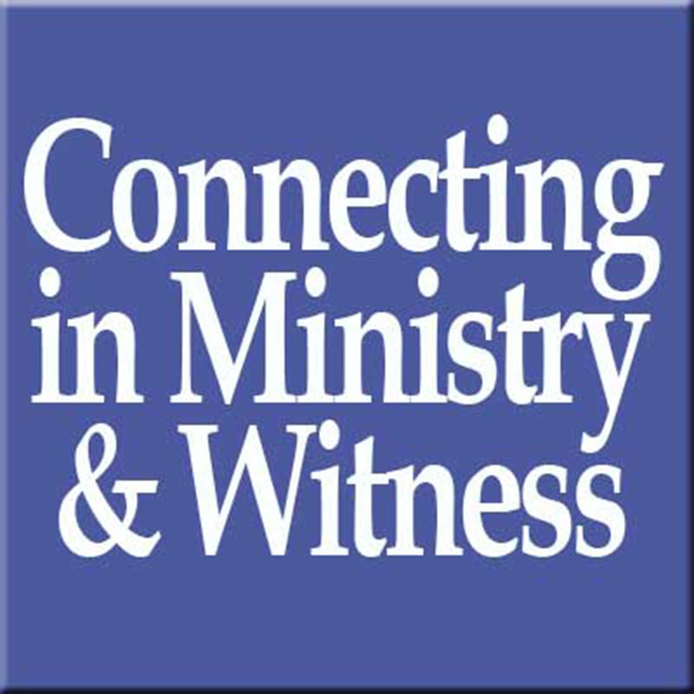
For the Life of the World

ELCA Rocky Mountain Synod • Church Together Ambassador

When you registered for this year’s Synod Assembly as a voting member of your congregation, we let you know there was an exciting new opportunity coming your way. Rather than participating in a one-time experience of our life as church together, we let you know that we would commission you at this Assembly as a Church Together Ambassador for the next year. What does this mean?

- You will serve as an advocate of our shared life and witness as the Evangelical Lutheran Church in America until we meet in Assembly in 2019.

- Specifically you will receive monthly materials containing stories and insights about why our life as church together matters; these materials will highlight ministries of our congregations, partners, synod and wider church. Each month will focus on a specific aspect of our life as church together. For example, in June we will focus on our life as Public Church. Here’s what you’ll receive:

  - Thoughts from the Bishop
  - Mission Moment story
  - Mission Moment image
  - Hymn suggestion
  - Prayer Petition
  - Offering Connections for each Sunday of the month connect how our shared resources allow us to engage in this particular area of ministry for the life of the world!

- In coordination with your pastor and congregational leadership, you will make sure that these stories and insights are shared with your congregation, ideally in worship, but also through other communication channels, through faith formation opportunities, etc.

- You will seek ways to share the stories of your congregation’s ministry and witness with the rest of us as you network with other Church Together Ambassadors in exploring additional avenues for passing along the energy and enthusiasm generated when we gather in Assembly.

- Questions or suggestions can be directed to Deacon Erin Power, Assistant to the Bishop for Synodical Life.
Together we proclaim and embody God’s unconditional love for the sake of the world

Commissioning of Church Together Ambassadors

Leader: As in one body we have many members,
Assembly: So we, who are many, are one body in Christ.

Leader: We give you thanks, O Lord, that you have called us to be your Church
Assembly: Your Church together, for the life of the world.

Leader: Called to new life in Christ
Assembly: We serve as the Spirit’s instruments of healing and hope

Leader: In all our expressions as your church, we are committed
Assembly: to proclaim and embody your unconditional love

Leader: for the sake of every neighbor, near and far.
Assembly: For the sake of your whole world

Leader: I ask you, will you as voting members of this Assembly agree to serve as our Church Together Ambassadors for the next year?
Assembly: We will, with the help of God.

Leader: Will you seek to inspire your communities of faith with the stories and insights of our shared ministry and witness for the life of the world?
Assembly: We will, with the help of God.

Leader: Will you seek opportunities to share the stories of YOUR congregation’s life with the rest of us, that we may be inspired, grow and learn from the ministry and witness you carry out on our behalf?
Assembly: We will, with the help of God.

Leader: May God who has given you the will to do these things, graciously give you the strength and compassion to perform them!

Let us pray: Gracious God, we give you thanks you have raised up these leaders to share the stories of your Church at work in the world. Give them all they need to be faithful ambassadors of our life together, and continue to stir up in us your Holy Spirit that our ministry and witness together may be for the life of your world! Amen

Leader: We give you thanks that we are your Church, O Christ
Assembly: We give you thanks that we are your Church, Better Together!
Thanks be to God! AMEN!

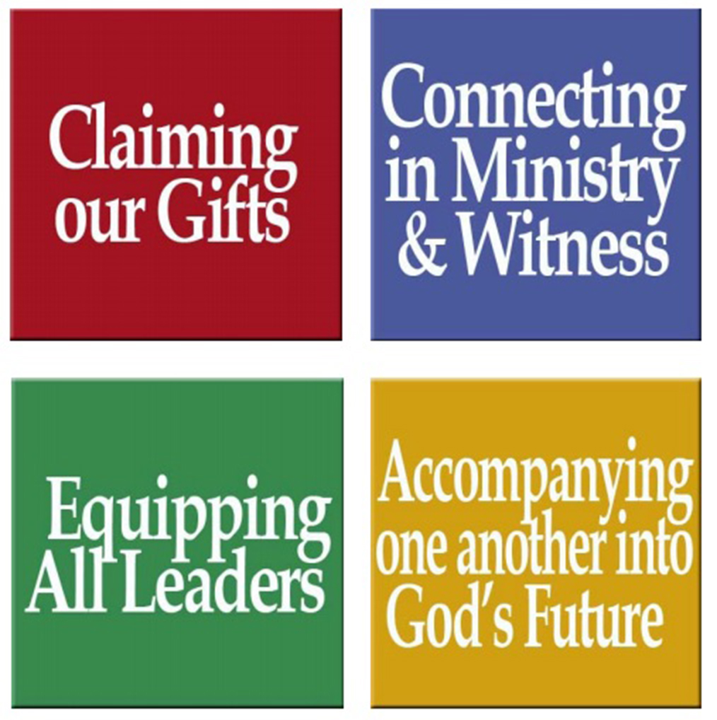
Assembly Ambassador Monthly Toolkit
j
JUNE 2018
For use in your bulletins, newsletters, social media, and worship

Ministry Focus: Public Church

Thoughts from Bishop Jim:
A church that is willing to step into the public arena for the sake of the neighbor is a church that is engaged in ministry for the life of the world. It matters to me that we are such a church, that through our hands-on service, our partnerships and our commitment to the long-term wellbeing of our neighbors, our hands contribute to God’s life-giving work in the world.

Mission Moment
As a church, we respond with care and compassion when people are facing a crisis in life, a personal or family need or are at their most vulnerable. We do this work together as part of a large network of partners, organizations and denominations. The ELCA and nearly 300 health and human service organizations participate in an alliance known as Lutheran Services in America, which serves more than 6 million people each year in the United States and the Caribbean. That’s one in 50 Americans every year. In the Rocky Mountain Synod, our support goes to several social ministry organizations (SMOs) that serve people in our territory, including: Lutheran Family Services Rocky Mountains, Eben Ezer Lutheran Care Center, and Urban Servant Corps.

Serving our neighbor as public church also happens when disaster strikes. Through Lutheran Disaster Response, we are equipped to bring God’s hope and healing to people whose lives have been disrupted by disasters in the United States and around the world. Members of Rocky Mountain Synod congregations have been especially generous in supporting our neighbors impacted by the destructive 2017 hurricane season.
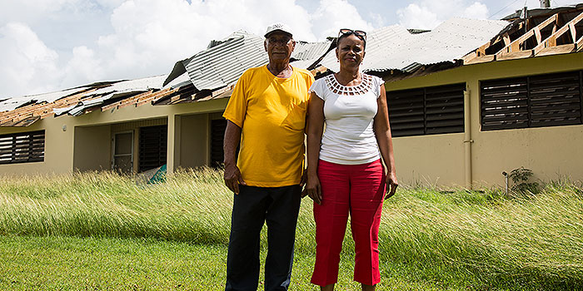

JUNE 2018

Mission Moment Image:
LDR has been a critical part of the response to the hurricanes that struck Puerto Rico in 2017

Hymn: ELW #710 Let Streams of Living Justice
Prayer Petition:

O God, we look to you in our times of greatest need and vulnerability. In your great mercy, you call us to respond in turn when our neighbors are in need. Inscribe our hearts with your desire for love and justice, that we would continue to walk together as your church to love and serve our neighbor.

Offering Connections (to include in the offering portion of worship)

June 3: Because of our mission support, 100% of money given to Lutheran Disaster Relief goes directly
to those affected by disaster.
June 10: In partnership with the ELCA, Lutheran Family Services Rocky Mountain has been serving our
communities for 70 years.
June 17: Together we celebrate the new building and expanded care offered at Eben Ezer Lutheran
Care Center, our ministry with our elder neighbors is strengthened through their care.

June 24: Because of your generosity, Urban Servant Corps (Denver) and Border Servant Corps
(Las Cruces/El Paso) continue to form young adults for life-long service to their communities.

