JUNE 2019
For use in your bulletins, newsletters, social media, and worship

Assembly Ambassador Monthly Toolkit

j

Ministry Focus: Public Church: Social Ministry Organizations

Thoughts from Bishop Jim:
We are a church that serves the neighbor in love because the love of God frees us to do so! While our service often takes very personal form whenever God’s work happens through our own hands, we’re also called to show up as Christ’s Church together for the sake of the larger community. This is called being public church and it’s part and parcel of our ELCA DNA. One way our public witness is extended to neighbors near and far is through our ELCA Social Ministry Organizations, who embody the gospel with specific skill and focus. What a gift to have such amazing ministry partners!
Social Ministry Organization Partners: Lutheran Family Services Rocky Mountains, Lutheran Disaster Response, Lutheran Immigration and Refugee Service, Urban Servant Corps, Border Servant Corps, Eben Ezer Lutheran Care Center

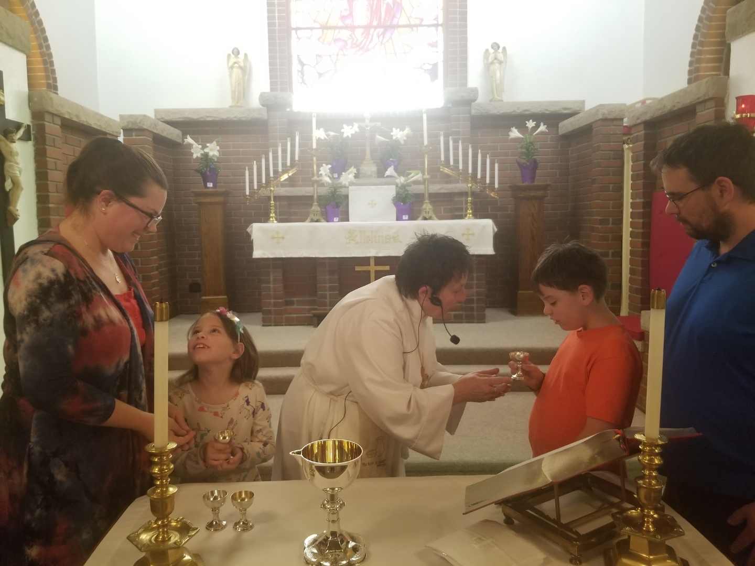
Mission Moment: Eben Ezer Lutheran Care Center

On Easter Sunday, 2019, Fraia and Mitchell Hall celebrated First Communion with their parents, Cat and Ramon Hall, the neighbors, their family members, and the Brush, CO community attending All Saints Church at the Eben Ezer Lutheran Care Center. Ramon, an Eben Ezer full-time nursing care partner who serves older adults and those with special needs, has been attending All Saints with his family since summer, 2018. Fraia and Mitchell, who love unicorns and dinosaurs, are learning each week about how God and older adults love them.

On this day the congregation fully recognized "Christ is risen! Christ is risen, indeed!" celebrating the first ever, first communion with children, in the congregation's 106 years. Organized as a Danish deaconess motherhouse congregation, health care has been the pre-dominant focus for the congregation, beginning with tuberculosis, followed by elder care. In 2019 eight children have been baptized, kid's conversation is weekly event, and both young and elder, wheelchairs and walkers, serve God and each other as readers, acolytes, gift bearers, companions, ushers, and loving brothers and sisters in Christ. We are indeed, Christ’s Church, Better Together!

Mission Moment Image: Fraia and Mitchell Hall celebrated their First Communion with Deacon Ro Fesser and the community of Eben Ezer Lutheran Care Center.

Hymn: ELW 643: We Are All One in Christ (Somos uno en Cristo)
Prayer Petition:
O God, we seek your mercy and healing in times of our greatest need and vulnerability. You offer us the gift of community so that we may care for one another and be your hands and feet in the world. Inscribe our hearts with your desire for love and justice, that we may continue to walk together as your church to love and serve our neighbor.”
JUNE 2019

Activities and Embodied Prayers
Lutheran Family Services Backpack Project
Collect school supplies and backpacks throughout the summer for foster and refugee children. Backpacks are distributed before the start of the school year in August. Visit https://www.lfsrm.org/get-involved/hands-on-activities/ for more information

Lutheran Disaster Response
Post a world map or globe in your narthex or gathering space. Mark the places around the world where Lutheran Disaster Response is currently serving our neighbors impacted by disaster. Print a coloring page map to children and youth during your children’s message or Sunday school. Tell the story of one place LDR is working and invite them to color that country on the map. Learn where LDR is at work here: https://www.elca.org/Our-Work/Relief-and-Development/Lutheran-Disaster-Response

Eben Ezer Lutheran Care Center
Invite your congregation, VBS, or Sunday School to draw pictures or write cards for the neighbors (residents) of Eben Ezer. Notes of blessing and encouragement to their dining services staff, laundry staff, receiving and shipping as they move into their new Support Services Building during the month of May.

Offering Connections (to include in the offering portion of worship)

June 2: Because of our mission support, 100% of money given to Lutheran Disaster Response goes
directly to those affected by disaster, including those affected by flooding in Colorado in 2013.
June 9: With your support, Lutheran Family Services Rocky Mountains is continuing their Welcome and
Respite ministry in Albuquerque, offering temporary hospitality to families released from
detention

June 16: A portion of your offering supports Urban Servant Corps in Denver, Colo., a year-long service
ministry that fosters a commitment to life-long service in our communities

June 23: Because of your generosity, Border Servant Corps in Las Cruces, N.M. continues their ministry
of radical hospitality to refugee and asylum seekers.

June 30: Together we celebrate the witness of Eben Ezer Lutheran Care Center in Brush, CO and their
witness of care and community since 1905

Community Conversations: Living the Tenets of Urban Servant Corps

Read one or more of the following texts:
Romans 12:9-21
Ephesians 4:1-6
Psalm 133

Video and Discussion
About Urban Servant Corps
Urban Servant Corps is a one-year full-time Lutheran volunteer program in Denver, Colo.. Volunteers commit to living in intentional community and embrace values of simplicity and spirituality as they serve at inner-city Denver non-profits. USC positions are at agencies that provide immediate and direct care service as well those who advocate for lasting solutions and long-term social change.
JUNE 2019

Members of the Urban Servant Corps Community commit to 4 tenets during their year of service: Intentional Community, Service, Simplicity, and Spirituality. A short reflection on each of these tenants can be found here: http://www.urbanservantcorps.org/about/tenets.html Following each clip, reflect together on the questions below

Community Questions:
- How do you see this tenant lived out in your faith community? In your own life?
- How do you see these values connected to our call to live as followers of Jesus?
- What other tenants or values would you include as commitments of your community’s witness?

Pray:
Close by praying for members of the USC community as they seek to serve their neighbors facing hunger and homelessness, for our call as Christians to embody the teachings of Jesus, and for our witness as a public church.

Just for Fun:
Take on USC’s Simplicity Challenge. Commit to one act of simple living for the month of June: flush the toilet less, attempt to go plastic free during your weekly grocery shopping, walk somewhere you usually drive, or commit to less appointments.

