Join us on Sept. 22 for
A public action by people of faith
An expression of What We Are FOR

People of faith will gather for a public action on Colorado Boulevard in front of Messiah Community Church on September 22nd, during afternoon rush hour.

We will lift up our voices in resistance to the cruel policies being enacted by the current administration and being supported by Christian nationalists. So much of what we are seeing is being done in the name of Christianity and yet we know it is distinctly anti-Christian.

People of all religious traditions can come together and say NO to the cruelty and abuses being
committed by our government, especially against the poor and marginalized, by standing
together to say what we are FOR. Multifaith voices add power to the message.

Date & Time: Monday, Sept. 22, 4–6 pm

Location: Messiah Community Church, ELCA, 1750 Colorado Blvd. Gather in the East
parking lot at 4 PM. *An estimated 50,000 cars a day drive past Messiah, which is why
we’re inviting you to “our place” for this action.

Signs: Please bring a sign stating what people of faith are FOR, following the format below.
This instruction isn’t meant to be limiting, but rather, unifying. The goal is to keep messaging
very clear. Let’s stand together in solidarity for the sake of those being harmed right now.
We want this to be a peaceful, and even joyful, act that also flows from the Love that
connects us.

For example:
People of faith for…
The Love of God for ALL Care for the Poor Racial Justice Climate Justice
LGBTQIA+ Rights Free Press Affordable Housing Clean Energy
Education and research Medicaid Care for Immigrants PEACE

The Plan: We’ll gather in the East parking lot at 4 pm, have a word of prayer together,
and then spread out along Colorado Boulevard with our signs by 4:30 pm. Let’s plan to
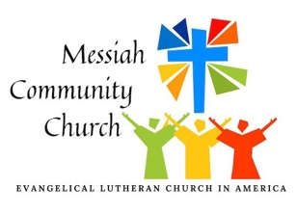
stay for one hour or as long as it works for you. Event will conclude by 6 pm.

For more information, contact pastor@messiahdenver.org.

