The Marianist Visitation State Community members in 2012 began an annual distribution of dollars donated to provide “Seeds for Tomorrow’s Church”. The Visitation State Community awards grants in December each year to groups or ministries within the United States. The proposed projects are submitted for consideration by a Marianist Community member either as ministries they participate with directly or support.
Proposals are accepted for programs or projects in four categories:
- Strengthen Marianist Lay Communities and Network
- Assist in building the Catholic church
- Impact the faith and involvement of young adults in the church
- Social justice including
  - Economic Justice
  - Environmental Justice
  - Human Rights
Funds Available each year
Grants are a minimum of $1,000 and not to exceed $5,000

No person or organization can submit more than one proposal per funding cycle.

Send completed application to:
Visitation Marianist State Community
6539 Harrison Avenue # 1118
Cincinnati, OH 45247
AND
email the scanned version to: vizcom65@outlook.com put “Seed Grant” in the Subject line. You will receive a confirmation of receipt of your application.

Applications Due by Tuesday August 31st by 7pm ET

Those selected for grants will be notified by October 30th 2021 and dollars distributed in December 2021.

A Summary Report from those awarded funds describing the project outcome are due by August 15th the following year.

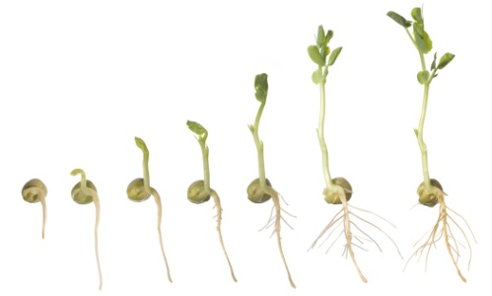
Marianist Visitation Lay Community ‘Seed’ Grant
Application Form
Today’s Date_____________________
Grant Contact Name____________________________ Phone number___________________________
Marianist Community Member Sponsor _______________________________
Group or Organization Name ________________________________
Mailing Address_______________________________________ E-mail address______________________

- Amount of Grant requested
A. Total cost of the proposed activities | $
B. Total dollars committed to date (from other sources) | $
C. Requested amount from Marianist SEED Project (please include detailed budget) | $
D. Request as a percent of total cost (line C/ line A) | %
Is this grant for a project that is:
____New ____Existing ___ Expanding (Check all that apply.)
- Grant Category___________________
In the space below, provide a short summary (not to exceed 300 words) explain the project’s purpose, its timetable, and the results you hope to achieve

- Describe mission or work of group or individual requesting grant

- What problem or need does the proposed request address? (300 words)

- How will your proposed project solve that problem ? (300 words)

- How will you measure your outcomes, and evaluate your progress? (300 words)

- Describe the organization’s partnerships and collaborations that will enhance the success of this project. (300 words)

