Dear Valued PHCC-ORSB Supporter,
Thank you for considering supporting the PHCC Orange, Riverside and San Bernardino Counties Gala and Table-Top Show. This year the event will be held at the Hyatt Regency in Newport Beach on Friday, December 9, 2022, from 6 pm-Midnight.
Our 007 Casino Royal Gala and Tabletop show will bring over 350 guests together to raise scholarship funds for the community’s future plumbers and HVAC contractors. Also, a portion of the proceeds will help us run the association and bring needed benefits to the Plumbing, Heating, and Cooling local chapter members. This is the perfect opportunity to get fantastic exposure, build great business connections and friendships, and give back to your local PHCC community. Your Sponsorship will also help make this a memorable occasion & get your company in front of the PHCC leaders and owners of the Southern California area!
We look forward to seeing you on Friday, Decemebr 9, 2022.
Thank you for being so supportive.
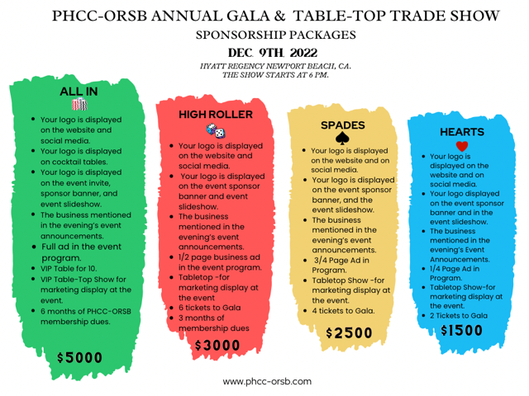

Dear Valued PHCC-ORSB Supporter,
Thank you for your generous donations to PHCC-ORSB 2022 Gala Fundraiser & Table-Top Show. A portion of your Sponsorship will go towards our PHCC-ORSB Educational Foundation Inc and Associated PHCC-ORSB.

- $5,000 – ALL IN-Title Sponsorship
- $3,000- HIGH ROLLER Sponsorship
- $2,500- SPADES Sponsorship
- $1,500- HEARTS Sponsorship
- $1,000- TABLE-TOP SHOW ONLY & 2 ticket to event
Sponsorship Amount $_____________
- A portion of your donation is tax-deductible with our Fed ID# 26-4499090
Method of Payment (please choose one)

- By Check: Please make checks payable to PHCC-ORSB.
1158 N. Gilbert St. Anaheim, Ca 92801

- By Credit Card: __Visa __MasterCard __AMEX

Card Number: __________________________________ Exp. Date: ______________
Cardholder Name: ______________________________________________________

Billing Address: ________________________________________________________

Email: _____________________________________Cell Number: ________________

Signature: __________________________________ Date: _______________________

Michael Prencavage Jr.- PHCC-ORSB President
Monica Roach- Executive Director PHCC-ORSB
Doug Allen- Education Director PHCC-ORSB

