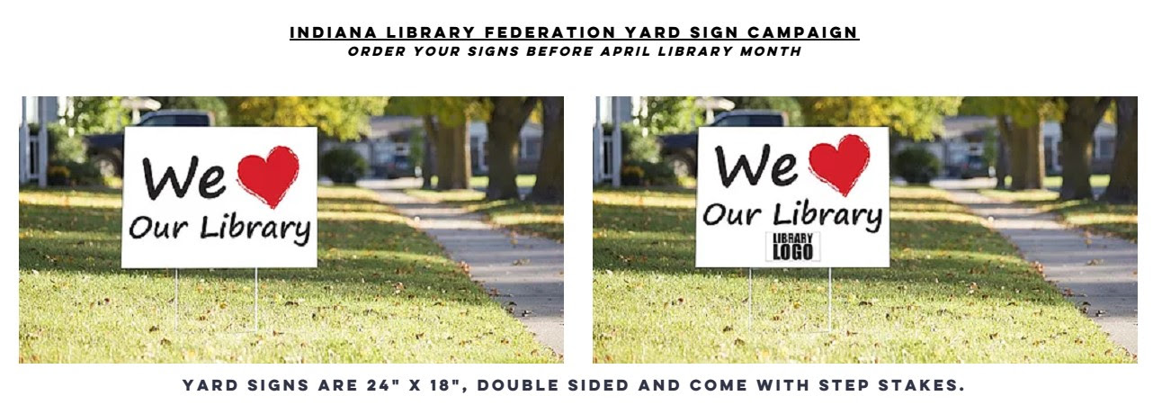
“We ♥ Our Library” Yard Sign Order Form
Full Color Double Sided 4mil Corrugated Plastic 18x24 Yard Signs.
FREE PREMIUM H STAKES WITH EVERY SIGN ORDER.
Please fill out this order form & provide all necessary information to complete your order.
Library Name: ______________________________________________________________________

Contact Name: ___________________________________ Phone: ____________________________

Email: __________________________________________________

10 qty $10.00ea + $15 Shipping 25 qty $8.00ea + $30 Shipping
50 qty $7.00ea + $35 Shipping 75 qty $6.50ea + $45 Shipping
100 qty $6.00ea + $50 Shipping 150 qty $5.50ea + $65 Shipping
_____ Other Amount (figure next lowest price break, i.e. 60 signs = 50 price point)
____ Please contact me for a larger quantity order or for other questions

______ A) We ♥ Our Library with no logo

______ B) We ♥ Our Library w/ Custom Logo (FREE SETUP with your suipplied acceptable logo artwork!)

Delivery Address:___________________________ City: ________________ State: ___ Zip: ______

Payment: Total Amount: $_______________ ____ Check enclosed (by mail order)

____ Credit Card: Name on Card: ________________________________

#______________________________ Exp. Date ________ CVV: _______

Please include your completed tax exemption form with this order to eliminate sales tax.

Send orders to: Stickersandmore.com

_____ Mail: Stickersandmore.com, Attn: Lindsay, 1648 E 675 S, Washington IN 47501

_____ Email: lindsay@stickersandmore.com

_____ Fax: 812-644-7745

_____ Phone: 888-644-7745

Production time is 7-10 working days. Shipping is one to two days.

Please order your signs by March

For questions, please contact Steve Gray at steve@iflinc.com or 812-698-0358

Visit us at…..

1648 E 675 S, Washington, IN 47501 888-644-7745

