What is your personal vision/goal for CANTO?

CANTO’s Vision is “To become the leading authority in shaping information, communication and
technology in the Caribbean Region and the Americas.” My personal vision for CANTO is aligned with
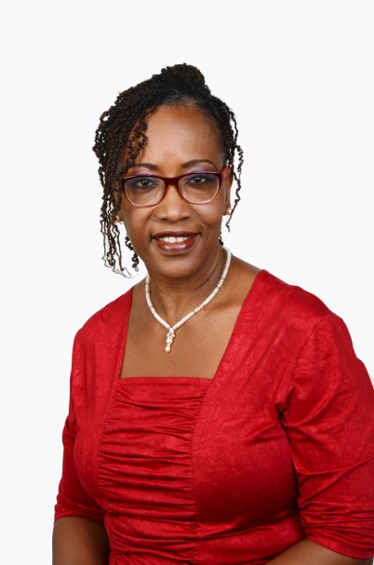
the stated vision. In actualizing this vision for me it is about CANTO using its unique position to influence the adoption of policies that go beyond providing access to people across the region. It extends to influencing the development of an ecosystem so ICTs will have positive and sustainable socio economic impacts. My vision is that the average citizen will be equipped to use ICTs to acquire information and knowledge, to develop skills and competencies, to create employment … essentially to fully participate in the opportunities made possible in this information age. In short, empowering people in all walks of life to use ICTs smartly for their own social and economic development. The end result being the social and economic development of countries and the region as a whole.

What do you like about the CANTO organisation?

CANTO brings people together. It provides forums such as the Annual Conference and Trade Exhibition and other opportunities for multiple stakeholders from the private and public sectors – network operators, service providers, equipment manufacturers and suppliers, government ministries, regulators to come together, discuss relevant and topical industry issues and find ways to pursue shared goals and objectives. CANTO effectively weaves in networking opportunities including social and cultural activities that enhance its distinctive value proposition.

Why did you become involved in the organization on the board level?

Over the years I contributed to the work of CANTO through participation in conferences and at the
committee level. With the knowledge and experience gained from working in the industry for over
20 years in various functional areas, particularly in the area of policy and regulations, and in
different markets across the region, I am keen to use my skills and experience it in a way that serves
the wider community. At the Board level I am able to draw on this to help to shape
the strategic direction, to ensure CANTO responds to the changes in the industry, and remain
relevant in providing value to its members and the wider community.

What would you tell a company/organization who is thinking of joining CANTO?

Membership and participation offer great value – the information gleaned, opportunities to
exchange ideas and benefit from information sharing, networking opportunities, for example the
Conference is a one stop shop for meeting and engaging government Ministers & regulators from
across the Caribbean. CANTO offers opportunities to building relationships, and promote your
business. The benefits outweigh the costs.

