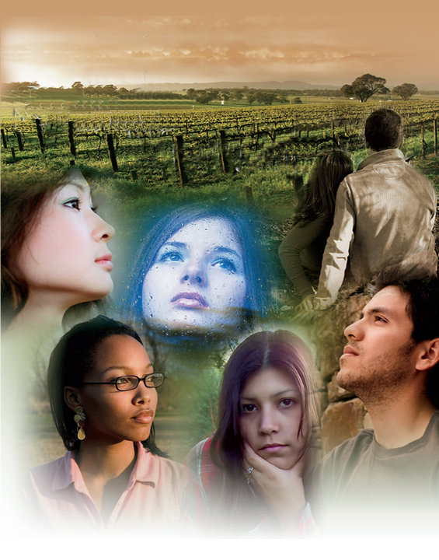
Rachel’s Vineyard

Rachel’s Vineyard-Kansas City Site

Healing Hearts in the Heart of the Nation

Are you, or someone you love, suffering the emotional pain of an abortion? Consider attending a local Rachel's Vineyard Retreat. Women and men of all ages are welcome. This weekend retreat offers a beautiful, confidential opportunity to experience healing and forgiveness.

Upcoming retreats in the Kansas City area:

July 22-24, 2022 October 21-23, 2022

Start the Healing!
For additional information, or to register, please call (816) 679-4973 or email rvkcmo@gmail.com.
You may also learn more by visiting www.rachelsvineyardkc.org or www.rachelsvineyard.org.

