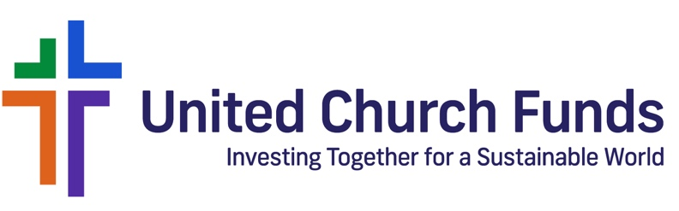

PRESS RELEASE

FOR IMMEDIATE RELEASE

From Vermont to Amsterdam: Advancing Dairy Workers’ Rights

June 11, 2025 — New York, NY — At a time when immigrant communities are increasingly under pressure and facing frightening confrontations with immigration enforcement officials, United Church Funds (UCF) is lending its support to Migrant Justice, a Vermont-based human rights organization. In April, UCF invited Migrant Justice to represent UCF at the Annual General Meeting (AGM) of Ahold Delhaize in Amsterdam to amplify the voices of immigrant dairy farmworkers and call for remedies to serious labor abuses within the dairy supply chain.

Migrant Justice has been at the forefront of advocating for improved working conditions through its Milk with Dignity program, modeled after the Coalition of Immokalee Workers’ Fair Food Program, which began in Southwest Florida. Both programs offer consumers the assurance that farmworkers’ rights and safety are respected and protected throughout the supply chain.

This issue hits close to home for customers throughout New England and New York, where Hannaford Supermarkets, one of the largest supermarket chains in the Northeast region and a subsidiary of Ahold Delhaize, has been under increasing pressure to join the Milk with Dignity program.

Since 2019, Migrant Justice has urged Hannaford Supermarkets to follow the lead of Ben & Jerry’s, the Vermont-based ice cream brand, which recently celebrated seven years of partnership with Migrant Justice and the Milk with Dignity program. Hannaford is a major buyer of dairy products sourced from farms where workers have reported grueling and unsafe conditions working conditions. These conditions include long working hours, inhumane living arrangements and wages that fall below minimum standards.

Marita Canedo, Program Coordinator for Milk with Dignity, sharing on UCF’s Just Investing Podcast (Ep. 8), said: "We have to recognize that these immigrant workers are climate refugees. They were forced to migrate, fleeing from environmental devastation and violence in their home countries. It is time to demystify the narrative that immigrant workers are just willing to take on the worst jobs. Every job is dignified, and every person deserves respect."

Press Release
From Vermont to Amsterdam: Advancing Dairy Workers’ Rights
Page 2

Matthew Illian, UCF’s Director of Responsible Investing, added, "Along with racial justice, climate justice and human rights issues remain top priorities for UCF, because they are all interconnected. The work we're doing here is not just about workers' rights; it is about securing a more sustainable, just future for all."

Guided by the United Church of Christ's long legacy of aligning economic practices with faith values, UCF manages the assets of churches and faith-based institutions with a commitment to justice, sustainability and equity. From shareholder engagement and proxy voting to investment manager selection, UCF's responsible investing strategies aim to drive long-term, positive change.

-end-

About United Church Funds
United Church Funds (UCF) is the leading provider of socially responsible, values-aligned investment management services to United Church of Christ churches and ministries, as well as all faith-based organizations. We offer customized investment portfolios and prudent investment strategies that provide competitive returns while also reflecting our clients’ values in seeking to achieve a just world. UCF also offers endowment governance consulting and superior, personalized service from our dedicated Client Services team. To learn more about how UCF can help your church or faith-based organization further its mission while achieving its long-term financial goals, please visit www.ucfunds.org, email us at info@ucfunds.org or call us toll-free at 877-806-4989.

Contact
Debbie Wibowo
Marketing and Communications Associate
debbie.wibowo@ucfunds.org

