REGISTER TODAY!
The Justice and Witness Ministries Committee of the Vermont Conference UCC is sponsoring a series of social justice webinars to address the challenges of the times we’re living in. Each webinar will be an hour-long examination of a different topic, with accurate information about how vulnerable people are being harmed and how we as people of faith can resist.
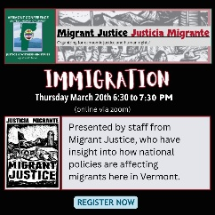
Immigration
Thurs, Mar 20 from 6:30 to 7:30 pm
Presented by staff from Migrant Justice, who have insight into how national policies are affecting migrants here in Vermont.

Register here:
https://us02web.zoom.us/meeting/register/-fMuiEajTM2ndE_bZNXd6g
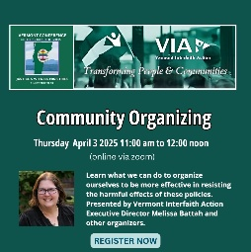
Community Organizing.
Thurs, April 3 from 11am to 12 noon
Learn what we can do to organize ourselves to be more effective in resisting the harmful effects of these policies. Presented by Vermont Interfaith Action Executive Director Melissa Battah and other organizers.

Register here:
https://us02web.zoom.us/meeting/register/6oHlAaf-SWCzKWFbxw8dSg

REGISTER TODAY!
The Justice and Witness Ministries Committee of the Vermont Conference UCC is sponsoring a series of social justice webinars to address the challenges of the times we’re living in. Each webinar will be an hour-long examination of a different topic, with accurate information about how vulnerable people are being harmed and how we as people of faith can resist.
Immigration
Thurs, Mar 20 from 6:30 to 7:30 pm
Presented by staff from Migrant Justice, who have insight into how national policies are affecting migrants here in Vermont.

Register here:
https://us02web.zoom.us/meeting/register/-fMuiEajTM2ndE_bZNXd6g

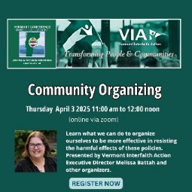
Community Organizing. Thurs, April 3 from 11am to 12 noon
Learn what we can do to organize ourselves to be more effective in resisting the harmful effects of these policies. Presented by Vermont Interfaith Action Executive Director Melissa Battah and other organizers.

Register here:
https://us02web.zoom.us/meeting/register/6oHlAaf-SWCzKWFbxw8dSg

