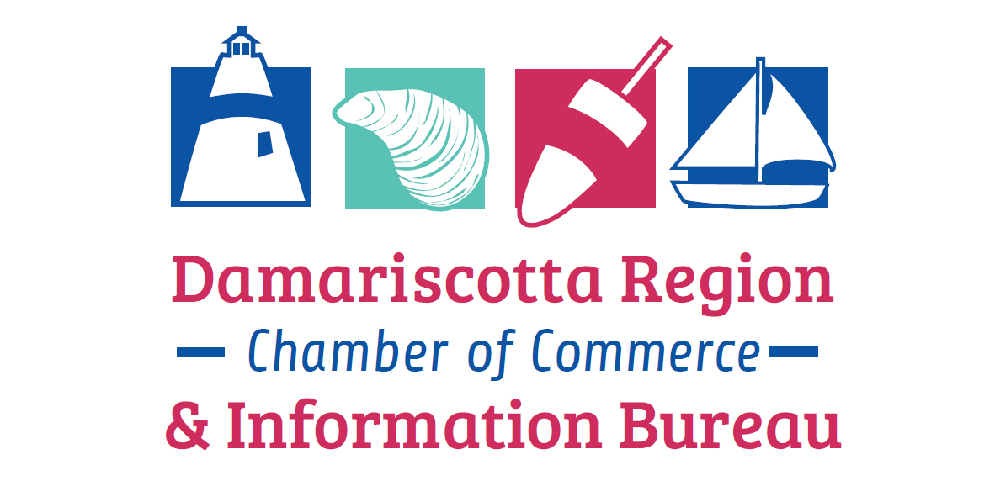
BAH 2025
Second Wednesday of the Month
Wednesday | 2025 | January 8 | NC Hunt
Wednesday | 2025 | February 12
Wednesday | 2025 | March 12 | Healthy Lincoln County -tentative | (Give to a first timer if possible)
Wednesday | 2025 | April 9 | Healthy Kids
Wednesday | 2025 | May 14 | Keller Williams-tentative | (give to a 1st timer if possible)
Wednesday | 2025 | June 11 | LCTV
Wednesday | 2025 | July 9 | Coastal Locker Room
Wednesday | 2025 | August 13 | Newcastle Realty
Wednesday | 2025 | September 10 | NA | Annual Meeting  TBD
Wednesday | 2025 | October 8 | Maritime Energy
Wednesday | 2025 | November 12
Wednesday | 2025 | December 10

