Misha Galant in Recital

Music by Beethoven and Chopin

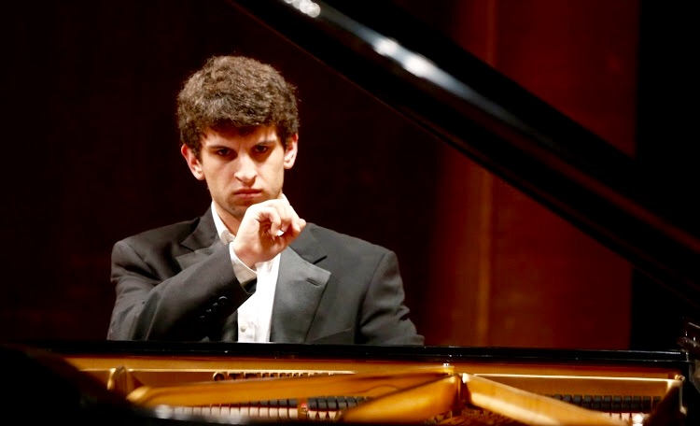

- Student in the Columbia University and Juilliard
School Exchange in New York City

- Prizewinner in many competitions, including the first Van Cliburn
Junior International Competition and Eastman Young Artist
International Piano Competition

- Soloist with numerous orchestras, including the
Rochester Symphony, the Fort Worth Symphony, and the Utah Symphony

Sunday May 19, 2019 6:15 pm
1498 24th Ave. San Francisco

Thursday May 23, 2019 7:00 pm
1000 E. Hillsdale Blvd. Foster City

