Facebook Fundraiser Creation Guide for
Every 9 Seconds: YWCA Challenge to End Domestic Violence

Thank you for supporting the YWCA Every 9 Seconds Fundraising Challenge! We’re trying to raise $150,000 during the month of October, to support survivors of domestic violence. That’s a big goal! By creating a Facebook fundraising page, you can help. Every donation will be matched dollar-for-dollar by an anonymous donor to help provide healing, housing and comprehensive support services for survivors of domestic violence.
Follow this guide to create your Facebook fundraiser and use our post templates to spread the word to your friends and family!
If you have any questions, please contact Mags Bouffard, Communications Manager at mbouffard@ywca-ens.org

Step 1
Find our YWCA Facebook page at www.facebook.com/YWCAEvanstonNorthShore and “Like” us if you haven’t already!

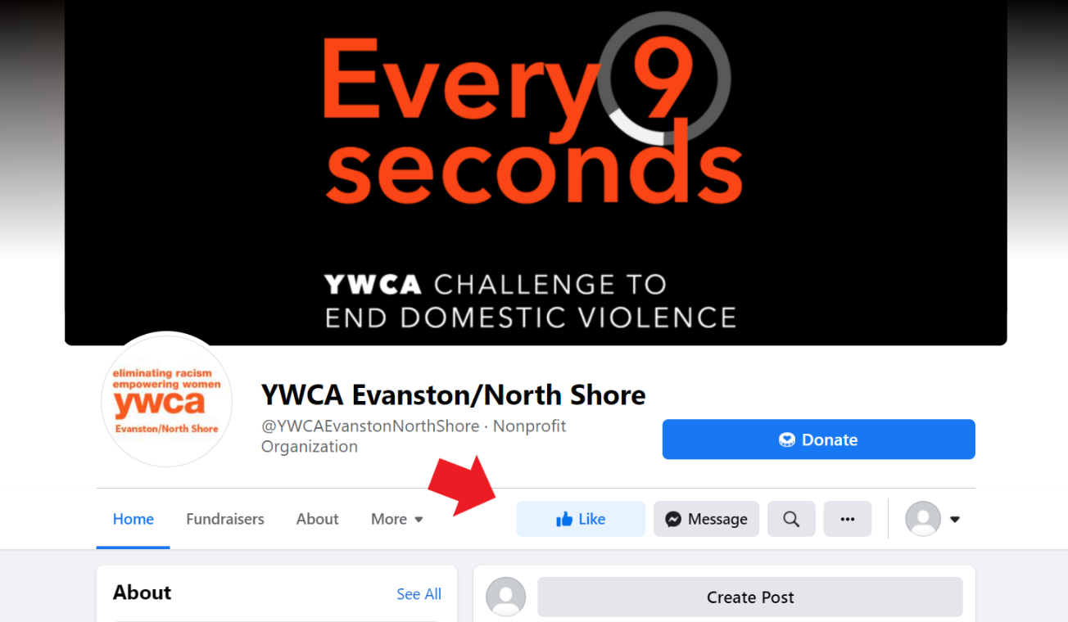

Step 2
Click on the “Fundraisers” tab underneath our logo. On the righthand side you’ll see a box with the title “Create a Fundraiser”; click on the button below that says “Raise Money”.
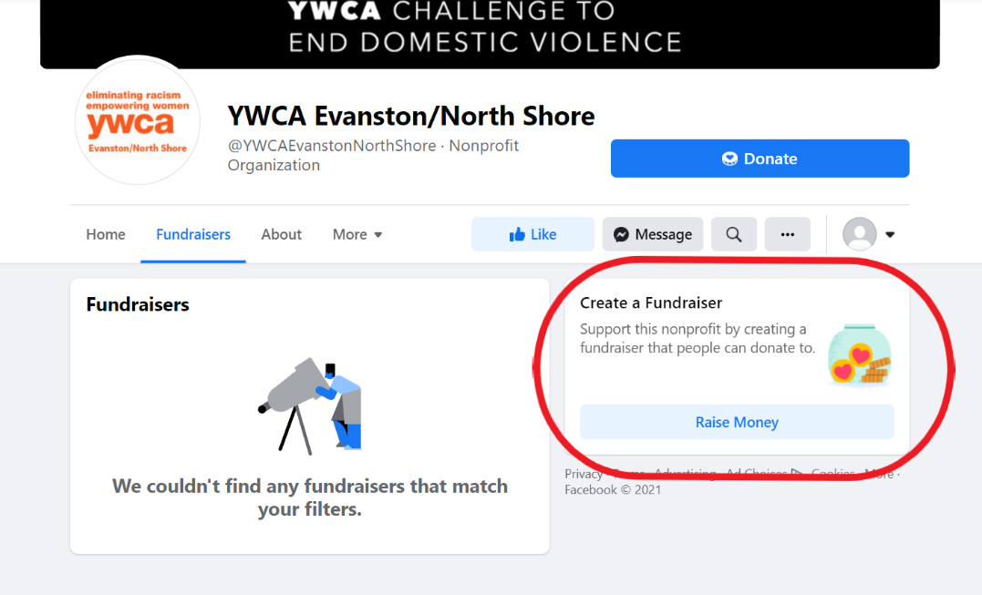

Step 3
Here is where you can get creative! In the “Details” Section on the left side, you can set your fundraising goal and write about why raising money for domestic violence survivors is important to you.
Facebook sets a default goal of $200 for each fundraiser, but we encourage you to aim as high as you want! When you are done editing, click “Create” in the bottom left corner and your fundraiser will be live!
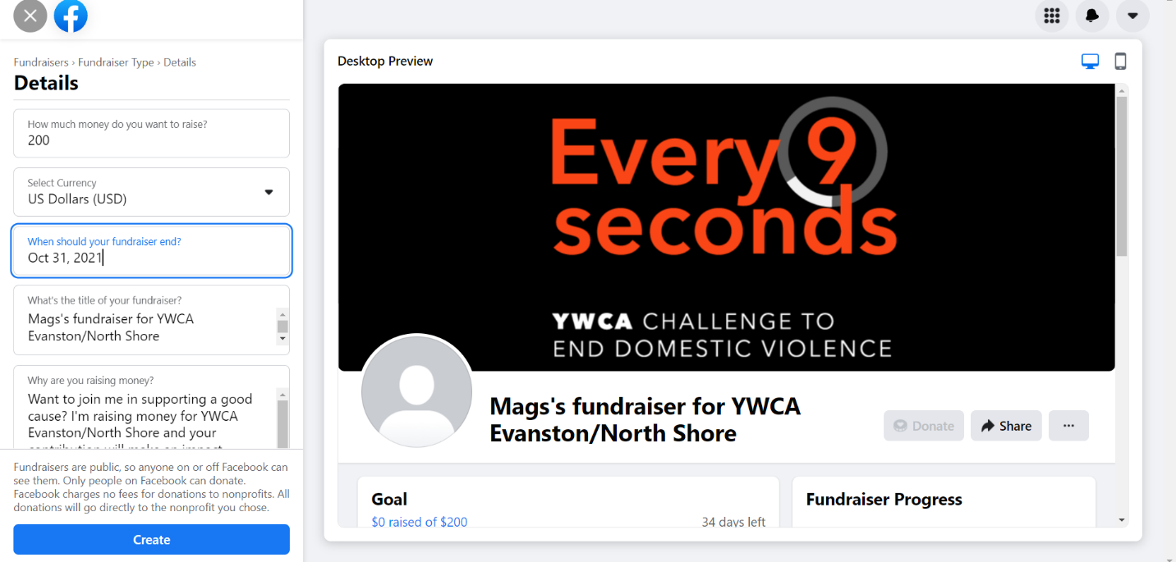

Step 4
You’ve created your fundraiser, now it’s time to promote! Share your fundraiser to your timeline or in a message to a friend by clicking “Share”.
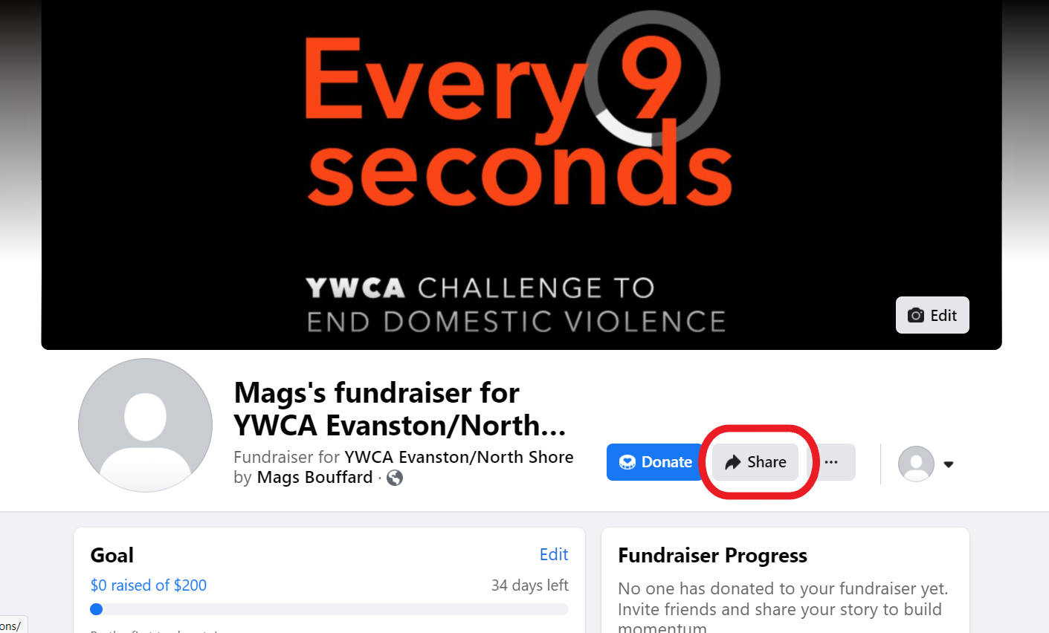

Our Every 9 Seconds Challenge ends on October 31st. Sharing your fundraiser to your timeline once per week is a simple best practice to ensure that your friends and family remember to donate.
We’ve created sample posts below, but we encourage all fundraisers to add a personal touch to their posts. Why are you drawn to the work of YWCA Evanston/North Shore? Do you have a story or experience at the YWCA that impacted you? Why is fighting for a world without domestic violence important to you? Your answers to these questions can be the deciding factor in why someone chooses to give!

Sample Posts
Week of 10/3- October is Domestic Violence Awareness Month and I’m raising money to support the critical services of YWCA Evanston/North Shore! Did you know that Every 9 seconds, a woman in the US experiences domestic violence? YWCA-ENS works 24/7 to ensure that survivors have access to emergency housing, counseling and legal services. Every gift to the Every 9 Seconds Challenge will be matched dollar for dollar by an anonymous YWCA donor! Give today to double your impact and help me reach my goal! #DVAM2022 #YWCAENS #Every9Seconds
Week of 10/10- Will you join me in supporting domestic violence survivors? I’m raising money for YWCA Evanston/North Shore and I am $X away from my goal! A $100 donation can help a survivor get an order of protection. All donations will be matched by an anonymous YWCA donor, so your gift will have twice as much impact! Give today to help YWCA-ENS #enddomesticviolence #DVAM2022 #Every9Seconds
Week of 10/17- I’m raising money to help end domestic violence! I am still $X away from my goal and I need your help. Not only will all donations be matched dollar for dollar, but all gifts from NEW donors will be matched 2 to 1! That means that new donors will TRIPLE their impact! Your gift will help the YWCA-ENS provide emergency housing for survivors, feed families in the shelter, and provide counseling for children who have witnessed abuse. Give today to make a difference in the lives of survivors and their families! #DVAM2022 #Every9Seconds #YWCAENS
Week of 10/24- Last chance to double your impact for survivors of domestic violence! Domestic Violence Awareness Month is almost over and I need your help to reach my goal to provide critical funds for YWCA Evanston/North Shore! Survivors of domestic violence are the most at risk for harm when they try to leave their relationships. The YWCA provides safe emergency shelter, trauma-informed care, and supportive counseling for survivors so they can focus on healing. Join me in building a better world for survivors by supporting the YWCA! #YWCAENS #DVAM2022

