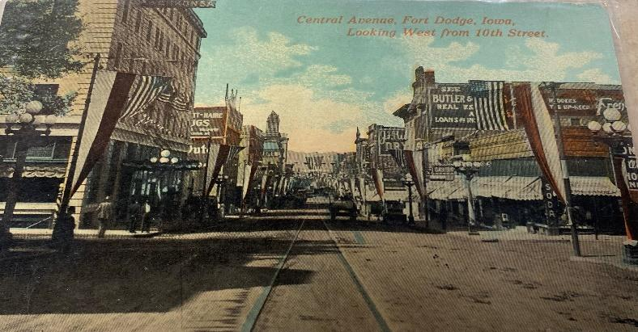

Press Release-1/31/2026
The Webster County Historical Society is pleased to announce it will be hosting an Open House on February 17^{th fr} 3:00-6:00pm at the Fort Dodge Public Library, Room 143, (the Roger Natte Archives Room). In recognition of President’s Day, this Open House will honor past political leaders from Fort Dodge and Webster County. Fort Dodge has a robust history of federal and state political leaders who have made a significant impact on our state and nation.The public will learn about these leaders and find out more about what the Webster County Historical Society collection has to offer. The collection of thousands of paper documents, books, photos and prominent family collections serves as a remarkable resource for historical research. Staff and volunteers will be at the Open House to assist with inquiries and to answer questions about Fort Dodge and Webster County history.
For more information, please contact the Webster County Historical Society at webcntyhistscty@gmail.com .
The Webster County Historical Society is located at the Fort Dodge Public Library, Rm. #143, 424 Central Avenue, Fort Dodge, IA 50501.

