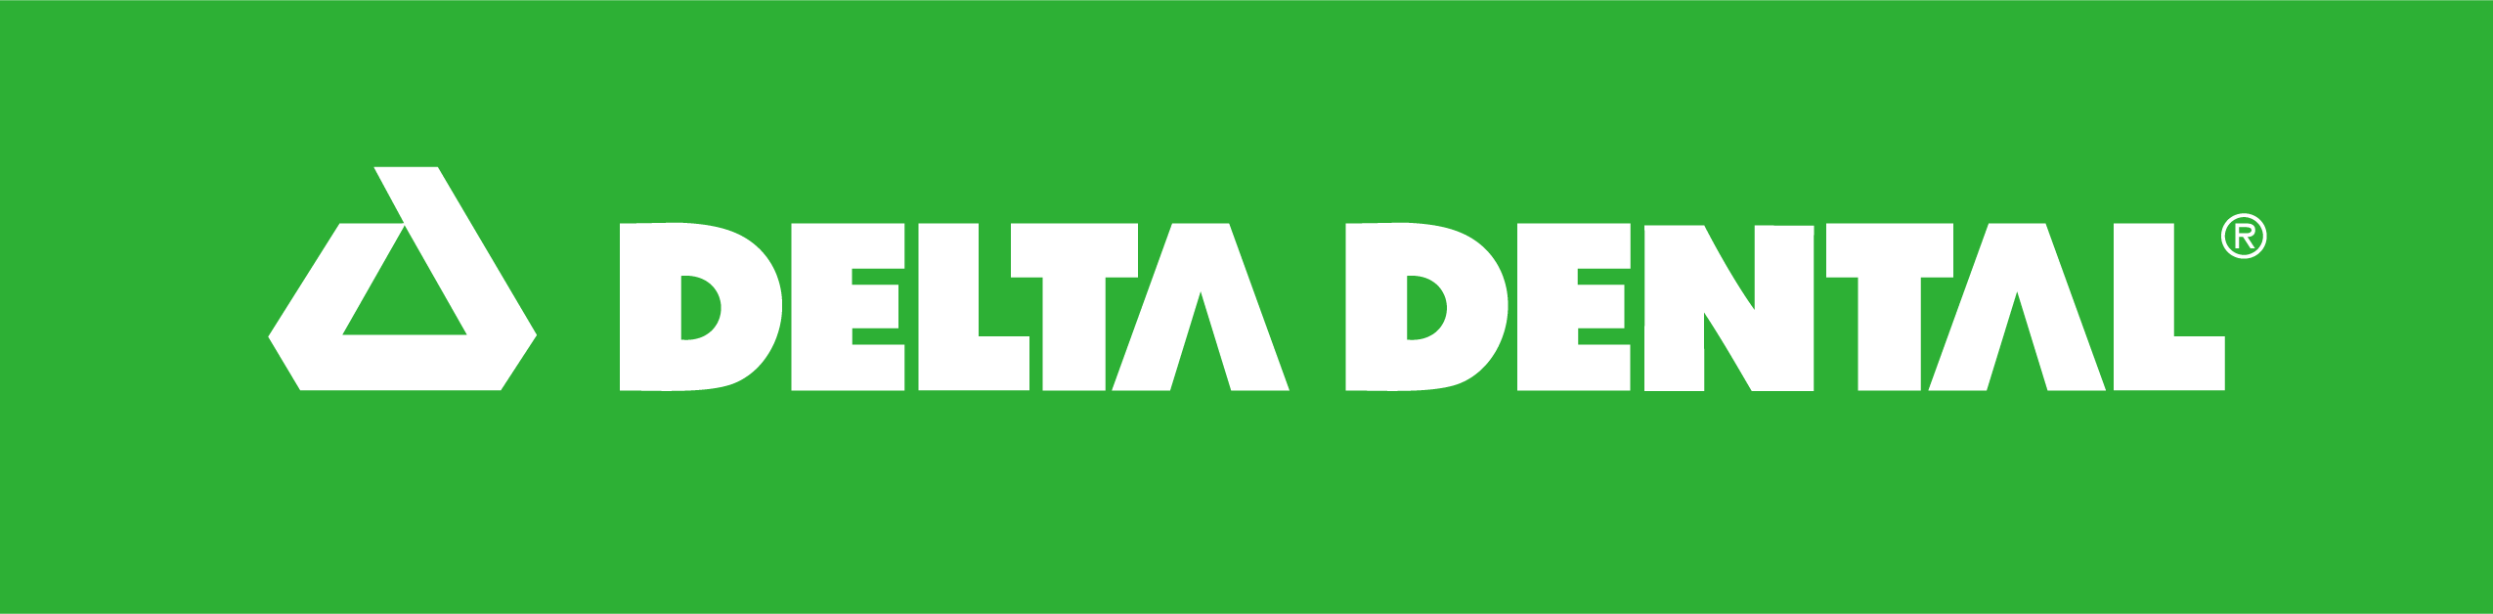
MEDIA ADVISORY

Delta Dental of Iowa  9000 Northpark Drive  Johnston, IA 50131  515-261-5500 | Contact:  Jill Feilmeier  Corporate Communications Director  515-261-5526  jfeilmeier@deltadentalia.com  Contact:  Regina Suhrbier  Outreach Coordinator  515-576-6500  rsuhrbier@chcfortdodge.com
Hundreds of Fort Dodge COMMUNITY Members
to Receive Free Eye Exams and Glasses

Delta Dental of Iowa Foundation in partnership with the Community Health Center of Fort Dodge, Prevent Blindness Iowa, and OneSight EssilorLuxottica Foundation will host a free vision clinic on June 19 and 20 at Butler Elementary School. The clinic will provide free eye exams and glasses for hundreds of adults and children.

The vision clinic will address unresolved vision needs for adults and children in the community who may otherwise lack access to eye exams and prescription glasses.

This is the vision clinic’s fifth year in Iowa and the first year held in Fort Dodge. Leveraging the OneSight EssilorLuxottica Foundation’s clinic model and manufacturing capabilities, most participants in need of glasses will receive newly prescribed, quality glasses manufactured on-site at the clinic.

Delta Dental of Iowa Foundation, the Community Health Center of Fort Dodge, Prevent Blindness Iowa, and OneSight EssilorLuxottica Foundation, along with local volunteers, including ophthalmologists, optometrists, opticians, and other skilled and general volunteers, will staff the daily operations of the clinic. Optically skilled volunteers, especially ophthalmologists and optometrists are still needed and those interested can register to volunteer at: http://www.deltadentalia.com/foundation/vision-clinic

Appointment Registration
The clinic will be open to registered patients Thursday, June 19 and Friday, June 20 from 9 a.m. to 7 p.m. both days at Butler Elementary School Gymnasium, located at 945 S. 18th St., Fort Dodge, Iowa. Individuals interested in receiving services are strongly encouraged to pre-register for an appointment. Appointments can be scheduled through the Community Health Center of Fort Dodge by visiting chcfd.com/free-vision or by calling 515-576-6500. Please note that walk-in appointments will be extremely limited and are not guaranteed.

“We recognize many Iowans face barriers to accessing vision care and we are excited to bring this free vision clinic to members of the Fort Dodge community,” said April Schmaltz, president and CEO of Delta Dental of Iowa. “Regular vision exams are important to overall health and can detect eye disease or symptoms of chronic disease such as diabetes or cardiac issues.”

“We are thrilled to bring the Free Vision Clinic to Fort Dodge,” said Renae Kruckenberg, CEO of the Community Health Center of Fort Dodge. “Several of our staff had the opportunity to volunteer at last year’s clinic in Eastern Iowa, and it was truly inspiring to witness the impact it had on that community. To now be able to offer this same experience here at home is incredibly exciting.”

“As healthcare professionals, we know that the eyes are a window into the body. These exams can detect much more than vision issues — including signs of diabetes, high blood pressure, and other underlying health conditions. We’re proud to not only help people see more clearly but to also provide them with the care they may need. If follow-up is needed, Community Health Center will be here to help.” added Colleen Miller, COO of Community Health Center of Fort Dodge.

About Delta Dental of Iowa
Delta Dental of Iowa, a not-for-profit health and wellness company, provides dental and vision benefits to more than 1.6 million Iowans. Locally focused and nationally networked, Delta Dental of Iowa and its Foundation invest in robust community systems and partnerships. These efforts empower and engage all Iowans to have optimal oral, vision, and overall health. Since 2002, Delta Dental has invested more than $73 million to improve the oral and overall health of Iowans.

Delta Dental of Iowa is a member of the Delta Dental Plans Association, the leading national network of independent dental service corporations. The Delta Dental member companies provide dental benefits to more than 89 million Americans in more than 166,000 employee groups throughout the country. For more information, visit the website at www.deltadentalia.com.

About Community Health Center of Fort Dodge
Community Health Center of Fort Dodge is a federally qualified health center that provides medical, dental and behavioral health services. Their services are available to patients regardless of insurance status. They accept Medicare, Medicaid, most major insurance plans, and they offer a sliding fee for those who qualify.

About OneSight EssilorLuxottica Foundation
The North America affiliate of the OneSight EssilorLuxottica Foundation is a 501(c)(3) nonprofit, registered in the United States. This regional affiliate supports the goals of the OneSight EssilorLuxottica Foundation, a French registered charitable organization (endowment fund) reflecting the commitment and values of EssilorLuxottica to contribute to eliminating uncorrected poor vision in a generation. https://onesight.essilorluxottica.com/

About Prevent Blindness Iowa
Prevent Blindness Iowa is the state’s only health and safety organization dedicated to preserving sight and preventing blindness. Prevent Blindness Iowa will support the clinic through vision screenings and volunteer engagement. https://iowa.preventblindness.org/

###

