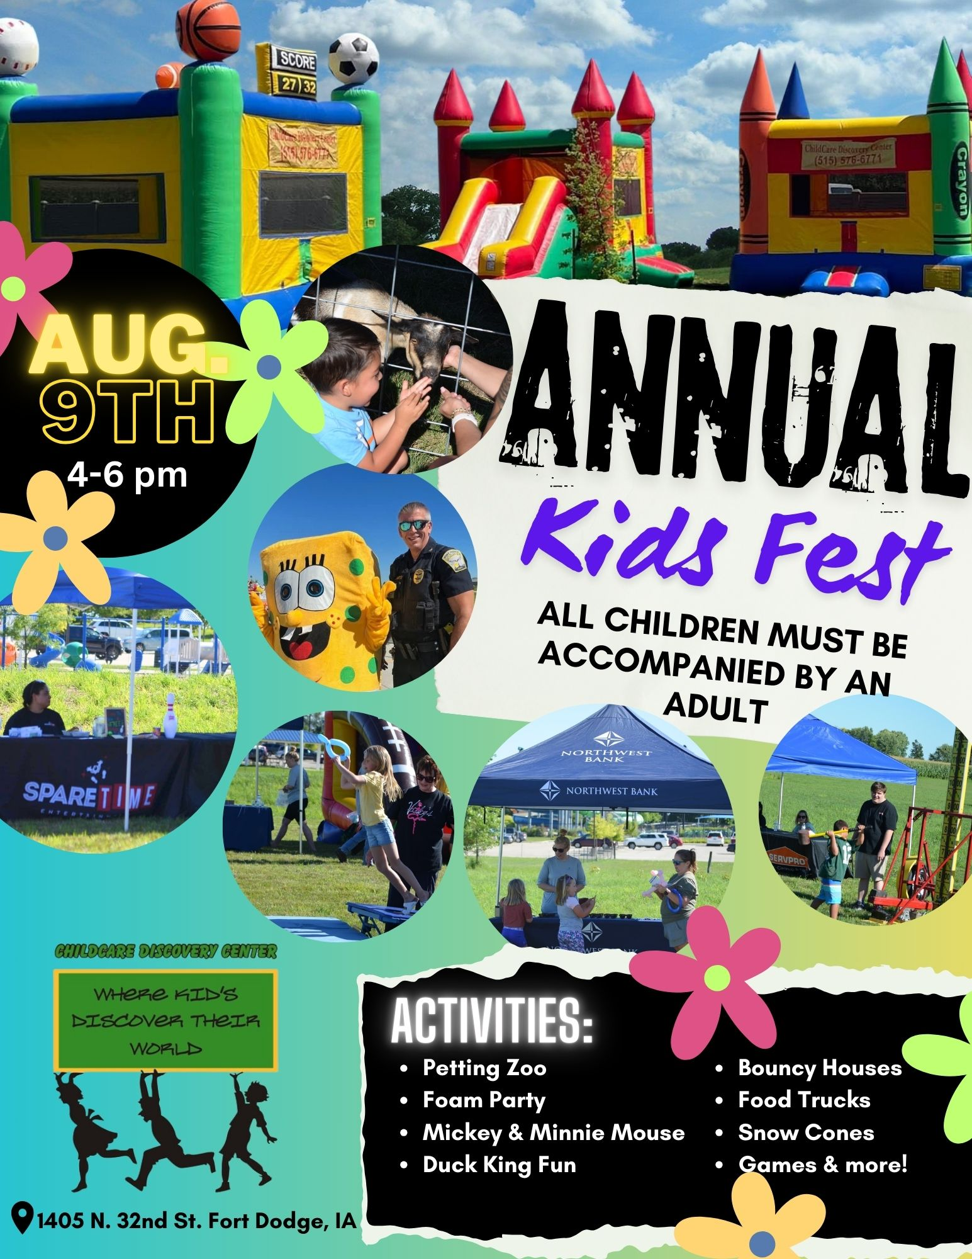
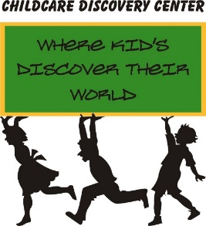
1405 North 32nd Street
Fort Dodge, IA 50501
515-576-6771 (Phone) 515-206-1908(FAX)
childcarediscovery@yahoo.com
www.childcarediscoverycenter.com
RE: Annual Kids Fest- Free for businesses and families!
Dear Businesses,
We are planning our annual Kids Fest for August 9th from 4:00pm to 6:00pm. Last year we had a great success with well over 1,000 families in attendance! This year, we expect more, as we have added more businesses to join us.
Our goal every year is to offer the children and families in our community a fun free event! We have the land and the perfect area to host this event each year and kids are what we are all about!
How this works: We do not charge any business to set up a booth to promote/or bring any promotional items—all we ask is that you bring a child activity (or pick one from the attached list) that will be free for the kids to participate.
We would love for you to join us along with several other businesses offering a fun free event for the families in our community. Give us a call at 515-576-6771 , or go to our webpage childcarediscoverycenter.com (under activities/Kids Fest) and let us know you can join us and what activity you will be doing! Attached is a list of available kid activities if you do not have one of your own to bring.

Optional items to bring with you: Table (if needed) for any promotional items you may have, chair(s), and a pop-up shade tent to help with any sun.
Set up starts by 10am the day of the event. You can bring your optional items anytime after that, but make sure you’re set up no later than 3pm. If the ground is not too wet, if you arrive by 3:00, you can park in the back grass area behind the fence.

Day: Saturday August 9th
Time: 4:00-6:00pm
Location: 1405 North 32nd Street- Fort Dodge (ChildCare Discovery Center)
Call us at 515-576-6771 or sign up on our webpage at childcarediscoverycenter.com to request a booth!
**Optional: We will be raffling off kids gifts/prizes. Is there anything your business would like to donate to the raffle? Last year we had bikes, birthday parties, and miscellaneous coupons from businesses.
Fort Dodge Annual Kids Fest August 9th 4:00-6:00pm
Activities Available- You can also bring your own!!
Duck King will set up and take down all their items.
Activity | Cost | People to operate activity
Foam Party  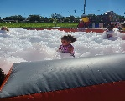 | $350.00  Make check payable to Duck King | Duck King operates
Snow Cone Machine  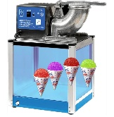 | $100.00  Make check payable to Duck King  Everything comes with it except ice. You will need to bring bags of ice in a cooler | You will need 1 person to operate
Dunk Tank  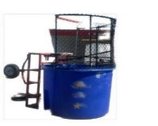 | $175.00  Make check payable to Duck King | 2 people. 1 person to operate and another to be dunked
17’ Hi-Striker game  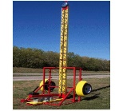 | $185.00  Make check payable to Duck King | 1 person to operate
Clown toss  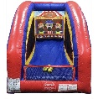 | $50.00  Make check payable to Duck King | 1 Person to operate
Basketball Hoop Shot  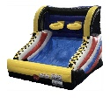 | $75.00  Make check payable to Duck King | 1 person to operate
Inflatable Football Game  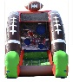 | $100.00  Make check payable to Duck King | 1 person to operate
Pony Hops  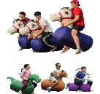 | $60.00  Make check payable to Duck King | 1person to operate
Giant connect four  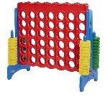 | $25.00  Make check payable to Duck King | 1 person to operate
Coin Operated Kiddie Rides  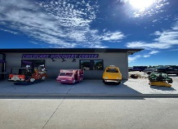 | $200.00  Make check payable to Duck King | 1 person to operate  Takes a quarter for each ride.  (Duck King will open them all and give you your quarters back at end)
Mickey Mouse  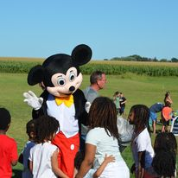 | Free | 1 person
Minnie Mouse  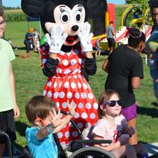 | Free | 1 person
Sponge Bob  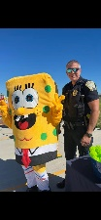 | Free | 1 Person
Yard Jenga  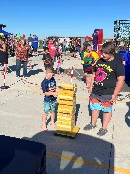 | Free | 1 Person
Bouncy House  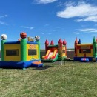 | Free | 1 person
Bouncy House  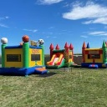 | Free | 1 person
Soccer  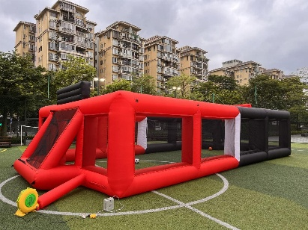 | Free | 1 person

