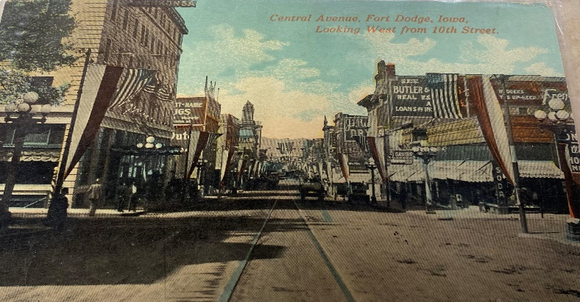

Press Release-01/07/2025

The Webster County Historical Society is pleased to announce they will be having their first “Chit Chat” session on January 17th from 1:30-4:30pm. The feature of the event will be Sam Arkoff, the movie director of over 500 films who was from Fort Dodge. The feature film to be shown will be “Beach Blanket Bingo” with Frankie Avalon/Annette Funicello. Items about Arkoff’s history in Fort Dodge as well as relics from his career will be on display. Members of the Webster County Historical Society will be available to discuss Arkoff and other items pertaining to the event. Public is encouraged to notify (WCHS) if they are coming to the event at webcntyhistscty@gmail.com This is an adult afternoon event. Attendees are encouraged to dress in beach wear, sunglasses, beach hats, bring a beach towel, their own snacks/beverages (non-alcoholic) too. The film will be shown in the meeting room at the FD Public Library from 1:30-4:30pm. A trivia activity will be done during the movie as well.
On January 18th, the room will be open for the public to come see the entire Sam Arkoff display shown the previous day during the film. The meeting room will be open from 9:30-12:30pm. Free to the public to attend.
The hours for the Webster County Historical Society Room are subject to the hours the library is open to the public during holidays or for the city in-services. The new email address is: webcntyhistscty@gmail.com The public is encouraged to come research, learn, and volunteer at the resource collections room. Staff is there during open hours to assist with inquiries the public has on Fort Dodge and Webster County history.
The Webster County Historical Society is located at the Fort Dodge Public Library, Rm.143, 424 Central Avenue, Fort Dodge, IA 50501.

