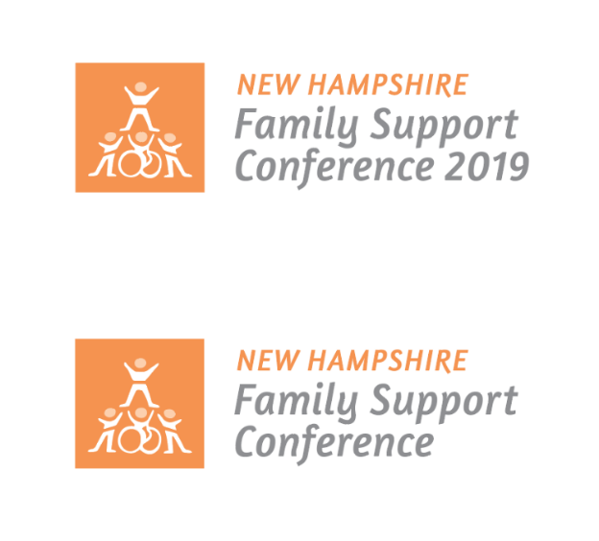*2025 Registration Form*

Please submit registration before May 20, 2025

Prior to completing this form, please review the workshop descriptions that are attached

**Family information *required**

**Address:**Click or tap here to enter text.

**Phone:**Click or tap here to enter text.

**Family Email:**Click or tap here to enter text.

|  |  |  |  |
| --- | --- | --- | --- |
| **Adult Name** | Morning Workshop:  Session 1  *(Put workshop letter in the column)* | Morning Workshop:  Session 2  *(Put workshop letter in the column)* | Will you be attending the welcome reception/ pizza party on Friday 5/30? |
| Click or tap here to enter text. | Choose an item. | Choose an item. | Yes  NO |
| Click or tap here to enter text. | Choose an item. | Choose an item. | Yes  NO |
| Click or tap here to enter text. | Choose an item. | Choose an item. | Yes  NO |
| Click or tap here to enter text. | Choose an item. | Choose an item. | Yes  NO |
| Click or tap here to enter text. | Choose an item. | Choose an item. | Yes  NO |

|  |  |  |  |  |
| --- | --- | --- | --- | --- |
| **Child / Teen Registration**  Teens : 13-18 $180  Children: 5-12 $130  Children Under 5: Free | Age | Morning Workshops  (if none please put “None”)  Music Therapy / Make a musical egg  Learn To be a DJ/Silent Disco  Quiet Activity Workshop | Afternoon Workshops  (if none please put “None”)  Music Therapy / Make a musical egg  Learn To be a DJ/Silent Disco  Quiet Activity Workshop | Will your child be attending the welcome reception/ pizza party on Friday 5/30?  Yes  NO |
| Click or tap here to enter text. | Choose an item. | ☐ Music Therapy / Make a musical egg☐ Learn To be a DJ/Silent Disco☐ Quiet Activity Workshop | ☐ Music Therapy / Make a musical egg☐ Learn To be a DJ/Silent Disco☐ Quiet Activity Workshop | Yes  NO |
| Click or tap here to enter text. | Choose an item. | ☐ Music Therapy / Make a musical egg☐ Learn To be a DJ/Silent Disco☐ Quiet Activity Workshop | ☐ Music Therapy / Make a musical egg☐ Learn To be a DJ/Silent Disco☐ Quiet Activity Workshop | Yes  NO |

**Will you/your family be attending the Welcome Reception / Pizza party on Friday night? Yes  No**

If you attend youth workshops, does your child require 1:1 support? Yes  No

Please list 1:1 name and relationship to child. _________________________________

Does anyone in your family have any medical restrictions? _Click or tap here to enter text.

Does anyone in your family have any dietary restrictions? _Click or tap here to enter text.

I am participating as a Family who receives services from an Area Agency, which is _Click or tap here to enter text.

|  |  |
| --- | --- |
| Registration Fees for Saturday.  Meals included: Friday Light Dinner, Saturday Breakfast and Lunch | Please share additional notes for the Conference Staff below if needed. |
| Adult (age 13+) - $180 Number of adults | Click or tap here to enter text. |
| Child (age 5-12) - $130 Number of children_Choose an item._______ | Click or tap here to enter text. |
| Age 4 and under – FREE Choose an item. | Click or tap here to enter text. |
| TOTAL: $Click or tap here to enter text. | Click or tap here to enter text. |

Registration Link: https://www.eventbrite.com/e/1230732226219?aff=oddtdtcreator