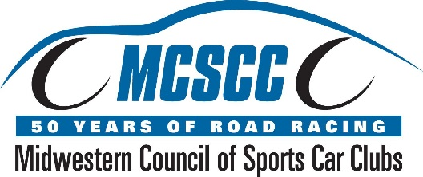

2016 Midwestern Council Awards Banquet
Recognizing Class Champions, Race Staff Awards, and Special Award Winners

Date
Saturday, January 21st, 2017

Location
The Ridge Hotel
W4240 State Hwy 50
Lake Geneva, WI 53147

Time
Social 5:30pm
Welcoming Remarks 6:45pm
Buffet Dinner to follow
Award Presentation 8:00pm

***Class Champions are FREE***
***Use your Worker Credits towards your dinner cost***

For Overnight Accommodations:
The Ridge Hotel
www.ridgelakegeneva.com
W4240 State Hwy 50
Lake Geneva, WI 53147
Special block reserved at $99.00 (mention Midwestern Council of Sports Car Clubs)
Email: reservations@ridgelakegeneva.com
Phone: 800-225-5558

Reservations and payment are required by January 15th, 2017

Please complete this page, and mail with your payment to:

Scott Durbin
15726 South Park Avenue
South Holland, IL 60473

Email: Treasurer@nsscc.org

MCSCC 2016 Awards Banquet Reservation Form

Driver/Staffer Name______________________________________________________

Total Cost of Reservations

$50 x _____________ = $___________
(# in party)

Less Free Class Champion - $___________
(please indicate class)

Less Worker Credits @ $5 per credit - $___________
(worker log book must accompany reservation; unused credits will be returned)

Total Amount Sent $___________
(Make checks payable to MCSCC)

Email Address or Phone # if registrar has questions:

________________________________

