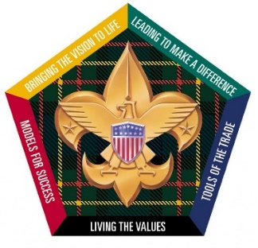
PTAC Wood Badge Alumni Association
For the last couple of months, we have been compiling a list of all Wood Badgers in the council. We have identified over 1500 individuals who have taken Wood Badge, but we only have current e-mails on 970 of these Wood Badgers. If you have not been receiving e-mails from us, you can join our Wood Badge Community and receive notices on upcoming Wood Badge events, by dropping us a note at pathwaywoodbadge@gmail.com. Include your name, address, phone number, e-mail, course number, critter, and if you have any experience staffing Wood Badge. We look forward to connecting with all Wood Badge members throughout the council.

