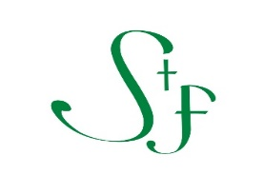

2025 PARISH WIDE EVENTS & WORSHIP

|  |  |
| --- | --- |
| **DATE** | **EVENT** |
| April 13 | Palm Sunday |
| April 17 | Maundy Thursday Worship (6:30PM) |
| April 18 | Good Friday Service (12PM) and Stations of the Cross (6:30PM) |
| April 19 | The Great Vigil of Easter (6:30PM) |
| April 20 | Easter Worship (7:45AM; 9:15AM; and 11AM) |
| May 11 | Bishop’s Visit: Confirmation Service (8AM) and Youth Service (10:15AM) |
| June 8 | Pentecost |
| June 9-13 | Vacation Bible School |

SAVE THE DATES. MORE INFORMATION TO COME.