St. Francis in-the-Field Episcopal Church
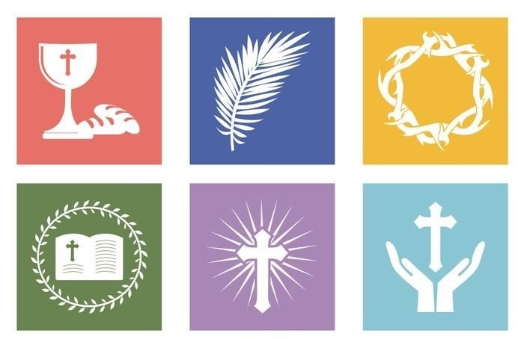

Holy Week & Easter Explained
2025

Holy Week
Palm Sunday through the Saturday before Easter

From early times Christians have observed the week before Easter as a time of special devotion. Numerous pilgrims to Jerusalem followed the path of Jesus in his last days. They formed processions, worshipped where Christ suffered and died, and venerated relics. From this beginning evolved the rites we observe today on Palm Sunday, Maundy Thursday, Good Friday, and Holy Saturday. These services provide a liturgical experience of the last days of Jesus' earthly life, as well as the time and events leading up to his resurrection. The three Holy Days, or Triduum, of Maundy Thursday, Good Friday, and Holy Saturday are at the heart of the Holy Week observance.

Great Vigil & Easter
The culmination of our Sacred Triduum observances will be the Great Vigil where we revisit our salvation history and ignite the Easter flame, heralding the resurrection of Jesus. Easter marks the finality of our celebrations, with the resurrection of Jesus Christ from the dead, a victory of life over death and the fulfillment of God's promises.
This coming Holy Week and Easter season is a special opportunity for our parish family to come together in worship and celebration. We encourage you to extend an invitation to your family, friends, and neighbors, sharing the hope and joy of Easter with the broader community.

To learn more about the specific worship services offered at St. Francis in-the-Field Episcopal Church during Holy Week & Easter, please go to the next pages.

Sunday of the Passion: Palm Sunday (April 13)
Christian Formation for all ages starting at 9AM
Worship 8AM Sanctuary (Live Stream Available) and 10:30AM Hope Pavilion

The Sunday before Easter is called Sunday of the Passion: Palm Sunday and has two main points. Traditionally, we process into the church carrying palm branches to represent the palm branches that the crowd scattered before Christ as he rode into Jerusalem. Second, we will hear the reading of one of the Passion accounts from Scripture, which is the story of Jesus’s crucifixion.

We will be offering an outdoor worship experience at our beautiful Hope Pavilion at 10:30AM. We will begin at the ceremony site behind our work garage, and we will process through our paved walkway and biblical town, up to the Pavilion. Our indoor service will take place at 8AM in our Sanctuary.

In between the services, we will be offering formation for all ages, including children, at 9AM. Children may be dropped off by a parent or guardian at our classrooms in our Youth & Children Building for age-appropriate study, prayer, and crafts. Adults have the option to attend Deacon Mark’s class in our Parish Hall. Coffee and refreshments will be available to all.

Maundy Thursday (April 17)
Worship 6:30PM Sanctuary (Live Stream Available)
Incense will be used at the end of this service to sanctify our symbolic Garden of Gethsemane for the Night Watch.

This service is the beginning of the three holy days before Easter, called the Triduum. This day commemorates the institution of the eucharist by Jesus and his new commandment to love one another as he has loved us (John 13:34). It is best known as the ceremony of washing of feet. At St. Francis in-the-Field you are invited to have either your feet or hands washed by a family member. Following this, all decorative furnishings are removed from the church in preparation for Good Friday. Afterward, the reserved sacrament is taken to the Parish Hall for a prayer vigil at our symbolic Garden of Gethsemane.

The Garden of Gethsemane: Overnight Prayer Vigil
April 17, 8PM until April 18, 12PM in Parish Hall (Live Stream Available)

A Prayer Vigil over the reserved sacrament is observed throughout the night on Maundy Thursday until noon on Good Friday in our symbolic Garden of Gethsemane surrounded by plants and private meditative space in our Parish Hall. You may sign up to pray in one-hour increments. “Will you stay awake and watch for just one hour?” You can sign up by scanning the QR code to the right.

Good Friday (April 18)
Liturgy at 12PM (Live Stream Available), Stations of the Cross at 6:30PM

The is the somber day on which the church commemorates the crucifixion of Jesus. There are two opportunities to worship this day. The liturgy at 12 pm includes John's account of the Passion gospel and includes a solemn form of intercession known as the solemn collects (dating from ancient Rome). At 6:30pm, we will have Stations of the Cross that begins outdoors at the Hope Pavilion. The Stations will be interactive. We will read Holy Scripture describing Jesus’s last moments and you will have the opportunity to walk the Way of the Cross in prayer. You will not want to miss either of these offerings. It is only when we recognize the lowest moment for our Savior that we experience the true joy of Easter.

Easter Vigil (April 19)
6:30PM Sanctuary
Incense will be used at this service.

The Easter Vigil, or Great Vigil of Easter, is the first celebration of Easter Day. The service begins outside while it is still dark where we will light a fire to symbolize the light of Christ overcoming sin and death. From that fire, we light the Paschal Candle and walk it into the church to remain there through the fifty days of the Easter season. The service includes a Renewal of Baptismal Vows and concludes with Holy Eucharist.

Following the Great Vigil, we will celebrate outside with light refreshments. Please bring a bottle of wine or a dessert to share.

Easter Festival Eucharist (April 20)
7:30AM, 9:15AM, and 11:30AM Sanctuary (Live Stream Available for all three services)

We will celebrate the feast of Christ's resurrection with three offerings of Holy Eucharist. At 9:15, we are offering a service dedicated to our family with children. Our worship music and sermon will be centered around our most youthful members. For more traditional (and quiet) services, we encourage you to attend our 7:30 or 11:30 services.

The Flowering of the Cross (April 20)
Starting at 9AM outside the Sanctuary

All families and guests are invited to bring a bouquet of flowers to help fill and decorate a large cross.

Easter Egg Hunt (April 20)
10:30AM Parish Front Lawn & Parish Hall

The wonder and awe of the resurrection of Christ is discovered by our children in the tradition of hiding and finding eggs. Our annual Easter egg hunt will take place in between the services at 10:30AM on the Parish Front Lawn. We will have separate areas for our younger and older children. Plenty of light refreshments and sweets will be offered after this family-friendly event in our Parish Hall.

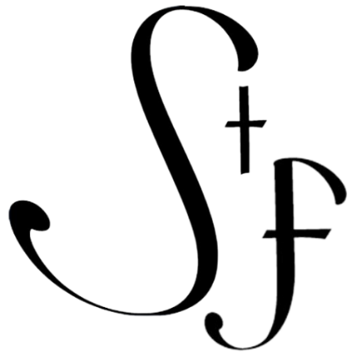

St. Francis in-the-Field Episcopal Church
895 Palm Valley Road, Ponte Vedra, FL 32081
Tel 904.615.2130
www.stfrancispvb.org

