ARTHUR’S INTERIORS
Phone (909) 337- 1115

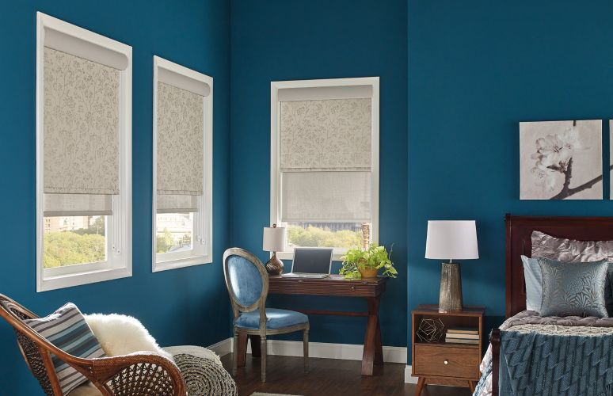
Graber roller shades pictured, one of the many beautiful products offered in our sale that runs from June 1st - 15th, with discounts up to 35% off retail.

Arthur’s Interiors June Sale applies to blinds and shades of all kinds including motorization. We sell wood and mini blinds, cellular and roller shades, woven woods, verticals, Luminettes, Vignettes, and other types of window coverings. In addition, we offer services in custom drapery and roman shades, custom bedding and reupholstery, but this is not part of our sale at this time.

Arthur's originally began in 1972 as a custom drapery and window covering retail store along with wallpaper and upholstery work. Designer Caren Cassidy joined the team at Arthur's in 1995, offering interior design services in addition to window coverings. In 2005, she bought the business from Arthur and eventually Arthur's became Arthur's Interiors.

The Blue Jay Design Group is a division of Arthur's focusing on interior design services such as kitchen and bath design, home staging and arranging to space planning, paint and flooring consultation, furniture and accessories purchasing, lighting, and all other forms of remodeling design work. Arthur's Interiors a full-service, mobile store which made for better servicing and availability of beautiful design and window coverings to clients while in addition producing better product discounts.

Quality window covering brands and services include: Hunter Douglas, Graber, and Skandia products. We sell custom made drapery and do reupholstery work. Arthur's has a large range of fabrics from Stout, Kasmir, Greenhouse, Fabricut, Kravet and Barrow as well as from other companies. Seabrook, Brewster, Wallquest, and Phillip Jeffries represent some of our wallpaper lines.

Arthur's Interiors has serviced the mountain communities for over 48 years and hopefully will continue to be of service in the years to come bringing fair priced products and in home service to help meet the needs of the folks who live here.

Call or email Caren Cassidy directly at arthursinteriors@gmail.com

