Town of Manchester Department of Public Works

Winter Information Guide



This brochure contains information regarding snow removal, parking bans, and other important information.

The goals of the Town of Manchester’s snow and ice control operations are to provide timely clearing and removal of ice and snow from town streets, to minimize the hazards of winter road conditions encountered by motorists, and to restore optimum traveling conditions throughout the Town as soon as possible after each storm event.

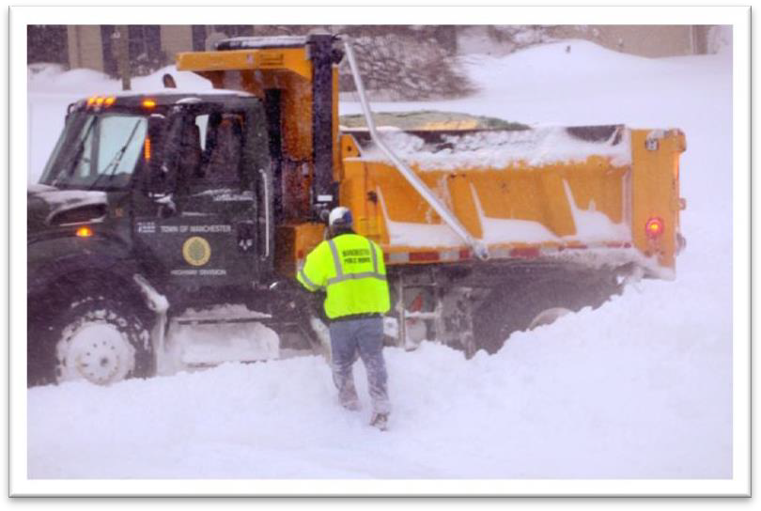
Photo Courtesy Hartford Courant / Stephen Dunn

TABLE OF CONTENTS

Page #
Winter Parking Ban 4
Sidewalk Clearing 4
School Closings or Delayed Openings 4
Mailboxes 5
Fire Hydrants 5
Catch Basins & Storm Inlets 5
Anti-Icing 6
Reduction of Sand Use 7
Christmas Trees 7
Driveway Clearing Tips 8
Winter Driving Checklist & Tips 8
Winter Sand 8
Potholes 9
Portable Basketball Hoops 10
Street Sweeping 10
Alternative Home Heating Methods 10
Numbers to Call Regarding Snow Questions 11


Winter Parking Ban
Parked vehicles are one of the biggest obstacles to effective snow removal. Please support our efforts by parking your vehicle in conformance with the winter parking ban.
- Overnight parking is not allowed on public streets or municipal parking lots between the hours of 2:00 AM and 6:00 AM from December 1st to April 1st.
- The Chief of Police may also declare a parking ban if a significant snow event is forecast or in progress.
- Residents are asked to remove vehicles from the street when a snowstorm is occurring. It makes plowing safer and more efficient if plow drivers do not have to operate around parked vehicles.
For information on whether a parking ban has been declared, tune to Channel 16 – Silk City TV or check the Town website at www.manchesterct.gov

Sidewalk Clearing
Residents are reminded that by Town Ordinance it is the responsibility of owners and occupants of buildings and vacant lots to remove snow, sleet and ice from public sidewalks abutting their property within 24 hours after the storm has concluded. Failure to comply with this ordinance may result in a fine. If you have difficulty with properties that have unshoveled sidewalks, you can report these to the Public Works Department at 860-647-3067.

Please remember that the final snow plow pass is not made until after the storm has concluded. Your cooperation in clearing the sidewalks is an essential safety measure for school children and other pedestrians using the sidewalks.

School Closings or Delayed Openings
Information regarding school closings and delays is reported to the following sources:
Radio: WDRC-AM (1360), WDRC-FM (102.9), WTIC (1080 AM), WTIC-FM (96.5), WWYZ-
FM (92.5), WHCN-FM (105.9), WKSS (95.7)

Television: WFSB (Channel 3), WTNH (Channel 8), NBC30 (Channel 30), FOX61 (Channel 61) The CT Weather Center provides a free email notification service regarding Manchester school cancellations, delayed openings & early dismissals. To register for this free service go to www.ctweather.com and click on e-notifications.

 Mailboxes

In the event that a mailbox or post is damaged by direct impact from a snow plow, the Town will reimburse the owner up to a maximum of $225.00 per occurrence. The cost of labor is not reimbursable.
When a mailbox is damaged, a Mailbox Damage Claim Form must be submitted to the Town Attorney’s office within thirty (30) calendar days of the occurrence.
To read the full Policy or to file a Mailbox Damage Claim click here.

Fire Hydrants
Owners of property and occupants of buildings that have a fire hydrant are required by Town Ordinance to clear a four-foot area in all directions around the hydrant and a three-foot wide path from the street to the fire hydrant. Failure to comply with this ordinance may result in a fine. The Fire Department counts on hydrants being cleared of snow to help protect your safety. If you have any questions, please contact the Town Fire-Rescue-EMS Department at 647-3266.

Catch Basins & Storm Inlets
Help minimize street flooding by shoveling snow and ice from in front of the storm inlet nearest your house. This includes keeping catch basin grates free of leaves and other debris all year long!

Anti-Icing
One of the relatively new weapons being used in the snow and ice control field involves the treatment of roads with anti-icing products in advance of snow storms. The Public Works Department will continue to implement some of these measures this year.

Anti-icing refers to a collection of strategies and techniques used to prevent snow from bonding to the road surface. Salt and salt treated with magnesium chloride is applied to the road surface in advance of the storm. The salt lowers the freezing temperature of water and prevents ice from bonding to the road. De-icing, in contrast, refers to snow and ice removal after bonding has occurred.

Anti-icing creates a brine on the road surface that acts as a barrier between falling snow and the pavement. Snow may accumulate on the road surface, but because of the brine barrier, the snow won’t bond to it.

The key to anti-icing is the timely application of salt. Timing is everything: if the salt is applied to the road too soon, the resulting brine may freeze as the falling snow dilutes it. If it is applied too late after the storm begins, snow will have already bonded to the road surface.

Treated salt will form a brine faster than standard rock salt. It also bounces less against the pavement than standard rock salt, so more material stays on the roadway and less in the gutter. Snowplow crews can more easily keep the road clear because they are working with snow that has not bonded to the pavement.
Anti-icing has many advantages:

- Town crews can respond to storms pro-actively by beginning treatment in advance of the storm
- Anti-icing enables a quicker return to improved road conditions resulting in fewer accidents and delays
- Treated salt doesn’t bounce off the roadway so material is more effectively used
- If the storm is delayed, some residual salt remains on the road ready to begin work when precipitation begins
- Crews can efficiently cover more territory because a truckload of salt will last longer than a traditional truckload of sand-salt mix

Reduction of Sand Use
The town no longer uses sand during the majority of its snow removal operations. Salt melts snow and ice. Sand does not.
Sand can increase friction, thereby providing better traction and control of vehicles. However, for sand to actually improve traction, it must remain between the tire and the ice. It does no good when it is buried in snow. Vehicle traffic will work sand into fresh snow and render it useless to improve traction. Research on friction on pavements treated with sand shows that there is little benefit when traffic is present.

Benefits of Reducing Sand Use
- Elimination of sand from entering our streams and waterways
- Reduction in Spring clean-up time both for property owners and the Town
- Reduction in air pollution from blowing sand particulates
- Buildings and homes are cleaner because less sand and mud is tracked in from streets and municipal parking lots
When is the most effective time to use sand? During very low temperatures (below 5°F) where salt is ineffective or during freezing rain conditions. The Town will continue to have sand available for use when conditions specifically warrant its use.

Christmas Trees
The Town provides residents with curbside pick-up of Christmas trees through the end of the second week of January. Trees are recycled into wood chips. Pick-up is done on your regular trash collection day. Please DO NOT bring your trees to any former drop-off sites.


Driveway Clearing Tips
The following suggestions are intended to make your driveway snow removal easier and safer:
- If possible, wait until the road has been completely plowed to the curb before shoveling the last 5-10 feet of your driveway. This way less snow from the road will end up in your driveway. It takes 3-5 hours after a typical storm has ended for the Town to completely clear snow from the road to the curb.
- It is best to place snow on the far side of your driveway, away from the direction the plow is traveling. In most cases, this means placing the snow on the right side of your driveway as you face the road. This way the plow will carry the snow away from your driveway, rather than back into it.
- Do NOT shovel, blow, or plow snow from your driveway into or across the road. It is a violation of Town Ordinances to push snow into the street, and you may be held liable if this snow causes an accident. Remember, you are also responsible for the actions of your contractor!
- Do NOT allow children to play on snow banks along the side of the road. The Town may need to push back snow banks days after a storm to create room for the next snow event.

Winter Driving Checklist & Tips
- Keep good, all-season tires on your car.
- Keep a shovel and some sand in your trunk.
- Clean your vehicle of all snow and ice, including the roof.
- Allow extra time to reach your destination. During storms, travel only when absolutely necessary.
- Keep a safe distance from plow trucks and other vehicles.

Winter Sand
Winter sand is available for residents at the parking lot of the Fleet garage at 263 Olcott Street. There is a limit of three 5-gallon buckets per vehicle. Sand is for residential use only.

Potholes
Potholes are formed when water seeps into cracks in the pavement surface and the continual freeze-thaw cycle in the early spring moves the surface of the pavement. This movement weakens the pavement. Traffic loosens the pavement even more, and it eventually crumbles and pops out. The pounding of tires wears a hole in the underlying gravel, and a pothole is formed.

During the weeks leading up to the winter season, Town crews make pavement repairs to help minimize the formation of potholes during the winter. The patching of potholes continues throughout the winter. During cold weather, temporary repairs are made with cold patch asphalt because the weather is too cold to use hot asphalt. During warmer temperatures, hot asphalt is used for more permanent repairs.

Unfortunately, during periods where the weather fluctuates from freezing to warm temperatures, the formation of potholes is unavoidable. Spring temperatures warm the cold pavement, melting and evaporating any frozen water. This creates air pockets that can eventually cause the pavement to break up. A winter of heavy snow or rain and several freeze-thaw cycles can mean a big pothole season ahead.

If you see a pothole that needs repair, please call the Highway Department at 647-3233 or the Customer Service Center at 647-5235.
To help expedite our response, please provide us with some specific information:
- The exact location
- Size (approximate length/width/depth)
- Is the hole on the sidewalk or roadway (driving lane or parking lane)?
- Is there a barricade or orange cone over this hole?

The more information we have, the better we can serve you.
Potholes on most heavily traveled roads are usually repaired within 48 hours of notification. Maintenance crews are constantly on the lookout for potholes, but we welcome citizen calls about potholes as well. The sooner the pothole is reported, the more quickly Public Works can remove that road hazard.

Portable Basketball Hoops
Residents are reminded that portable basketball hoops should NOT be in the Town Right-of- Way. (This is like encouraging your children to play in traffic.) The Town is not responsible for damage done by plows to basketball hoops left in the Town Right-of-Way. You could be fined and may also be liable for damage done to vehicles and/or personal injury claims from placement of hoops on Town property.

Street Sweeping
The Public Works Department generally begins the Street Sweeping program around the last week of March, weather permitting. Residents can assist us in the following ways:

- Limit parking on the street until your street has been swept.
- Keep leaves, branches, rocks, and other debris out of the street. This may cause damage to the sweeper and delay the program.
- Do NOT sweep sand or other debris into catch basins and storm inlets.

Alternative Home Heating Methods
As traditional energy costs continue to rise, citizens are looking for alternative methods to heat their homes for the upcoming winter. Many are turning to space heaters, fireplaces and wood and coal burning stoves for warmth. Citizens should be aware that
while these heat sources can be effective alternatives, they could pose serious home safety dangers.
The Fire Department stresses the importance of having smoke and carbon monoxide detectors in the home and maintaining them. Replace batteries in detectors and assure they are operating.
Detectors do save lives. Statistics dramatically validate this.

Before using alternative heating sources, call the Town Fire Marshal at 647-3267. The Fire Marshal’s Office can help identify potential hazards and offer suggestions for safe use.



Numbers to Call Regarding Snow Questions
- Field Services Division
M-F, 7:00 AM to 3:30 PM 647-3233
- Customer Service Center
M-F, 8:30AM to 5:00 PM 647-5235

- After Hours – During Snow Storms Only ...647-3245

- For snow deposits on the street causing a hazard Police Department 645-5500
- Difficulties with properties that have
unshoveled sidewalks 647-3067

Other Useful Phone Numbers
- For alternative home heating methods information Town Fire Marshal 647-3267
Town Building Department 647-3052

