PRESS RELEASE
José Cuadrado appointed Global CEO of Yanmar Compact Equipment
Cuadrado will lead the continuing transformation of Yanmar Compact Equipment into a global market leader.
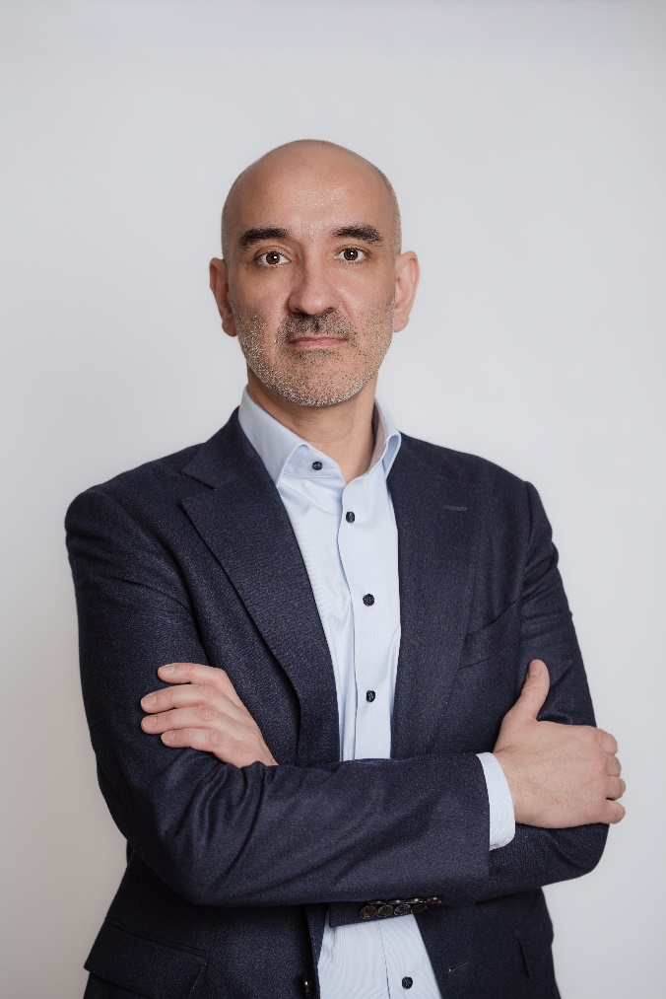
Effective 1st April 2024, José Cuadrado has been appointed Global Chief Executive Officer at Yanmar Compact Equipment (Yanmar CE), and Chairman of the Board at Yanmar Holdings Co., Ltd. Cuadrado replaces Giuliano Parodi who, for the last six years, has successfully led the transformation of Yanmar CE into a global leader – and who is now transferring to manage the Yanmar Group’s Strategy Division, as Chief Strategy Officer.
In a career spanning more than 25 years, Cuadrado brings with him a wealth of relevant construction, industrial and automotive experience, working at leading brands that include Ingersol Rand, Doosan and CNH Industrial. He joined Yanmar CE in early 2023, where he is managing director of the company’s Europe, Middle East and Africa region; markets that equate to a third of the company’s global sales. A search has begun for his replacement, and Cuadrado will combine both Global CEO and EMEA roles until his successor is appointed, from his current base in Europe.
Objective: Become best-in-class
In his new role Cuadrado is responsible for leading increased organizational integration and improving financial performance, as well as driving customer success through best-in-class product development. He will play an important role in continuing the work of establishing Yanmar CE as a global leader in the compact equipment industry.
Commenting on his appointment Cuadrado said: “I fully support our current strategy to become a leader in the compact equipment industry. To achieve this, we will continue our journey to become a truly global company, focusing on extending our product portfolio and strengthening our dealer network across all major markets. Equally important, we have very ambitious and exciting plans to embrace upcoming technologies. I’m very pleased to be given this opportunity to continue the good work that has happened under Giuliano’s leadership.”
“José is an experienced and dynamic leader and, having helped shape the strategy as part of the global leadership team since joining the company, is fully aligned to our goals and aspirations,” said Giuliano Parodi, newly appointed Chief Strategy Officer (CSO) at Yanmar. “We are confident that he will continue to drive Yanmar CE towards meeting its objective of becoming a customer-centric, innovative, global leader in compact equipment. We offer José our full support in his new role.”
A Spanish national, Cuadrado holds a master’s degree in business & economics from University of Valladolid (Spain).
Ends.
19th March 2024
Valeria Iervolino Brian O’Sullivan
Global Marketing & Communications PR support
Yanmar Compact Equipment Daredevil
valeria_iervolino@yanmar.com brian.osullivan@daredevilpr.com
+39 380 58 20 485 +44 77 333 50307

About Yanmar Compact Equipment

Today Yanmar is a leading global player in the industrial machinery industry. In the construction equipment sector, Yanmar was first to market with the launch of the first mini excavator in 1968 and its invention of the revolutionary zero-tail excavator in 1993.

Yanmar’s Compact Equipment Business has four plants, in Japan, France, Germany and the U.S., to deliver a range of products and services to the global market.
For more details, please visit the official website.

https://www.yanmar.com/global/construction/

About Yanmar

With beginnings in Osaka, Japan in 1912, Yanmar was the first ever to succeed in making a compact diesel engine of a practical size in 1933. Moving on, with industrial diesel engines as the cornerstone of the enterprise, Yanmar has continued to expand its product range, services, and expertise to deliver total solutions as an industrial equipment manufacturer. As a provider of small and large engines, agricultural machinery and facilities, construction equipment, energy systems, marine, machine tools, and components — Yanmar’s global business operations span seven domains.

On land, at sea, and in the city, Yanmar’s Mission of “providing sustainable solutions focused on the challenges customers face, in food production and harnessing power, thereby enriching people’s lives for all our tomorrows,” stands testament to Yanmar’s determination to provide us with “A Sustainable Future”.

For more details, please check out the official website of Yanmar Holding

