Master Naturalist -Registration is open now
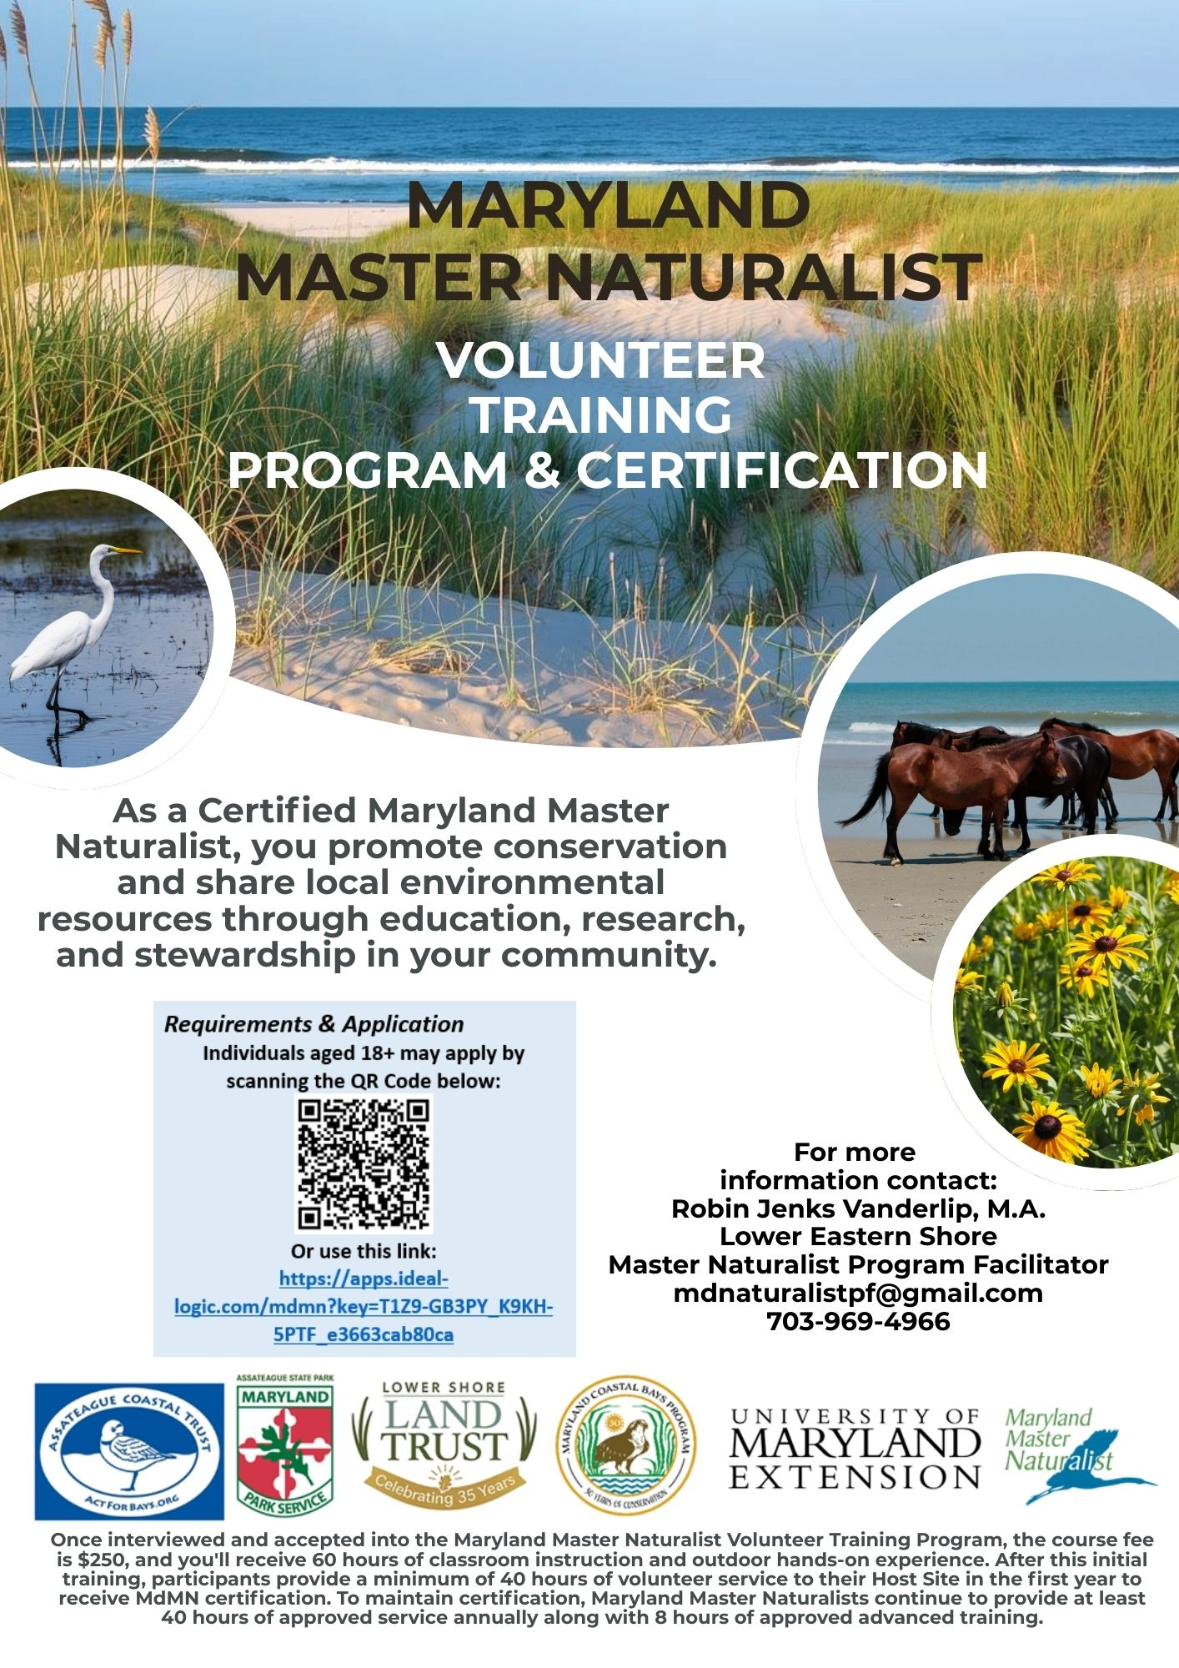

Maryland Naturalist Volunteer Training
Program& Certification on the Lower Eastern Shore

Have you ever had an interest in learning about nature and our natural world? Maryland Master Naturalist (MdMN) participants will obtain the skills of a naturalist, learn the importance of the environment and being better stewards of our planet, and learn how they can share information with the public. With so many topics of nature to learn about, this program will target the Lower Eastern Shore area of Maryland. Assateague Coastal Trust, Assateague State Park, Lower Shore Land Trust, and Maryland Coastal Bays Program are proud to make up the Lower Eastern Shore Consortium for this MdMN Training. As a Certified Maryland Master Naturalist, you will help foster the need to preserve, conserve and share our local, city, state and regional wealth of natural and environmental resources with others in the community. You will participate in and serve as a catalyst for local environmental conservation through education, research, and stewardship.

The Maryland Master Naturalist Program’s mission is to “engage individuals as stewards of Maryland’s natural resources and ecosystems through science-based education and volunteer service in their communities." The MdMN Volunteer Training Program is a science-based format with participants learning from some of the leading experts in their fields. Topics include Ecosystems, Chesapeake Bay Watershed, Botany & Plant ID, Entomology, Ornithology, Geology & Soils, Ecological Principles, MD Natural History, Reptiles & Amphibians, Sustainable Living, Taxonomy, Weather & Climate, Fossils, and much more. Environmental Justice in an urban environment will be a key component of this training as well.

Lessons extend beyond classroom lecture to sites throughout the Lower Eastern Shore where participants can immerse themselves in hands-on experiences that supplement the lesson materials. Field work and field trips round out the training. The course fee of $250 (assistance may be available) includes at least 52 hours of instruction and a minimum of 8 hours on field trips.

Schedule & Location
Dates: July 23, 2026 – March 18, 2027
Days: 3rd or 4th Thursday of the Month
Times: 9:00 am – 4:00 pm
(may be slight variations in days/times for speaker schedules/field trips)
Primary classroom facility:
Paul S. Sarbanes Coastal Ecology Center
11802 Marsh View Lane
Berlin, MD 21811
https://wwwcp.umes.edu/psscec/directions/

Robin Jenks Vanderlip, M.A.
Master Naturalist Program Facilitator
Certified Master Naturalist
mdnaturalistpf@gmail.com
703-969-4966
**Apologies please for "AI" changes**

