|  |
| --- |
| Action Items Coming Out of the February Steering Committee Meeting:   * **Committees** will come up with a list of accomplishments or metrics to track for their group and plan to have a better idea of what those metrics might look like at the next steering committee meeting * **Sophia, Dan, and Kate** will make a spreadsheet for committees to record this information * **Sophia** will forward the network information on Chesapeake WILD funding – ideally march newsletter * **Sophia** will update the network about the official results of the logo vote * **Darlene, Jessica, Dan, Kate, and Sophia** will get together to discuss creating an open forum for DAAP and DRCN members this Spring (purpose: allow people to share projects and talking about topics of interest) * **The Working Lands, Land Protection, and Restoration & Resilience Committees** hope to organize a cross-committee meeting to discuss their overlap sometime in the next few months * **Sophia** will reach out to Jackie Spect of TNC to get their updated report including the redone slam model using the updated UVVR data * **Sophia:** Contact Steve Strano about NRCS April meeting and whether he wants any info about this sent out to the network via the newsletter |

**Meeting Notes**

*\*Notes with time stamps are messages from the chat*

*Agenda Items*

*Action items highlighted in blue*

*Dates*

* **Welcome message *(Dan or Kate)* and coordinator Introduction (10:00-10:05)**
* **Discussion: accomplishment tracking *Kate* (10:05-10:20)**
  + **Kate Patton**: As we look ahead, how are we going to tell the story of what we have accomplished? How far back do we want to track? And how can we align this with our strategic plan?
  + **[10:13 AM] Erik Meyers:** I would be arbitrary and pick the date that we formally launched the DRCN
    - For other metrics like land protection, I would suggest we do cumulative tracking for all members, with the idea that our partnership allows us to fill these gaps and accomplish things
    - It would benefit us because the concept of DRCN is very people-centric, we could also look at economic metrics during the time we have existed as a group
      * Ex: the ag and forestry economy
  + **[10:13 AM] McNally, Erin**
    - Could the subcommittees establish metrics relevant to their groups then the steering committee establish overarching metrics or ones that cover several groups?
  + **Dave Curson**: There are a few hazards to that economic approach, because we need to be sure to find economic metrics that truly reflect or work
    - For example, forestry may or may not be sustainable
    - We need to be careful not to endorse and appear to be taking credit for economic activities that we may not support
  + **Steve Strano:**
    - Economic metrics from this group could be hazardous
    - It’s not our expertise
  + **Dave Satterfield:**
    - Land protected and living shorelines metrics are options for accomplishments, which benefit the community, but also directly relate to our mission
  + **Jared Parks:** Could we used the in-plan *(spelling?)* economic tool? To specifically track money going into restoration efforts
    - It’s a very accepted tool
  + **Kate:** Could we demo that tool at a future meeting or the annual meeting?
  + use of information in the annual report
  + **Dan**: Fish and Wildlife uses that tool as well
  + **Jared Parks:**
    - These tools also help us justify why we’re working where we are, and how we are
    - We could use it to communicate WHY we’re working places, as opposed to taking credit for those metrics
    - Would be a useful addition to our reports and other methods of communication with the public
  + **Steve Kline**: An update…the earmark did come through for half a million dollars. We’re going to have a cooperative agreement with the Fish and Wildlife Service to set some goals together
    - One of which is hiring a firm, such as Green Fin to help with communications
    - We could communicate about our progress in terms of “the value of conservation on Delmarva means this….” For example, “When we protect a thousand acres on Delmarva…” it means “________”
    - We could be in contact with folks who can quantify these things and help us with communicating in this way, for example: Mark Duda or Rob Southwick
  + **Steve Strano**: I could be in support of economic metrics as they directly relate to our work on Delmarva, especially if we are utilizing a widely accepted tool
  + **Kate:** Committees could come up with a list of accomplishments or metrics to track for their group
    - We could try to have a better idea of what those metrics might look like at the next steering committee meeting?
    - Could also reach out to our forestry, ag, and recreation partners to real get their input on what metrics they think might be most effective/accurate
    - Dan, Kate, and Sophia will get together spreadsheet for gathering this information
  + **Erik Meyers**: we ought to include narrative not just numbers
* **RAE updates - coastal focus groups *Sophia* (10:20-10:25)**
  + **Sophia Seufert**: Last meeting, we mentioned that RAE is conducting a project where they are piloting community focus groups in coastal communities and that there might be funding available
    - Genevieve and I along with another FWS staffer Faren Wolter recently met with staff from the RAE team and learned more about the project
    - Place (3 locations)
      * gulf coast
      * Mid-Atlantic
      * long island sound
    - Timeline
      * This year they are implementing the interviews in the gulf coast region
      * And will be conducting interviews in the other 2 regions to get further background
      * Right now it looks like the focus groups IN OUR REGION would happen in the spring of next calendar year and preparatory work would start this fall
    - Since our last meeting there have been discussions with various partners to determine what projects/areas might be the best fit and it has been decided that the focus groups will best pair with the saltmarsh project that the restoration and resilience group is working on
      * adding a community engagement component to this work
      * Focus groups in communities in dorchester or somerset county
    - Genevieve wants to thank everyone for their time and input. We will provide further details as the project unfolds
* New funding (10:25-10:40) **- Kate**
  + **Kate Patton:** The Lower Shore Land Trust was awarded $38,382 from National Fish and Wild Foundation to provide the DRCN with support for the administrative and facilitation necessary to achieve success in implementing the Strategic Action Plan.
    - Funding from the first round of the new grant program, Chesapeake WILD
    - Outcomes of the project include facilitating the annual meeting of the network and creation of a DRCN annual report (which we hope will help increase visibility of the DRCN to decision makers at the state and federal level)
  + **Dan Murphy**: This WILD grant and the earmark are huge steps in having more consistent coordination of the network. We’ve also submitted an INSR grant.
* Present logo for consideration *Sophia* (10:40-10:50)
  + In chat: Suggestion of a black and white print version of the logo
  + Option 4 was chosen through the vote. No major concerns were voiced.
  + Option 4 logo:

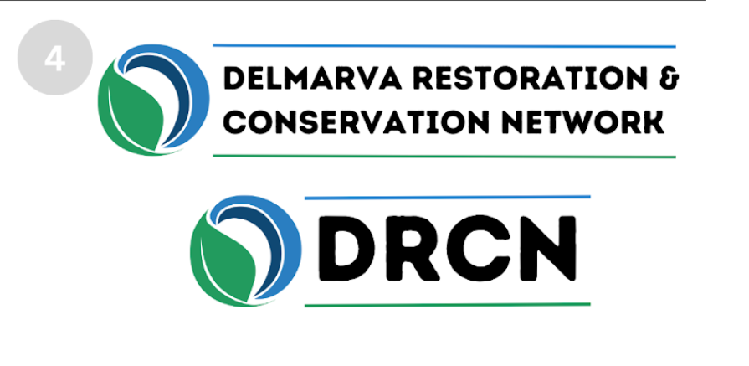

* + There were no votes for option 5 “I do not feel comfortable with any of the logo options presented”
  + <https://forms.gle/aWa1KapCLBDo59tq5>
* Chesapeake WILD updates *Dan?* (10:50-11:00)
  + Mike Slattery: The Chesapeake WILD RFP came out
    - Appropriations were doubled this year
    - One of the main differences between Chesapeake WILD and Small Watershed Grants is that they don’t have a strong water quality focus, and this year they can be used for recreational access
    - If you see that you’re eligible for both consider SWG because they have a larger pool of funding available this year
    - This year we will be having proposal labs and will forward information on these
  + **David _____?:** if we got another grant last year and we haven’t gotten the money yet, does that mean we’re not eligible to apply again?
  + **Mike Slattery**: No, we’re working through that, and you should still be available to apply. But, it will important to detail that it not that the money hasn’t been spent, it’s that you haven’t received it
  + **[10:51 AM] Steve Farr**
    - We in the Coastal Bays wish NFWF would offer more non-Chesapeake centric grant opportunities in the region.
* Presentations: (11:00-11:30)
  + Darlene Finch and Jessica Mcintosh of NOAA will give us a short presentation on the results of the October 2022 DRCN and Delmarva Alliance of Adaptation Practitioners Collaboration Survey
  + **Darlene** (Mid-Atlantic Coastal Lead):
    - Last summer we pulled together the group of “Delmarva alliance of conservation practitioners” because we wanted to know about the unique challenges of climate adaptation in the region
    - The challenge: How can we build off existing expertise and funding opportunities to advance climate adaptation in Delmarva?
    - Why collaboration: helps people learn about each other’s efforts, flag common challenges, take advantage of the existing expertise and knowledge, and utilize the survey to identify some collaborative actions moving forward.
    - Strong themes observed:
      * A want for more peer-to-peer sharing opportunities (especially in the climate adaptation side)
      * Wanting to share information about needs and funding for projects in the region
    - What types of projects did responders want to discuss with others:
      * Nature-based solutions
      * Marsh Migration
      * General habitat restoration
      * Community engagement to advance diversity, equity, inclusion, and justice
    - Follow-up conversations:
      * Talked to members of both DRCN and DAP
      * All three states
      * Non-profit, state, and federal
    - Slido Poll (conducted live):

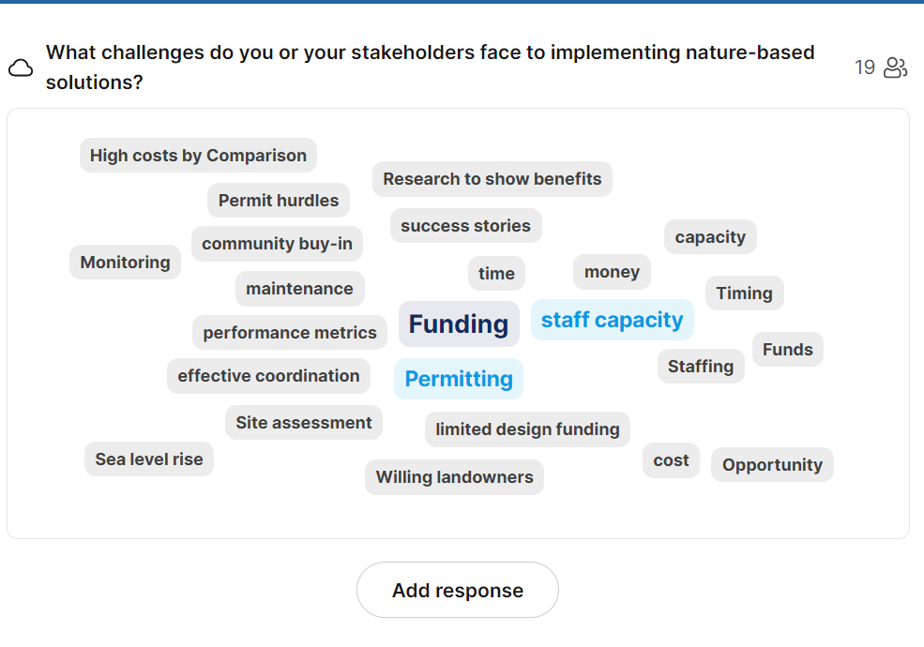

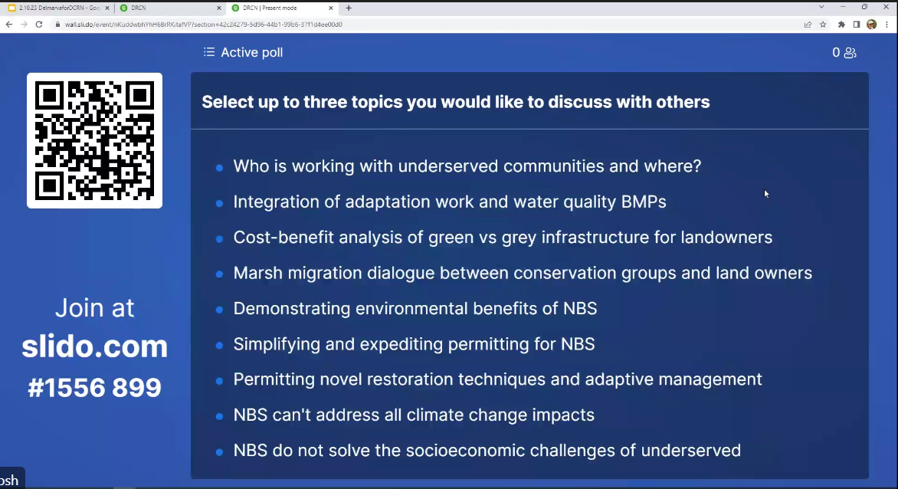

* + **[11:05 AM] Lisa -** **Nanticoke Wateshed Alliance (Guest)**
    - * there is plenty of funding but it is hard to link up multiple sources in the needed timeline while keeping landowner interest
  + **[11:09 AM] Steve Kline**
    - The Cost Benefit analysis doesn't exactly fit the bill for me. We need to be able to clearly express the long-term success of nature based solutions over traditional solutions. Including their cost-effectiveness over time.

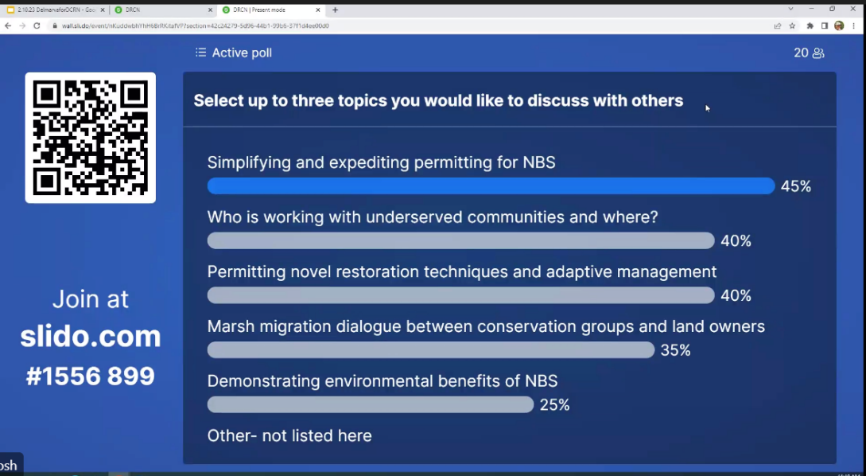

* + **[11:09 AM] Jen Merritt (Guest)**
    - Other - How can local governments (like Crisfield) work with DRCN partners to implement NBS?
  + **[11:10 AM] Murphy, Dan R**
    - Coordinating Landscape Scale Planning and Implementation
  + **[11:11 AM] Brenda Davis**
    - Agree with Steve. Finding funding for Coastal Bays work is a challenge
  + **[11:12 AM] Erik Meyers**
    - Agree with Dan's comment. Working across ownership types - public to private - is a challenge to the landscape level of change that is happening and the solutions that would make most sense
  + **[11:13 AM] Erik Meyers**
    - Planned DRCN annual meeting would make sense and connecting with current Audubon and TNC planning efforts
  + **[11:13 AM] Strano, Steve - NRCS, Annapolis, MD**
    - Something as a combination of an expert presentation followed by group discussion. Expert can be whoever has experience with the issue within the group.

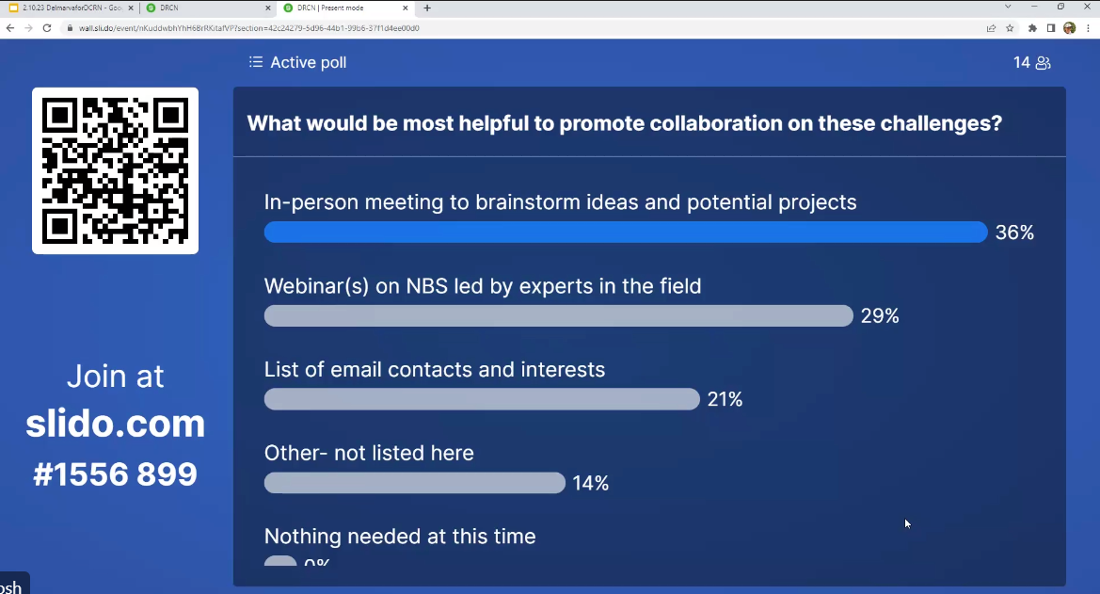

* + **Darlene:** I suggest creating an open forum to allow people to share projects and talking about topics of interest (Spring)
    - * For both DAAP and DRCN members (whoever is interested)
      * We hope to be able to have DRCN provide more support to the project (especially now that Sophia’s here)
      * And then we can start to work on action items that come up
  + **Jessica:** Let’s get together offline and talk about how to move forward given this new information
  + **Dan Murphy:** We should be sure to keep the collaboration going between the two networks.
* Operating Committee Report-outs (11:30-12:00)
  + **Land Protection – David Satterfield, ESLC**
    - Haven’t met in a while, because we have been having issues keeping momentum since Alex left
    - Will try to meet soon and talk about applications for WILD or a NAWCA grant project ideas
    - But we hope to meet by the end of Feb/early March
  + **Town/Urban - Owen Bailey, ESLC**
    - Dave Satterfield on behalf of Owen: The committee last met on Jan 10 via zoom and elected Jen Merritt as co-chair
    - The committee suggested inviting more local/county officials to join
    - Next meeting: April 27, 10 am (in person)
  + Agriculture and Forestry (Working Lands) – Jared Parks, LSLT
    - The committee last met in the fall
    - Next meeting is set for February 22 at 1 (see February newsletter for details)
    - Will host Bob Long to talk about forestry practices
    - Will talk about successful an unsuccess grant applications to share experiences
    - We hope to do a cross-committee meeting with Restoration and Resilience committee to talk about our overlap in the next few months
      * Would also like to invite some of the land protection group
    - **David Satterfield**: would like to attend
    - **Erik Meyers**: Also want to talk about management of invasives, ghost forest, and management of salt damaged tree edge
  + **Restoration and Resilience – Dave Curson, Audubon Mid-Atlantic/Erik Meyers, TCF** 
    - **Erik Meyers**: One great effort underway is the MD saltmarsh planning effort, which we are doing in parallel with TNC’s coastal resilience framework plan
      * Last meeting, we had some interesting dialogue with NOAA and Sean Corson about low marsh/shallow water habitat for fish
      * How can we maximize the conservation utility of both of those resources as their proportions change?
    - **Dave Curson**: The low marsh that the high marsh will transition into, they don’t know how valuable that is for fish habitat – which is something they hope to study
      * We may become a sub-group to continue that discussion
      * New name: Marshes for tomorrow
      * TNC: redid the slam model using the updated UVVR data
      * We will make that report available to all DRCN members
      * Sophia will reach out to Jackie Specht and request the updated TNC slam model report (check with Dan about phrasing of this message)
    - **Dave Curson:** Marshes of tomorrow updates:
      * Target of 25000 acres
      * 4 focal areas (need to identify conceptual strategies for each area)
        + Fishing bay
        + Black water
        + Pocomoke sound
        + The Coastal Bays
      * Want to utilize funding to implement a meaningful community engagement aspect
      * Will bring in marsh geomorphologists, because we really want to understand how water behaves on marsh surfaces and catch marsh deterioration early
      * Have spoken with TNC to be intentional about coordinating and hope to collaborate with TNC on a collaborative project in Somerset or Dorchester County
      * Dave is hiring a coastal program manager to help on this
    - **Eric Meyers**: TCF has procured some funding to continue work at Black Water National Wildlife Committee
      * Examining initial Blackwater 2100 strategies for high marsh resilience and targeted conservation of high marsh birds
      * Examining whether these techniques stood the test of time
* **Dan Murphy**: Any last discussion topics before we wrap up the meeting?
  + Marcia Pradines:
    - As a future discussion topic, it might be good for the larger group to talk the implications for getting landowners to accept coastal resilience easements on private lands
  + **Dan Murphy**: Could rural legacy be a solution? As an alternative to the CRE
  + **Kate Patton:** Jared’s been very active in the Nature Conservancy’s work on this, and while a lot of the economic value may be lost, there’s still recreational value and this can help transition them to a different activity on these lands
  + **Erik Meyers**: There definitely are opportunities there, but the value and use is a really big change
  + **Jared Parks**: The easement payment is based on the entire area of the parcel (pre-sea level rise) so that’s an incentive for people to do it now
    - * We want to be able to use this as a management tool, not a restriction tool
      * The CRE gives them an incentive to begin a managed retreat from their current activity on that parcel of land.
  + **Beth Carter**: Yes, that’s something we are exploring, and we have Throwe environmental leading the incentivizing action plan. So, we will have to see what recommendation comes out from that plan
    - **More info on Throwe’s work**: [Resilient Protection Frameworks: Maryland’s Eastern Shore](https://throwe-environmental.com/rpf)
    - But I think that it’s important to recognize that a lot of these lands are generational lands, so it’s not just about the money but the general grief
  + **Steve Kline:** ESLC is looking for a communications manager
  + **Steve Strano:** NRCS is trying to hold more state technical meetings to get stakeholder feedback on our programs
    - We are organizing a meeting April 13 meeting (9-2:30), focused on climate adaptation
    - Want stake holders to present and say what they’re working on that might overlap with NRCS work
    - May be interested in having the network share information on this, but will need to talk to his public affairs person about it
    - Not an “open” meeting, but maybe people could contact him if they are interested in providing a representative

*Break for day (12:00 pm)*