Music in Corrales Presents
Baracutanga

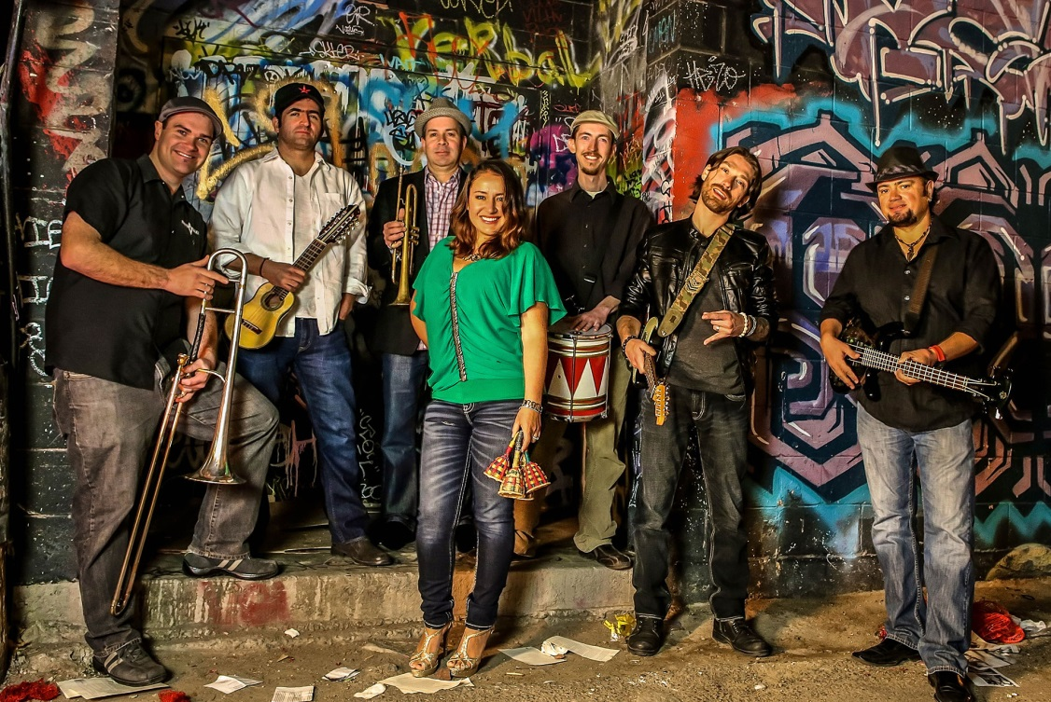

Baracutanga is a seven-piece band representing four different countries (Bolivia, Ecuador, Peru, and the USA) that prides itself on arranging traditional South American rhythms in new and interesting ways. This kind of experimentation, blending ancestral traditions with a modern sensibility, yields an exciting and distinct Latin flavor all its own. Lyrically and musically, Baracutanga builds bridges between the south and the north.

Date: Saturday, November 17 at 7:30 PM

Location: Historic Old San Ysidro Church, 966 Old Church Road, Corrales
Tickets: $25 in advance (plus applicable fees), $30 at door, if available
Tickets at: http://baracutanga.brownpapertickets.com
Frame-n-Art in Corrales (898-0660), and at the door, if available

Information: www.musicincorrales.org and https://baracutanga.org/

