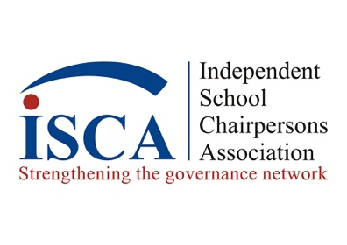

Subject: Share Your Voice for Our 50th Anniversary Celebration!
We’re excited to celebrate 50 years of leadership and community at ISCA! As part of this milestone, we’re creating a special video featuring insights from independent school board chairs like you—and we’d love for you to be part of it. So get your phone cameras ready and share your message!

How to Participate
1. Choose Your Prompt
Select 1–2 prompts from each of the 2 lists below that resonate most with your experience:
List 1 –
- Describe how ISCA has benefitted you as Board Chair?
- How has being a part of ISCA strengthened your school?
- Share why you think other board chairs should join ISCA
- What is the one thing you value the most about ISCA?
List 2 –
- How does strong board leadership shape the success of a school
- Share one piece of advice for a new board chair
- Share the best advice you have received as a board chair
- What is the most impactful decision your board has faced?
- Why did you choose to take on the chair role? What has been the best part?
- What is the most challenging part of being a board chair and what strategies do you use to address them?
- What new ideas will help define the future of board leadership?
- Who or what has inspired you most as a board chair?

2. Prepare Your Response
• Keep each answer 30–60 seconds.
• Speak naturally—your authentic voice matters.
• Include specific examples or stories if possible.

3. Record Your Video
- Phone cameras can be used for video recording or Zoom.
- Lighting: Face a window or use soft lighting.
- Background: Quiet, uncluttered space (school or office works well).
- Orientation: Record in horizontal (landscape) mode.
- Start by stating your name, your title (Current board share, former board chair, chair elect), name of school and where school is located.
- Please check your video before submitting.

4. Submit Your Video
• Save and upload your video via SHAREFILE by January 15th.
https://khlawfirm.sharefile.com/i/ia384fcfd8b946e58

Tips for Success
• Keep it short and impactful.
• Avoid jargon—speak in plain language.
• Smile and let your passion for governance shine!
Thank you for helping us honor this incredible milestone. Your voice will inspire the next generation of leaders.

Questions? Contact us at bethany@iscachairs.org; lawrence@khlawfirm.com

Warm regards,
Allegra Lawrence-Hardy
Chair, ISCA 50th Anniversary Committee
ISCA Board of Directors
* By submitting your video, you are giving permission to ISCA to use your video for promotional purposes.

