Sample Investment Policy Statement Templates
This document contains two templates for the Board of Trustees or Investment Committee of an endowed nonprofit organization to use in crafting an investment policy statement.
The Risk-based Investment Policy Statement is designed for organizations with access to financial simulation and modeling tools (sometimes called Monte Carlo models) that can be used to estimate ranges of future returns for given portfolio choices and create “stress-testing” scenarios to examine the performance of portfolios in illiquid or non-normal market environments. This approach requires more intensive quantitative work on the part of the Board or Committee, usually in partnership with the organization’s investment advisor; the result is a more dynamic investment policy process that places risk and liquidity considerations on an equal footing with portfolio returns in making asset allocation and spending decisions.
The Traditional Investment Policy Statement is designed for organizations that do not have access to, or choose not to use, the financial simulation and modeling tools employed in the Risk-based Investment Policy Statement. It places asset allocation at the center of the investment policy, does not focus on multiple levels or types of risk parameters to the same degree as the Risk-based Statement, and does not require the same degree of dynamic involvement by the Board or Committee in the investment process.
Both templates comprise a main body, which forms the permanent text of the Statement; this is followed by an appendix containing the Operating Guidelines that set forth the working parameters to be used by the Board or Committee in managing the portfolio. This structure is intended to facilitate the Committee’s annual review of the Statement, and to make the process of revision relatively simple and clear.
Both statements also incorporate references to the investment, fiduciary and spending standards of the Uniform Prudent Management of Institutional Funds Act (UPMIFA), which is the law in virtually all states of the United States. It is recommended that an institution consult its counsel to confirm that the Investment Policy Statement conforms to the version of UPMIFA adopted in its state.

Template I:
Risk-based Investment Policy Statement

[NAME OF INSTITUTION]
Statement of Investment Policy

Adopted: [Date]

Table of Contents

Page
Statement of Purpose 2
General Principles 2
Roles and Responsibilities 2
Policy Review 3
Goals and Objectives 3
Objectives of the Fund 3
Investment Philosophy 3
Modeling Assumptions and Process 3

Investment Policies and Procedures 3
Operating Guidelines 3
Risk and Liquidity 4
Investment Policy 4
Asset Allocation, Investment Strategies, Guidelines and Restrictions 6

Spending 7
Appendix A: Operating Guidelines 8
Investment Policy Metrics 8
Hypothetical Target Asset Allocation 9
Investment Strategies, Guidelines and Restrictions 10

Statement of Purpose
The purpose of this Investment Policy Statement (together with its Appendix, the “Statement”) is to set forth the policies and procedures that shall guide the Board of Trustees (the “Board of Trustees” or the “Board”) of [name of institution] (“XYZ”) in supervising and monitoring the management of XYZ’s investable assets (the “Fund”).
General Principles
The risk parameters and related return objectives set forth in this Statement shall form the basis for the Fund’s investment strategy, as more fully described herein.
XYZ shall diversify the investments of the Fund unless the Board and, if applicable, the Investment Committee (the “Investment Committee” or the “Committee”), after appropriate deliberation, reasonably determine that because of special circumstances the purposes of the Fund are better served without diversification.
The Fund shall be managed in accordance with high standards of fiduciary duty and in compliance with applicable laws and regulations.
Standards for risk, return, asset allocation, diversification and liquidity shall be determined from a strategic perspective and measured over successive market cycles.
Roles and Responsibilities
If the Board of Trustees elects to oversee investment matters directly, it shall undertake the roles and responsibilities prescribed for the Investment Committee herein. Otherwise, the Investment Committee shall implement the management process and monitor the Fund in accordance with this Statement. The Chair of the Committee shall be a current member of XYZ’s Board of Trustees; other Committee members need not be Trustees.
The Investment Committee, acting pursuant to this Statement and to instructions from the Board of Trustees, shall have direct responsibility for the oversight and management of the Fund and for the establishment of investment policies and procedures.
The Investment Committee shall, as more fully described herein, manage the Fund via a set of risk and return parameters at the asset class level, combined with policy liquidity and asset allocation mixes for the portfolio.
In fulfilling its responsibilities under this Statement, the Investment Committee shall, among other activities, recommend to the Board of Trustees the hiring and dismissal of investment managers, fiscal agents and other advisors.
Reports on the Fund shall be provided quarterly to the Investment Committee. The [insert title of appropriate staff person] shall be responsible to the Investment Committee for maintaining detailed records of all invested funds and for carrying out the investment policies and procedures established by the Board of Trustees and the Investment Committee.
Policy Review
This Statement shall be reviewed annually by the Investment Committee and any recommendations for changes presented to the Board of Trustees.
Goals and Objectives
Objectives of the Fund
The Fund has a long-term investment horizon. The primary investment objectives of the Fund are to:
- Maintain the real purchasing power of the Fund after inflation, costs and spending (i.e., achieve “intergenerational equity”);
- Maximize the Fund’s risk-adjusted returns; and
- Provide a stable source of liquidity and financial support for the mission of XYZ.
Investment Philosophy
While acknowledging the importance of preserving capital, the Board of Trustees also recognizes the necessity of accepting risk if the Fund is to be able to meet its long-term investment goals. It is the view of the Board of Trustees that choices made with respect to asset allocation and liquidity risk will be the major determinants of investment performance. The Committee shall seek to ensure that the risks taken are appropriate and commensurate with the Fund’s goals.
Modeling Assumptions and Process
In setting risk and liquidity parameters for the management of the Fund, the Committee shall use appropriate financial simulation models to determine the Fund’s portfolio structure and calculate risk levels. In so doing, the Committee shall not assume that normal market environments will prevail, but shall instead engage in “stress testing” scenarios for the portfolio. These stress scenarios, including “left tail” or loss scenarios, shall form the basis for the risk and liquidity parameters that shall guide the management of the Fund.
Investment Policies and Procedures
Operating Guidelines
The Fund shall be managed in accordance with the Operating Guidelines for risk and liquidity described in this section, a template for which is set forth in Appendix A. Once the Operating Guidelines have been approved by the Board, the Investment Committee shall have the authority to manage the Fund within the Operating Guidelines without further authorization from the Board. The following policy descriptions refer to items in the corresponding sections in Appendix A.
Risk and Liquidity
Definition of Risk: Using appropriate financial simulation models, the Committee shall begin by specifying its goals for the following parameters over a 20-year period:
- Probability of achieving intergenerational equity (expressed as a percentage)
- Maximum cumulative drawdown for the Fund, from absolute market cycle peak to trough (expressed as a percentage of asset value)
- Conditional Value at Risk (CVaR) for the aggregate portfolio (expressed in basis points)
- Risk of not meeting payout requirements (expressed as the percentage of occasions when the amount spent declines from one period to the next)
Liquidity Policy: From the above inputs, the model will produce a target asset allocation for the Fund, which shall be designed to achieve the above objectives and entered in Appendix A.
- The Committee shall determine the liquidity mix of this target portfolio as of the present time, in normal market conditions, and in conditions representing market stress, giving due regard to the operating needs of the institution. These three liquidity mixes shall be depicted in, respectively, the “Current Portfolio”, “Normal Market” and “Stress Testing” subsections of the “Liquidity Policy” section in Appendix A.
- The overall liquidity constraints of the Fund for the target portfolio shall be closely derived from the “Stress Testing” subsection, and shall be entered in the “Liquidity Mix” section of Appendix A.
Current Risk Metrics: The Fund shall be managed on a risk-adjusted basis to maintain purchasing power after inflation, costs and spending, within the “Stress Testing” liquidity environment.
- On an ongoing basis, the aggregate portfolio shall be managed to the 12-month average CVaR for the Fund. The Committee shall also monitor trends and changes in this metric.
- When possible, the Committee shall monitor and compare the Fund’s performance relative to:
  - Absolute return objectives for the Fund
  - The respective benchmarks for each asset class or strategy in which the Fund is invested, as set forth in the asset allocation table in Appendix A
  - A representative group of peer institutions identified by the Committee
  - A representative group of peer investment managers
Investment Policy
Asset allocation. The Committee shall, consistent with the above sections, invest the Fund using an asset allocation that is designed to meet the Fund’s long-term goals. The allocation will be based on the objectives of the Fund as set forth above.
Illiquid investments. Because of their long-term nature, investments in and commitments to illiquid investment strategies, including but not limited to private capital, private equity real estate, natural resources, distressed debt and other similar private investments, shall be analyzed and discussed by the Committee separately.
Targets and ranges. The asset allocation shall be implemented using a policy portfolio, with target allocations and ranges for each investment strategy. Due to the need for diversification and the longer funding periods for certain investment strategies, the Committee recognizes that an extended period of time may be required to fully implement the asset allocation plan. It is expected that market value fluctuations will cause deviations from the target allocations to occur.
Rebalancing. The purpose of rebalancing is to maintain the Fund’s policy asset allocation within the targeted ranges, thereby ensuring that the Fund does not incur additional risks as a result of having deviated from the policy portfolio. Rebalancing will take place on a portfolio basis to reduce expenses as far as practicable. More frequent tactical rebalancing of asset classes within their ranges will also be permitted in order to take advantage of shorter-term market conditions, as long as such changes or reallocations do not, in the opinion of the Committee, cause undue risk or expense to the Fund.
Standard of conduct. In managing and investing the Fund, the Committee shall:
- act in good faith and with the care an ordinarily prudent person in a like position would exercise under similar circumstances;
- incur only costs that are appropriate and reasonable in relation to the assets, the purposes of XYZ and the skills available to XYZ;
- make a reasonable effort to verify facts relevant to the management and investment of the Fund;
- consider the following factors, if relevant:
- general economic conditions;
- the possible effect of inflation or deflation;
- the expected tax consequences, if any, of investment decisions or strategies;
- the role that each investment or course of action plays within the overall investment portfolio of the Fund;
- the expected total return from income and the appreciation of investments;
- other resources of XYZ;
- the needs of XYZ and the Fund to make distributions and to preserve capital; and
- an asset’s special relationship or special value, if any, to the charitable purposes of XYZ;
- make management and investment decisions about an individual asset not in isolation, but rather in the context of the Fund’s portfolio of investments as a whole and as a part of XYZ’s overall investment strategy, including the risk and return parameters set forth in this Statement.
Delegation. Subject to any specific limitation set forth in a gift instrument, the Committee may delegate to an external agent the management and investment of all or part of the Fund to the extent that XYZ could prudently delegate under the circumstances. The Committee shall act in good faith, with the care that an ordinarily prudent person in a like position would exercise under similar circumstances in: (1) selecting an agent; (2) establishing the scope and terms of the delegation, consistent with the purposes of XYZ and the Fund; and (3) periodically reviewing the agent’s actions in order to monitor the agent’s performance and compliance with the scope and terms of the delegation.
In this regard, the Committee shall engage qualified external professional investment managers that have demonstrated competence in their respective investment strategies. These managers shall have full discretion and authority for determining investment strategy, security selection and timing of purchases and sales of assets subject to the guidelines specific to their allocation.
Investment manager reporting and evaluation. The investment managers responsible for the investment of the Fund’s assets shall report quarterly on their performance. Reports shall include, at a minimum, the following information:
- Comparative returns for the Fund assets under management against their respective benchmarks.
- A complete accounting of all transactions involving the Fund during the quarter.
Each investment manager shall review the portfolio with the Investment Committee at least annually; these review meetings may be supplemented by such other meetings as the Committee may think necessary.
Asset Allocation, Investment Strategies, Guidelines and Restrictions
The Fund shall be diversified both by asset class and within asset classes. Within each asset class, investments shall be diversified further among economic sector, industry, quality and size. The purpose of this diversification is to provide a reasonable assurance that no single security or class of securities will have a disproportionate impact – positive or negative – on the overall performance of the Fund.
The Operating Guidelines, a template for which is set forth in Appendix A, contain the Fund’s target asset allocation and range for each asset class or investment strategy, together with the applicable guidelines and restrictions. Taken together, these constitute a framework to assist XYZ and its investment managers in achieving the Fund’s investment objectives at a level of risk consistent with the parameters set forth in this Statement.

Spending
Policy spending rate. The policy spending rate for the Fund shall be [ ] percent.
Spending formula. The amount available for appropriation during each fiscal year shall be calculated by applying the policy spending rate to the average of the previous three fiscal years’ beginning-period endowment values.
Special appropriations and decisions not to spend. Any special appropriation or decision not to spend the amount indicated by the spending formula must be approved in advance by the Board of Trustees.
Standard of conduct. Subject to the intent of a donor expressed in a gift instrument, XYZ may appropriate for expenditure or accumulate so much of the Fund as the Board of Trustees determines to be prudent for the uses, benefits, purposes and duration for which each of the separate endowments in the Fund is established. In making a determination to appropriate or accumulate, XYZ shall act in good faith, with the care of an ordinarily prudent person in a like position would exercise under similar circumstances and shall consider, if relevant, the following factors:
- the duration and preservation of the Fund;
- the purposes of XYZ and the Fund;
- general economic conditions;
- the possible effect of inflation or deflation;
- the expected total return from income and the appreciation of investments;
- other resources of XYZ; and
- XYZ’s investment policy.

Appendix A: Operating Guidelines
Investment Policy Metrics
Modeling Results
NB: These Allocations Are Samples and are Provided for Illustrative Purposes Only
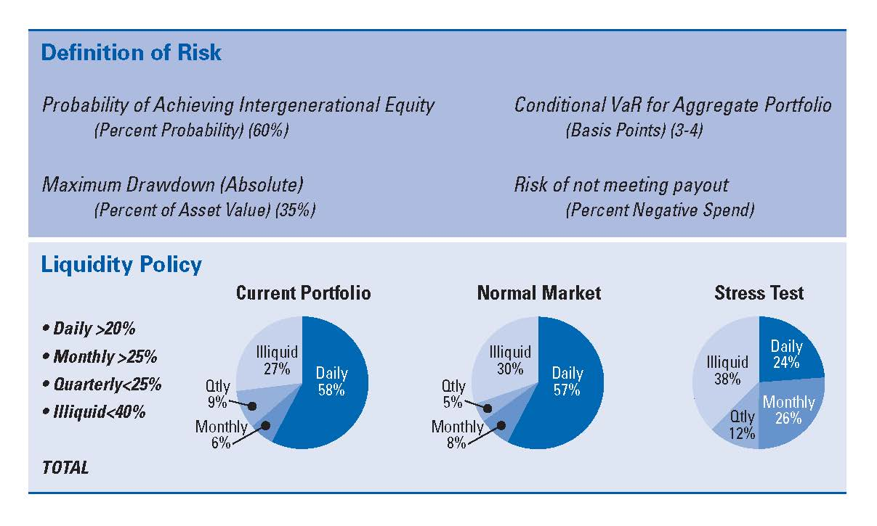

Hypothetical Target Asset Allocation
NB: These Allocations Are Samples and are Provided for Illustrative Purposes Only
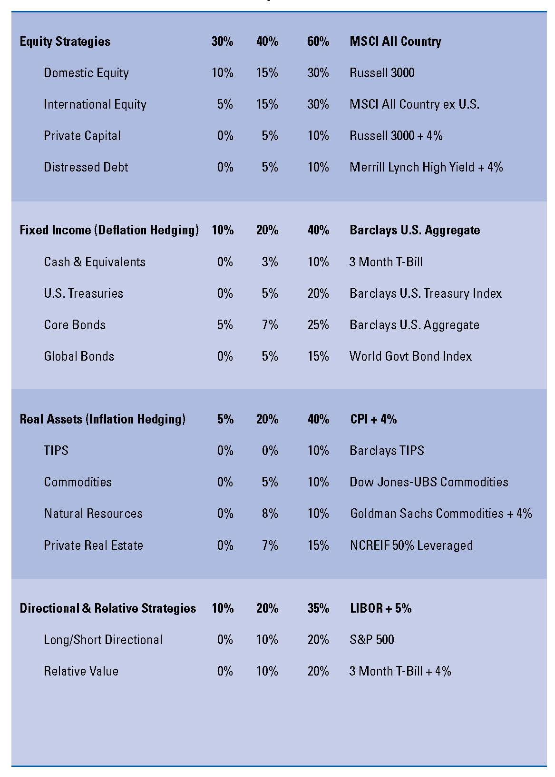
Investment Strategies, Guidelines and Restrictions
Equity Securities. The purpose of equity investments, both domestic and international, in the Fund is to provide capital appreciation, growth of income, and current income. This asset class carries the assumption of greater market volatility and increased risk of loss, but also provides a traditional approach to meeting portfolio total return goals. This component includes domestic and international common stocks, American Depository Receipts (ADRs), preferred stocks, and convertible stocks traded on the world’s stock exchanges or over-the-counter markets.
Public equity securities shall be restricted to high quality, readily marketable securities of corporations that are traded on the major stock exchanges, including NASDAQ, and have the potential for meeting return targets. Equity holdings must generally represent companies meeting a minimum market capitalization requirement of respective asset class profiles with reasonable market liquidity where customary. Decisions as to individual security selection, number of industries and holdings, current income levels and turnover are left to manager discretion, subject to the standards of fiduciary prudence. However, investments in securities of issuers representing a single major industry (as determined by the Committee) shall not at time of investment exceed 10 percent of the Fund’s total market value, and investments in securities of any one issuer shall not at time of investment exceed 5 percent of the Fund’s total market value, unless approved by the Committee.
Within the above guidelines and restrictions, the Fund’s investment managers shall have complete discretion over the selection, purchase and sale of equity securities.
Fixed Income Securities. Domestic and international fixed income investments are intended to provide diversification and a dependable source of current income. Fixed income investments should reduce the overall volatility of the Fund’s assets and provide a deflation or inflation hedge, where appropriate.
The fixed income asset class includes the fixed income markets of the U.S. and the world’s other developed economies. It includes, but is not limited to, U.S. Treasury and government agency bonds, non-U.S. dollar denominated securities, public and private corporate debt, mortgages and asset-backed securities, and non-investment grade debt. Also included are money market instruments such as commercial paper, certificates of deposit, time deposits, bankers’ acceptances, repurchase agreements, and U.S. Treasury and agency obligations. The investment managers shall take into account credit quality, sector, duration and issuer concentrations in selecting an appropriate mix of fixed income securities. Investments in fixed income securities should be managed actively to pursue opportunities presented by changes in interest rates, credit ratings, and maturity premiums.
Within the above guidelines and restrictions, the Fund’s investment managers shall have complete discretion over the selection, purchase and sale of fixed income securities.
Cash and Equivalents. The Fund’s investment managers may invest in the highest quality commercial paper, repurchase agreements, U.S. Treasury Bills, certificates of deposit, and money market funds to provide income, liquidity for expense payments, and preservation of the Fund’s principal value. Investments in the obligations of a single issuer shall not at time of investment exceed 5 percent of the Fund’s total market value, with the exception of the U.S. Government and its agencies.
Since the Investment Committee does not consider short-term cash equivalent securities to be appropriate investment vehicles for long-term portfolios, uninvested cash reserves shall be kept to a minimum except where needed to comply with the Fund’s liquidity parameters. However, such vehicles are considered appropriate (i) as a depository for income distributions from longer-term investments, (ii) as needed for temporary placement of funds directed for future investment to longer-term investment strategies and (iii) for contributions to the current fund or for current operating cash.
Within the above guidelines and restrictions, the investment managers shall have complete discretion over the selection, purchase and sale of cash equivalent securities.
Alternatives. The following alternative strategies shall be permitted investments for the Fund, subject to the respective guidelines set forth in each section. Investments in alternative strategies shall not at time of investment exceed 25 percent of the Fund’s total market value, unless approved by the Committee.
Marketable Alternative Strategies - Investments may include (among other strategies) equity-oriented or market-neutral hedge funds (i.e. long/short, macro event driven, convertible arbitrage, and fixed income strategies), which can be both domestic and international market oriented. These components may be viewed as equity-like or fixed income-like strategies as defined by their structures and exposures.
Private Capital - Investment allocations may include venture capital, private equity and international private capital investments, typically held in the form of professionally managed pooled limited partnerships. Such investments must be made through funds offered by professional investment managers.
Energy & Natural Resources - Investments may include oil, gas, and timber investments, typically held in the form of professionally managed pooled limited partnerships, as well as commodity-based investments. All such investments must be made through funds offered by professional investment managers.
Private Equity Real Estate - Investments may include equity real estate, held in the form of professionally managed, income producing commercial and residential property. Such investments may be made only through professionally managed pooled real estate investment funds.
Distressed Debt - Investments may include the debt securities of companies undergoing bankruptcy or reorganization. Such investments may be made only through professionally managed funds.
Derivatives and Derivative Securities. Certain of the Fund’s managers may be permitted under the terms of their specific investment guidelines to use derivative instruments. Derivatives are contracts or securities whose market value is related to the value of another security, index, or financial instrument. Investments in derivatives include (but are not limited to) futures, forwards, options, options on futures, warrants, and interest-only and principal-only strips. No derivative positions can be established that have the effect of creating portfolio characteristics outside of portfolio guidelines.
Examples of appropriate applications of derivative strategies include hedging market, interest rate, or currency risk, maintaining exposure to a desired asset class while making asset allocation changes, gaining exposure to an asset class when it is more cost-effective than the cash markets, and adjusting duration within a fixed income portfolio. Investment managers must ascertain and carefully monitor the creditworthiness of any third parties involved in derivative transactions.
Each manager using derivatives shall (1) exhibit expertise and experience in utilizing such products; (2) demonstrate that such usage is strategically integral to their security selection, risk management, or investment processes; and (3) demonstrate acceptable internal controls regarding these investments.
Investment Restrictions. The Investment Committee may waive or modify any of the restrictions in these guidelines in appropriate circumstances. Any such waiver or modification shall be made only after a thorough review of the investment manager and investment strategy involved. An addendum supporting such waiver or modification shall be maintained as a permanent record of the Investment Committee. All such waivers and modifications shall be reported to the Board of Trustees at the meeting immediately following the granting of the waiver or modification.
Adherence to the restrictions in these guidelines shall be measured as of the time of initial investment. It is recognized that subsequent market action may result in the investment or strategy ceasing to adhere to these restrictions, through no fault of the XYZ staff or the respective outside manager. In such a situation, XYZ and the manager shall make reasonable attempts to bring the investment or strategy back within adherence to these restrictions, bearing in mind the long-term interests of XYZ and the Fund and the desirability of avoiding harmful forced sales of assets.
Investments in mutual funds or commingled funds shall be reviewed and approved by the Investment Committee on a case-by-case basis and, if approved, may vary from this Statement. For each such mutual or commingled fund, the prospectus, offering memorandum or Declaration of Trust documents of the respective fund will govern the investment policies of the fund investments. While the Investment Committee understands that such funds have their own stated guidelines which cannot be changed for individual investors, those guidelines should be similar in principle and spirit to the guidelines stated herein. To the extent that a mutual or commingled fund departs from any or all of such guidelines, the Investment Committee shall make itself aware of the possible consequences and be confident that the investment manager thoroughly understands the risks being taken, has demonstrated expertise in such investment strategies and has guidelines in place for monitoring their risk-adjusted performance.

Template II:
Traditional Investment Policy Statement

[NAME OF INSTITUTION]
Statement of Investment Policy

Adopted: [Date]

Table of Contents

Page
Statement of Purpose 2
General Principles 2
Roles and Responsibilities 2
Policy Review 3
Goals and Objectives 3
Objectives of the Fund 3
Investment Philosophy 3
Investment Policies and Procedures 3
Operating Guidelines 3
Investment Policy 5
Asset Allocation, Investment Strategies, Guidelines and Restrictions 5
Spending 6
Appendix A: Operating Guidelines 7
Hypothetical Target Asset Allocation 7
Investment Strategies, Guidelines and Restrictions 8

Statement of Purpose
The purpose of this Investment Policy Statement (together with its Appendix, the “Statement”) is to set forth the policies and procedures that shall guide the Board of Trustees (the “Board of Trustees” or the “Board”) of [name of institution] (“XYZ”) in supervising and monitoring the management of XYZ’s investable assets (the “Fund”).
General Principles
- XYZ shall diversify the investments of the Fund unless the Board and, if applicable, the Investment Committee (the “Investment Committee” or the “Committee”), after appropriate deliberation, reasonably determine that because of special circumstances the purposes of the Fund are better served without diversification.
- The Fund shall be managed in accordance with high standards of fiduciary duty and in compliance with applicable laws and regulations.
- Standards for return, asset allocation and diversification shall be determined from a strategic perspective and measured over successive market cycles.
Roles and Responsibilities
If the Board of Trustees elects to oversee investment matters directly, it shall undertake the roles and responsibilities prescribed for the Investment Committee herein. Otherwise, the Investment Committee shall implement the management process and monitor the Fund in accordance with this Statement. The Chair of the Committee shall be a current member of XYZ’s Board of Trustees; other Committee members need not be Trustees.
The Investment Committee, acting pursuant to this Statement and to instructions from the Board of Trustees, shall have direct responsibility for the oversight and management of the Fund and for the establishment of investment policies and procedures.
The Investment Committee shall, as more fully described herein, manage the Fund via a set of asset allocation targets and ranges for the portfolio.
In fulfilling its responsibilities under this Statement, the Investment Committee shall, among other activities, recommend to the Board of Trustees the hiring and dismissal of investment managers, fiscal agents and other advisors.
Reports on the Fund shall be provided quarterly to the Investment Committee. The [insert title of appropriate staff person] shall be responsible to the Investment Committee for maintaining detailed records of all invested funds and for carrying out the investment policies and procedures established by the Board of Trustees and the Investment Committee.

Policy Review
This Statement shall be reviewed annually by the Investment Committee and any recommendations for changes presented to the Board of Trustees.
Goals and Objectives
Objectives of the Fund
The Fund has a long-term investment horizon. The primary investment objectives of the Fund are to:
- Maintain the real purchasing power of the Fund after inflation, costs and spending (i.e., achieve “intergenerational equity”);
- Provide a stable source of liquidity and financial support for the mission of XYZ.
Investment Philosophy
While acknowledging the importance of preserving capital, the Board of Trustees also recognizes the necessity of accepting risk if the Fund is to be able to meet its long-term investment goals. It is the view of the Board of Trustees that choices made with respect to asset allocation will be the major determinants of investment performance. The Committee shall seek to ensure that the risks taken are appropriate and commensurate with the Fund’s goals.
Investment Policies and Procedures
Operating Guidelines
The Fund shall be managed in accordance with the Operating Guidelines described in this section, a template for which is set forth in Appendix A. Once the Operating Guidelines have been approved by the Board, the Investment Committee shall have the authority to manage the Fund within the Operating Guidelines without further authorization from the Board.
Investment Policy
Asset allocation. The Committee shall, consistent with the above sections, invest the Fund using an asset allocation that is designed to meet the Fund’s long-term goals. The allocation will be based on the objectives of the Fund as set forth above.
Illiquid investments. Because of their long-term nature, investments in and commitments to illiquid investment strategies, including but not limited to private capital, private equity real estate, natural resources, distressed debt and other similar private investments, shall be analyzed and discussed by the Committee separately.
Targets and ranges. The asset allocation shall be implemented using a policy portfolio as set forth in Appendix A, with target allocations and ranges for each investment strategy. Due to the need for diversification and the longer funding periods for certain investment strategies, the Committee recognizes that an extended period of time may be required to fully implement the asset allocation plan. It is expected that market value fluctuations will cause deviations from the target allocations to occur.
Rebalancing. The purpose of rebalancing is to maintain the Fund’s policy asset allocation within the targeted ranges, thereby ensuring that the Fund does not incur additional risks as a result of having deviated from the policy portfolio. Rebalancing will take place on a portfolio basis to reduce expenses as far as practicable. More frequent tactical rebalancing of asset classes within their ranges will also be permitted in order to take advantage of shorter-term market conditions, as long as such changes or reallocations do not, in the opinion of the Committee, cause undue risk or expense to the Fund.
Standard of conduct. In managing and investing the Fund, the Committee shall:
- act in good faith and with the care an ordinarily prudent person in a like position would exercise under similar circumstances;
- incur only costs that are appropriate and reasonable in relation to the assets, the purposes of XYZ and the skills available to XYZ;
- make a reasonable effort to verify facts relevant to the management and investment of the Fund;
- consider the following factors, if relevant:
- general economic conditions;
- the possible effect of inflation or deflation;
- the expected tax consequences, if any, of investment decisions or strategies;
- the role that each investment or course of action plays within the overall investment portfolio of the Fund;
- the expected total return from income and the appreciation of investments;
- other resources of XYZ;
- the needs of XYZ and the Fund to make distributions and to preserve capital; and
- an asset’s special relationship or special value, if any, to the charitable purposes of XYZ;
- make management and investment decisions about an individual asset not in isolation, but rather in the context of the Fund’s portfolio of investments as a whole and as a part of XYZ’s overall investment strategy, including the risk and return parameters set forth in this Statement.
Delegation. Subject to any specific limitation set forth in a gift instrument, the Committee may delegate to an external agent the management and investment of all or part of the Fund to the extent that XYZ could prudently delegate under the circumstances. The Committee shall act in good faith, with the care that an ordinarily prudent person in a like position would exercise under similar circumstances in: (1) selecting an agent; (2) establishing the scope and terms of the delegation, consistent with the purposes of XYZ and the Fund; and (3) periodically reviewing the agent’s actions in order to monitor the agent’s performance and compliance with the scope and terms of the delegation.
In this regard, the Committee shall engage qualified external professional investment managers that have demonstrated competence in their respective investment strategies. These managers shall have full discretion and authority for determining investment strategy, security selection and timing of purchases and sales of assets subject to the guidelines specific to their allocation.
Investment manager reporting and evaluation. The investment managers responsible for the investment of the Fund’s assets shall report quarterly on their performance. Reports shall include, at a minimum, the following information:
- Comparative returns for the Fund assets under management against their respective benchmarks.
- A complete accounting of all transactions involving the Fund during the quarter.
Each investment manager shall review the portfolio with the Investment Committee at least annually; these review meetings may be supplemented by such other meetings as the Committee may think necessary.
When possible, the Committee shall monitor and compare the Fund’s performance relative to:
- Absolute return objectives for the Fund
- The respective benchmarks for each asset class or strategy in which the Fund is invested, as set forth in the asset allocation table in Appendix A
- A representative group of peer institutions identified by the Committee
- A representative group of peer investment managers
Asset Allocation, Investment Strategies, Guidelines and Restrictions
The Fund shall be diversified both by asset class and within asset classes. Within each asset class, investments shall be diversified further among economic sector, industry, quality and size. The purpose of this diversification is to provide a reasonable assurance that no single security or class of securities will have a disproportionate impact – positive or negative – on the overall performance of the Fund.
The Operating Guidelines, a template for which is set forth in Appendix A, contain the Fund’s target asset allocation and range for each asset class or investment strategy, together with the applicable guidelines and restrictions. Taken together, these constitute a framework to assist XYZ and its investment managers in achieving the Fund’s investment objectives at a level of risk consistent with the parameters set forth in this Statement.

Spending
Policy spending rate. The policy spending rate for the Fund shall be [ ] percent.
Spending formula. The amount available for appropriation during each fiscal year shall be calculated by applying the policy spending rate to the average of the previous three fiscal years’ beginning-period endowment values.
Special appropriations and decisions not to spend. Any special appropriation or decision not to spend the amount indicated by the spending formula must be approved in advance by the Board of Trustees.
Standard of conduct. Subject to the intent of a donor expressed in a gift instrument, XYZ may appropriate for expenditure or accumulate so much of the Fund as the Board of Trustees determines to be prudent for the uses, benefits, purposes and duration for which each of the separate endowments in the Fund is established. In making a determination to appropriate or accumulate, XYZ shall act in good faith, with the care of an ordinarily prudent person in a like position would exercise under similar circumstances and shall consider, if relevant, the following factors:
- the duration and preservation of the Fund;
- the purposes of XYZ and the Fund;
- general economic conditions;
- the possible effect of inflation or deflation;
- the expected total return from income and the appreciation of investments;
- other resources of XYZ; and
- XYZ’s investment policy.

Appendix A: Operating Guidelines
Hypothetical Target Asset Allocation
NB: These Allocations Are Samples and are Provided for Illustrative Purposes Only
Investment Strategies, Guidelines and Restrictions
Equity Securities. The purpose of equity investments, both domestic and international, in the Fund is to provide capital appreciation, growth of income, and current income. This asset class carries the assumption of greater market volatility and increased risk of loss, but also provides a traditional approach to meeting portfolio total return goals. This component includes domestic and international common stocks, American Depository Receipts (ADRs), preferred stocks, and convertible stocks traded on the world’s stock exchanges or over-the-counter markets.
Public equity securities shall be restricted to high quality, readily marketable securities of corporations that are traded on the major stock exchanges, including NASDAQ, and have the potential for meeting return targets. Equity holdings must generally represent companies meeting a minimum market capitalization requirement of respective asset class profiles with reasonable market liquidity where customary. Decisions as to individual security selection, number of industries and holdings, current income levels and turnover are left to manager discretion, subject to the standards of fiduciary prudence. However, investments in securities of issuers representing a single major industry (as determined by the Committee) shall not at time of investment exceed 10 percent of the Fund’s total market value, and investments in securities of any one issuer shall not at time of investment exceed 5 percent of the Fund’s total market value, unless approved by the Committee.
Within the above guidelines and restrictions, the Fund’s investment managers shall have complete discretion over the selection, purchase and sale of equity securities.
Fixed Income Securities. Domestic and international fixed income investments are intended to provide diversification and a dependable source of current income. Fixed income investments should reduce the overall volatility of the Fund’s assets and provide a deflation or inflation hedge, where appropriate.
The fixed income asset class includes the fixed income markets of the U.S. and the world’s other developed economies. It includes, but is not limited to, U.S. Treasury and government agency bonds, non-U.S. dollar denominated securities, public and private corporate debt, mortgages and asset-backed securities, and non-investment grade debt. Also included are money market instruments such as commercial paper, certificates of deposit, time deposits, bankers’ acceptances, repurchase agreements, and U.S. Treasury and agency obligations. The investment managers shall take into account credit quality, sector, duration and issuer concentrations in selecting an appropriate mix of fixed income securities. Investments in fixed income securities should be managed actively to pursue opportunities presented by changes in interest rates, credit ratings, and maturity premiums.
Within the above guidelines and restrictions, the Fund’s investment managers shall have complete discretion over the selection, purchase and sale of fixed income securities.
Cash and Equivalents. The Fund’s investment managers may invest in the highest quality commercial paper, repurchase agreements, U.S. Treasury Bills, certificates of deposit, and money market funds to provide income, liquidity for expense payments, and preservation of the Fund’s principal value. Investments in the obligations of a single issuer shall not at time of investment exceed 5 percent of the Fund’s total market value, with the exception of the U.S. Government and its agencies.
Since the Investment Committee does not consider short-term cash equivalent securities to be appropriate investment vehicles for long-term portfolios, uninvested cash reserves shall be kept to a minimum except where needed to comply with the Fund’s liquidity parameters. However, such vehicles are considered appropriate (i) as a depository for income distributions from longer-term investments, (ii) as needed for temporary placement of funds directed for future investment to longer-term investment strategies and (iii) for contributions to the current fund or for current operating cash.
Within the above guidelines and restrictions, the investment managers shall have complete discretion over the selection, purchase and sale of cash equivalent securities.
Alternatives. The following alternative strategies shall be permitted investments for the Fund, subject to the respective guidelines set forth in each section. Investments in alternative strategies shall not at time of investment exceed 25 percent of the Fund’s total market value, unless approved by the Committee.
Marketable Alternative Strategies - Investments may include (among other strategies) equity-oriented or market-neutral hedge funds (i.e. long/short, macro event driven, convertible arbitrage, and fixed income strategies), which can be both domestic and international market oriented. These components may be viewed as equity-like or fixed income-like strategies as defined by their structures and exposures.
Private Capital - Investment allocations may include venture capital, private equity and international private capital investments, typically held in the form of professionally managed pooled limited partnerships. Such investments must be made through funds offered by professional investment managers.
Energy & Natural Resources - Investments may include oil, gas, and timber investments, typically held in the form of professionally managed pooled limited partnerships, as well as commodity-based investments. All such investments must be made through funds offered by professional investment managers.
Private Equity Real Estate - Investments may include equity real estate, held in the form of professionally managed, income producing commercial and residential property. Such investments may be made only through professionally managed pooled real estate investment funds.
Distressed Debt - Investments may include the debt securities of companies undergoing bankruptcy or reorganization. Such investments may be made only through professionally managed funds.
Derivatives and Derivative Securities. Certain of the Fund’s managers may be permitted under the terms of their specific investment guidelines to use derivative instruments. Derivatives are contracts or securities whose market value is related to the value of another security, index, or financial instrument. Investments in derivatives include (but are not limited to) futures, forwards, options, options on futures, warrants, and interest-only and principal-only strips. No derivative positions can be established that have the effect of creating portfolio characteristics outside of portfolio guidelines.
Examples of appropriate applications of derivative strategies include hedging market, interest rate, or currency risk, maintaining exposure to a desired asset class while making asset allocation changes, gaining exposure to an asset class when it is more cost-effective than the cash markets, and adjusting duration within a fixed income portfolio. Investment managers must ascertain and carefully monitor the creditworthiness of any third parties involved in derivative transactions.
Each manager using derivatives shall (1) exhibit expertise and experience in utilizing such products; (2) demonstrate that such usage is strategically integral to their security selection, risk management, or investment processes; and (3) demonstrate acceptable internal controls regarding these investments.
Investment Restrictions. The Investment Committee may waive or modify any of the restrictions in these guidelines in appropriate circumstances. Any such waiver or modification shall be made only after a thorough review of the investment manager and investment strategy involved. An addendum supporting such waiver or modification shall be maintained as a permanent record of the Investment Committee. All such waivers and modifications shall be reported to the Board of Trustees at the meeting immediately following the granting of the waiver or modification.
Adherence to the restrictions in these guidelines shall be measured as of the time of initial investment. It is recognized that subsequent market action may result in the investment or strategy ceasing to adhere to these restrictions, through no fault of the XYZ staff or the respective outside manager. In such a situation, XYZ and the manager shall make reasonable attempts to bring the investment or strategy back within adherence to these restrictions, bearing in mind the long-term interests of XYZ and the Fund and the desirability of avoiding harmful forced sales of assets.
Investments in mutual funds or commingled funds shall be reviewed and approved by the Investment Committee on a case-by-case basis and, if approved, may vary from this Statement. For each such mutual or commingled fund, the prospectus, offering memorandum or Declaration of Trust documents of the respective fund will govern the investment policies of the fund investments. While the Investment Committee understands that such funds have their own stated guidelines which cannot be changed for individual investors, those guidelines should be similar in principle and spirit to the guidelines stated herein. To the extent that a mutual or commingled fund departs from any or all of such guidelines, the Investment Committee shall make itself aware of the possible consequences and be confident that the investment manager thoroughly understands the risks being taken, has demonstrated expertise in such investment strategies and has guidelines in place for monitoring their risk-adjusted performance.

Including but not limited to the version of the Uniform Prudent Management of Institutional Funds Act enacted in this state, if applicable.
A spending policy must be based on an institution’s own specific spending requirements. Examples of the main spending formulas currently in use include spending a percentage of a moving average of market value; a fixed percentage; increasing spending dollars each year by an inflation measure; and using a hybrid or weighted average approach.
Where the version of UPMIFA passed in the state contains the provision creating a rebuttable presumption that spending above a specified amount is imprudent, the spending rate set forth in this section must fall within the permissible range. New York state institutions are reminded that the version of UPMIFA passed in that state (New York Prudent Management of Institutional Funds Act, New York Not-for-Profit Corporation Law (N-PCL) §§ 550-558) establishes requirements for record-keeping on spending decisions.
Including but not limited to the version of the Uniform Prudent Management of Institutional Funds Act enacted in this state, if applicable.
A spending policy must be based on an institution’s own specific spending requirements. Examples of the main spending formulas currently in use include spending a percentage of a moving average of market value; a fixed percentage; increasing spending dollars each year by an inflation measure; and using a hybrid or weighted average approach.
Where the version of UPMIFA passed in the state contains the provision creating a rebuttable presumption that spending above a specified amount is imprudent, the spending rate set forth in this section must fall within the permissible range. New York state institutions are reminded that the version of UPMIFA passed in that state (New York Prudent Management of Institutional Funds Act, New York Not-for-Profit Corporation Law (N-PCL) §§ 550-558) establishes requirements for record-keeping on spending decisions.

