SYNOD OF SOUTH ATLANTIC STATED MEETING
Friday and Saturday, February 24-25, 2023

Epworth-by-the-Sea
100 Arthur J. Moore Drive
St. Simons Island, Georgia 31522
The Jones Room

Meeting registration link: STATEDMEETING2023
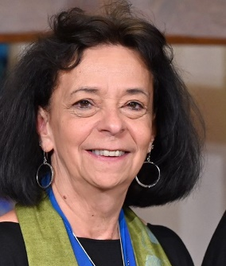
Deadline to register: February 1, 2023

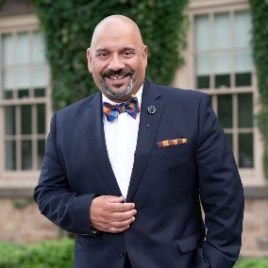
Keynotes by, The Rev. Ruth Faith Santana-Grace,
Co-Moderator, 225th General Assembly

Preaching by, The Rev. Dr. Victor Aloyo,
President, Columbia Theological Seminary

WORKSHOPS:
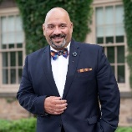
FRIDAY, FEBRUARY 24TH: 2:15 pm ~ 60-75 minutes
Paradigm Shifts–Seminary Education in an In-Between Time............... The Rev. Dr. Victor Aloyo
President, Columbia Theological Seminary

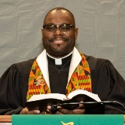
Facing Racism: Addressing the Church’s Original Sin........................The Rev. Dr. Wylie V. Hughes
Pastor, Orchard Park Presbyterian Church

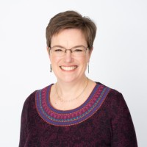
Forms of Spiritual Practice ~ Explore Various Forms of Spiritual Practice, including the opportunity to experience a few of them...............................................The Rev. Cindy Kohlmann
Connectional Presbyter/Stated Clerk, New Castle Presbytery
Former Co-Moderator of the 223rd General Assembly

SATURDAY, FEBRUARY 25th: 10:30 am ~ 60-75 minutes

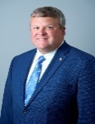
Legacy Giving: How to start (or re-ignite) a legacy, wills emphasis, planned giving, and endowment
program for your congregation.............................................................................Robert Hay Ministry Relations Officer of the Presbyterian Foundation

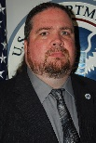
Cybersecurity Concerns for Houses of Worship .....................Klint Walker, CISS, Cybersecurity Advisor
Cybersecurity and Infrastructure Security Agency (CISA)
Courtesy of the Insurance Board

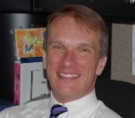
Conversations about Transformational Leadership.......The Rev. Dr. David Shelor, Synod Moderator
Pastor, First Presbyterian Church, Dunedin, Florida

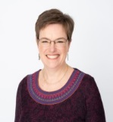
Forms of Spiritual Practice ~ Explore Various Forms of Spiritual Practice, including the opportunity to experience a few of them......................................................................The Rev. Cindy Kohlmann
Connectional Presbyter/Stated Clerk, New Castle Presbytery
Former Co-Moderator of the 223rd General Assembly

For more information, please contact Lisa Lovelady, lisa@synodsa.org or 904.356.6070

