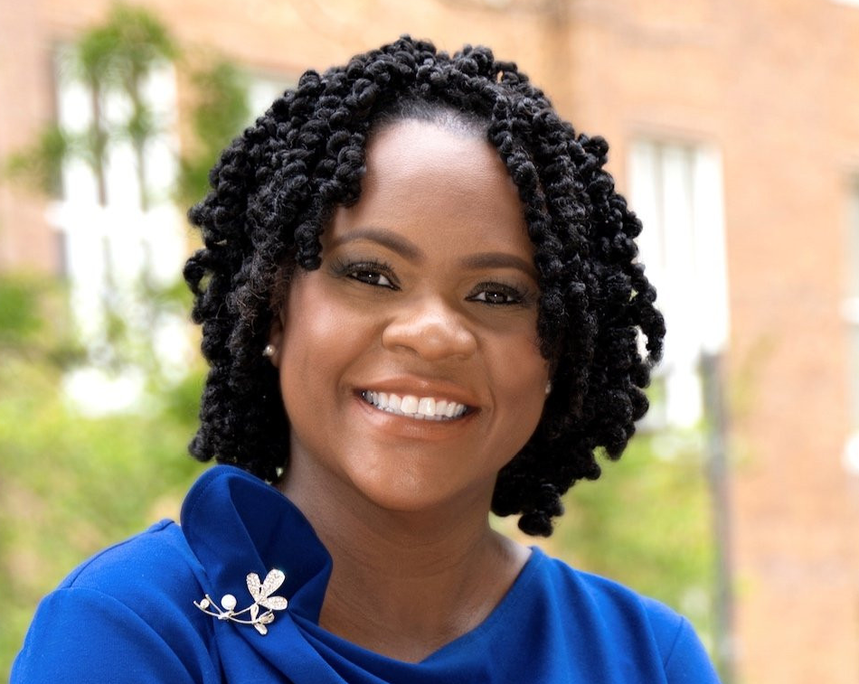
Dr. Yolanda Pierce will be the 2026 Heritage Lecturer at Westminster Presbyterian Church in Greenville on Sunday, August 9, 2026.
Dr. Pierce currently serves as Professor and Dean of the Vanderbilt Divinity School. Immediately prior to accepting this position she was Dean and Professor of Religion and Literature at Howard University Divinity School. A scholar, writer, and theologian, her research specialties include Literature & Religion; Womanist Theology; and African American Religions. A widely-published author, she has written several books as well as essays and articles for academic and trade journals including Time Magazine, Theology Today, and Christianity & Literature. She is a current columnist for Christian Century.
In 2023 the American Academy of Religion awarded the Martin E.Marty Award for the Public Understanding of Religion to Dr. Pierce.
In 2016, Dr. Pierce became the Founding Director of the Center for African American Religious Life at the Smithsonian National Museum of African American History and Culture (NMAAHC). She is the creator and curator of “Touching the Sacred,” an exhibit on material religion and the Black Church. She also served as the Founding Director of the Center for Black Church Studies and Associate Professor of Religion and Literature at Princeton Theological Seminary.
A native New Yorker and a first-generation college student, Dr. Pierce earned degrees from Cornell University and Princeton University.
Dr. Pierce will speak at the 9:00 a.m. Sunday School class and preach at the 10:00 a.m. worship service. Both events will be live streamed from the church's website and recorded for later viewing from the same location.
==========================================================
Link to "live streamed" - https://wpcgreenville.org/connect/live-stream/
bit.ly link to "live streamed" - https://bit.ly/4pJGTe0
The following two links are “autobranded” and don’t allow me to create bit.ly links
Link to Center for African American Religious Life - https://nmaahc.si.edu/explore/museum-centers/center-study-african-american-religious-life
Link to Center for Black Church Studies - https://www.ptsem.edu/academics/betsey-stockton-center

