# National Eye Institute (NEI)

## Stargardt Disease Campaign Social Media Toolkit

### Overview

The National Eye Institute (NEI) is funding [a clinical trial](https://www.nei.nih.gov/learn-about-eye-health/eye-conditions-and-diseases/stargardt-disease/oral-metformin-treatment-abca4-retinopathy) to find a treatment for [Stargardt disease](https://www.nei.nih.gov/learn-about-eye-health/eye-conditions-and-diseases/stargardt-disease) — a rare genetic disorder that causes blindness in children. As a part of this campaign, NEI is recruiting trial participants through social media posts.

As part of the campaign, NEI is asking that partners help promote the trial to help maximize participant recruitment. In this document, NEI has included social media posts and graphics that partners may use to help share information about this campaign on Twitter, Facebook, and LinkedIn.

#### Twitter

* @NatEyeInstitute is now enrolling patients for a new study to treat #Stargardt disease! Learn more about the disease and the study: <https://www.nei.nih.gov/learn-about-eye-health/eye-conditions-and-diseases/stargardt-disease/oral-metformin-treatment-abca4-retinopathy> #EyeHealthEducation
* #Stargardt disease is a rare genetic disorder that usually starts in childhood. Learn more about this disease and what @NatEyeInstitute is doing to help people living with it: <https://www.nei.nih.gov/learn-about-eye-health/eye-conditions-and-diseases/stargardt-disease/>#EyeHealthEducation

#### Facebook

* #Stargardt disease is a rare genetic disorder that can cause vision loss that usually starts in childhood! @NationalEyeInstitute is looking for patients to participate in a clinical study to evaluate a potential treatment. If you or someone you know has Stargardt disease, please consider enrolling in the study! You can learn more about the disease and the study on NEI’s website: <https://www.nei.nih.gov/learn-about-eye-health/eye-conditions-and-diseases/stargardt-disease/oral-metformin-treatment-abca4-retinopathy> #EyeHealthEducation
* #Stargardt disease is a rare genetic disorder that usually starts in childhood. Learn more about this disease and what @NationalEyeInstitute is doing to help people living with it: <https://www.nei.nih.gov/learn-about-eye-health/eye-conditions-and-diseases/stargardt-disease/>#EyeHealthEducation

#### LinkedIn

* Do you work with patients who have #Stargardt disease? @national-eye-institute-nei is running a clinical study on a potential treatment! Please consider referring your patients — you can find information here: <https://www.nei.nih.gov/learn-about-eye-health/eye-conditions-and-diseases/stargardt-disease/oral-metformin-treatment-abca4-retinopathy> #EyeHealthEducation
* @national-eye-institute-nei is now enrolling patients in a new study on a possible treatment for #Stargardt disease! Interested in referring your patients? Read about the study: <https://www.nei.nih.gov/learn-about-eye-health/eye-conditions-and-diseases/stargardt-disease/oral-metformin-treatment-abca4-retinopathy> #EyeHealthEducation

### Graphics

In addition to the social media posts above, please use the following graphics:

#### To use with posts about the clinical trial:

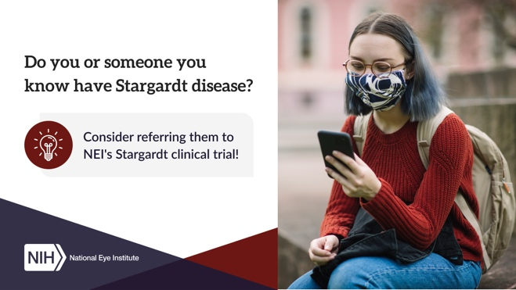

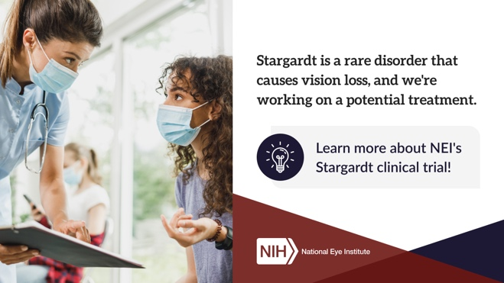

#### To use with general posts about Stargardt disease:

