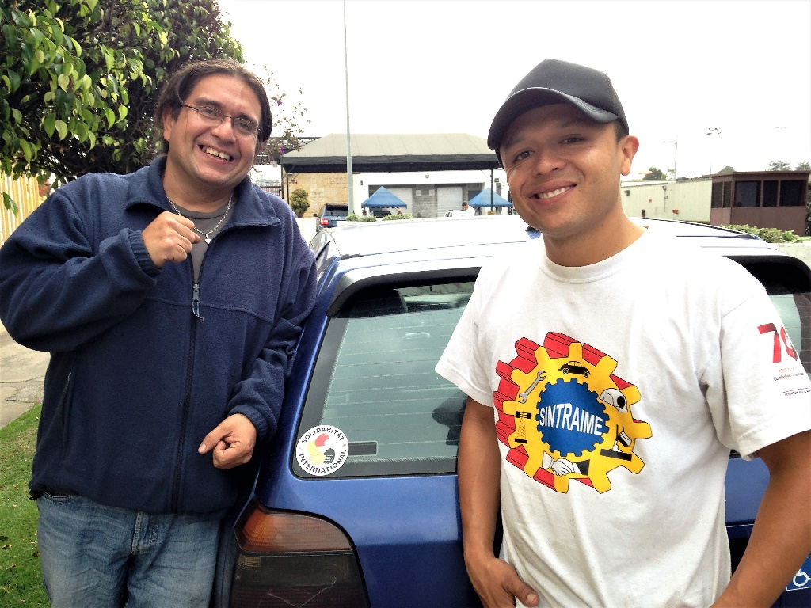
MCHR SOLIDARITY DELEGATION HEADED TO BOGOTA, COLOMBIA TO SUPPORT FIRED, INJURED GM WORKERS
Jorge Parra and Carlos Trujillo, ASOTRECOL, with the US Embassy in the background, Bogota, Colombia (2016)
by Kim Redigan & Frank Hammer

The MCHR has stood in solidarity with ASOTRECOL, the Association of Injured Workers and Ex-Workers of General Motors Colmotores in Bogota, Colombia, for several years. In the wake of an in-depth discussion about the role of the MCHR - especially internationally, the Board of Directors at its February meeting agreed to sponsor an MCHR delegation to bear witness to the nonviolent action for justice by the GM workers.

The brave fired, injured workers have occupied a tent outside the U.S. Embassy for almost seven years, demanding a just settlement with GM. Their three hunger strikes, with lips sewn shut, a dramatized crucifixion, and self-imposed burials have all brought attention to GM’s unsafe factory in Bogota, and the mass, illegal firings of workers injured on the job.

The MCHR, founded in Detroit in 1980 by three religious leaders, is committed to ensuring that GM offers these workers - and others fired by GM more recently - redress for their grievances.

The delegation of six will travel to Bogota during Holy Week and Passover (March 29-April 3), to highlight the spiritual fortitude of these workers, and to call upon GM to respond to the moral imperative to uphold the dignity of the human person and the rights of workers.

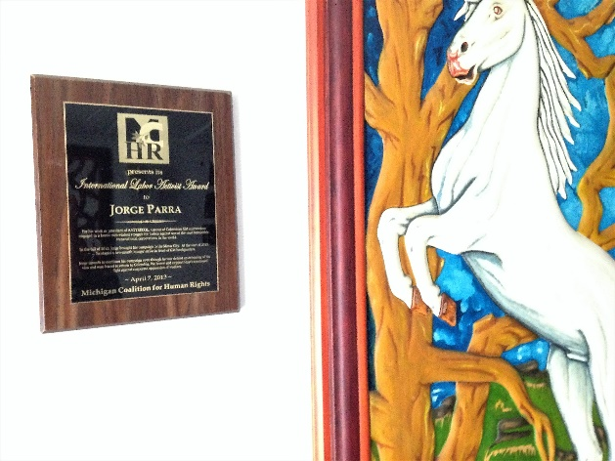
Informed of the planned delegation, ASOTRECOL President Jorge Parra expressed excitement and gratitude, saying, “without the support of U.S. activists, we would not have been able to sustain our struggle.”
Hanging on the wall of Jorge Parra's apartment in Bogota, Colombia: "International Labor Activist Award," Michigan Coalition of Human Rights (2016).

The MCHR has a long association with Brother Parra. At its Annual Dinner in 2013, our Coalition recognized his and his brothers’ valor by presenting him with a Human Rights award. In 2015, during a visit to Detroit, the MCHR hosted a reception on his behalf. In between, we’ve reached out to General Motors, circulated petitions, and more.

Though the ex-GM workers haven’t won justice for themselves, their heroic encampment triggered GM investment in ergonomic improvements at their former plant, has helped to strengthen the injured workers’ movement in the factory and throughout Colombia, and sparked resistance to proposed legislation to make legal the firing of injured workers – which stopped the legislation.

Internationally, solidarity has grown. In turn, the courts have declared GM’s most recent firings illegal, and compelled the company to reinstate injured workers. In some instances, GM has defied the court orders and refused.

In June 2017, the US Colombian Consulate abruptly cancelled Jorge Parra’s visa, thus stopping a planned 6-state tour which included a return to Detroit.

The MCHR delegation represents faith and labor:

1. Kim Redigan, MCHR Vice Chair, Pax Christi, Meta Peace Team
2. Frank Hammer*, MCHR Board member, UAW-GM International Representative, retired
3. Laila Hamdan, ASOTRECOL Solidarity Network
4. Todd Askew*, Ecology Center, UAW Local 174
5. Russell Lum, Global Justice Committee Co-Chair, Portland Jobs with Justice
6. Debra Simmons*, ASOTRECOL Solidarity Network, AFT Local 231, retired
* Participants in prior delegations.

While in Colombia, the delegation will express our solidarity with the former workers at their encampment, meet with recently-fired, injured GM workers, local and religious leaders, and deliver funds and a much-needed wheelchair to the son of one of the fired, injured workers.

The delegation will give a report-out upon its return in Detroit at the Swords into Plowshares Peace Center and Gallery, Sunday, April 29, 1-5 pm.

There is a growing list of endorsers, including: Moratorium Now!, Autoworker Caravan, Workers Solidarity Action Network, IWW-Detroit, Jobs with Justice (Portland, OR), Portland Central America Solidarity Committee, and others.

Organizations and individuals can lend their support in the following ways:
- Endorse the MCHR delegation, by contacting the MCHR ____________
- Make a donation via YouCaring (search “mchr”) to help fund the delegation and the tent encampment
- Attend an organizing meeting, 2-4 pm Sunday, April 15th at Aladdin Sweets & Café 11945 Conant St, Hamtramck 48212 to build for the April 29th report out;
- Publicize and attend the April 29th Report-out and Strategizing meeting, 1-5 pm Sunday, April 29th, at Swords into Plowshares Peace Center and Gallery.

