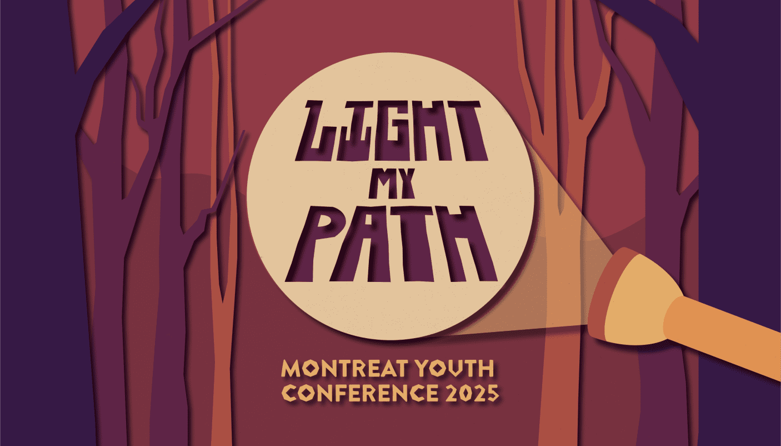
July 6th – 12th 2025

Name__________________________________________

Parents’ Email___________________________________

Grade (rising)______________ t-shirt size_____________

Our youth will spend a week in the mountains of North Carolina alongside youth and adults from around the country. Through worship, keynote, music, recreation, and small group, our young people will explore what it means to be a child of God and discover how to have a transformational relationship with God.
The total cost for the conference is $300 and includes transportation, conference fee, housing, and meals. A deposit of $100 along with this registration form will complete your child’s registration. The remaining balance will be due by July 1, 2024.

