Lovely 3-4 BR Westville Home - $237,500
Classic Westville! Gleaming hardwood floors, landscaped garden full of perennial blooms all season long, a welcoming eat-in kitchen, full dining room, and double-size living room with fireplace. This is the perfect home for family and friends, quet evenings and entertaining, all an easy walk from Westville Village Center, Edgewood Park, Mitchell Library, or West Rock Park. Easy on/off access to route 15. About 5 min drive from SCSU, or 15 min drive from Yale.
Recently redone kitchen has gleaming counters and stainless appliances. Bonus room on first floor could be family room or a 4th bedroom. Nice half-bath on 1st floor. 2nd floor has three large bedrooms and a full bath with working Jaccuzzi. Pull-down stairs lead to attic with plenty of storage. Basement could easily be finished as a rec room. Recently replaced high-efficiency on-demand water heater, and newer electrical service. Furnace is older but still in good working order. Call for an appointment and see how you can make this home your own today!
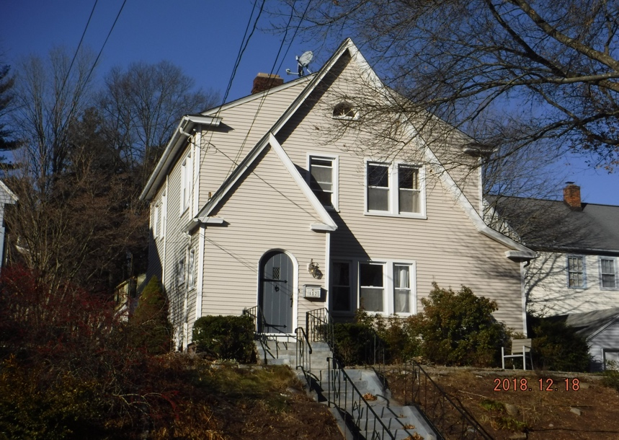 | 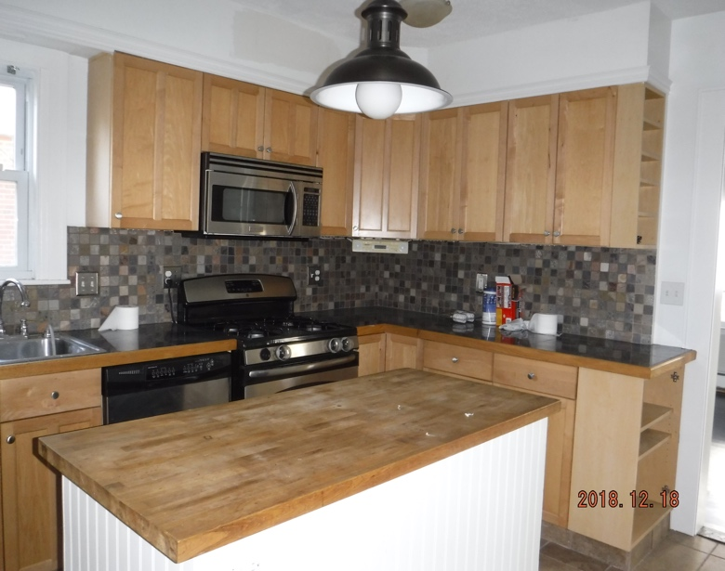
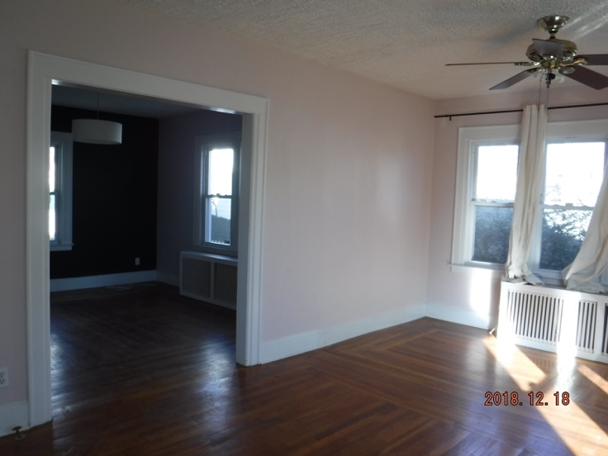 | 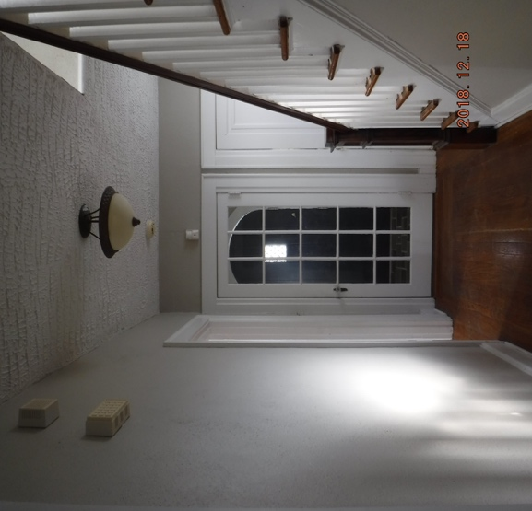
FOR MORE INFORMATION: Please contact Rebecca Weiner, Betsy Grauer Realty, 197 Bradley Street, New Haven, CT 06511 . rhweiner@sbcglobal.net, 203-687-8227.

