A Call for Artists

Overview:
Massaro Community Farm has organized two events featuring Paul Winter (a 7-time Grammy winner) to celebrate the 50th anniversary of Earth Day:

Thursday, March 19, 2020 5-8 pm at the Jewish Community Center of Greater New Haven (JCC), 360 Amity Road, Woodbridge, CT:

PAUL WINTER ONE-ON-ONE Flyways: a Musical Celebration of the Great Bird Migration from Southern Africa through the Middle East to Eurasia
and

Sunday, March 22, 2020 2 -7 pm at the Church of the Assumption, 61 North Cliff St. Ansonia, CT:

THE PAUL WINTER CONSORT In Celebration of the Earth, a concert by the five-member Consort featuring vocalist Theresa Thomason

The main purposes for organizing these events are:
- To remind the audiences of the majesty of our planet earth and our need to protect and celebrate it;
- To raise funds for Massaro Community Farm (MCF), a 57-acre organic farm in Woodbridge, CT as it enters its second decade of farming, education and food justice programs. See: https://massarofarm.org

Offer to Artists:
MCF is seeking commitments from 15 physical media artists (e.g. painters, sculptors, jewelers, quilters, etc.) to offer their wares for sale. We will be promoting these two back-to-back events heavily and expect as many as 800 people to attend them. This could be an excellent set of venues for you to reach new audiences to purchase your art and to learn about your celebration of our planet through your work.

We will provide you with tables to present your art on both Thursday, March 19th and Sunday, March 22nd. You will be featured in pre-event publicity. There will be a two-hour, pre-event reception with food and beverages on the 22nd before the Paul Winter Consort concert. Each artist may attend both events free of charge.

Cost to Artists:
In exchange for these venues for offering your art works, MCF asks each artist to donate one (or more) work of art with a value of $300 or more. These works will be auctioned off at the conclusion of the Sunday, March 22nd event at the Paul Winter Consort concert. If a minimum offer of $300 is not reached in the “silent auction”, the work of art will be held in storage for offering at the Labor Day Dinner on the Farm at Massaro, which has been a SOLD OUT event every year for the past decade.

50th Anniversary of EARTH DAY events

TWO PRESENTATIONS BY PAUL WINTER (Seven-time Grammy Winner) and 15 Earth-centric artists (presenting their art work)

Thursday, March 19, 2020 5-9 pm at the Jewish Community Center,

360 Amity Rd. Woodbridge, CT:

PAUL WINTER ONE-ON-ONE
Flyways: a Musical Celebration of the Great Bird Migration from Southern Africa through the Middle East to Eurasia

A musical chronicle of the long journey of the migrating birds using indigenous music of the 16 cultures over which they fly, and incorporating the vocalizations of the birds. The Flyways project is a collaboration between Paul Winter and world-renowned Israeli ornithologist Yossi Leshem. The motto of Flyways is: "Migrating Birds Know no Borders.” See: http://www.flywaysmusic.org/israel/

Sunday, March 22, 2020 2-7 pm at the Church of the Assumption,

61 North Cliff Street Ansonia, CT:

THE PAUL WINTER CONSORT
In Celebration of the Earth

This is a concert by the five-member Paul Winter Consort, in the magnificent architectural space of the Church of the Assumption. Built in the 1880s the church has spectacular acoustics that will include its pipe organ as part of the musical program. See: https://bit.ly/2TfYRYp. The pipe organ of the Church will be incorporated in the program. The Consort presented a memorable concert there in February of 2017. Paul Winter Consort will be featuring vocalist Theresa Thomason (To hear Theresa sing, go to: https://bit.ly/2R7gk2z. She performed at Paul Winter’s recent 12/20/19 Winter Solstice concert at the Cathedral St. John the Divine in NYC.)

***********

Information on the Flyways Project: http://www.flywaysmusic.org

Paul’s Discography: https://paulwinter.bandcamp.com

The History of the Paul Winter Consort: http://www.paulwinter.com/paul-winter/

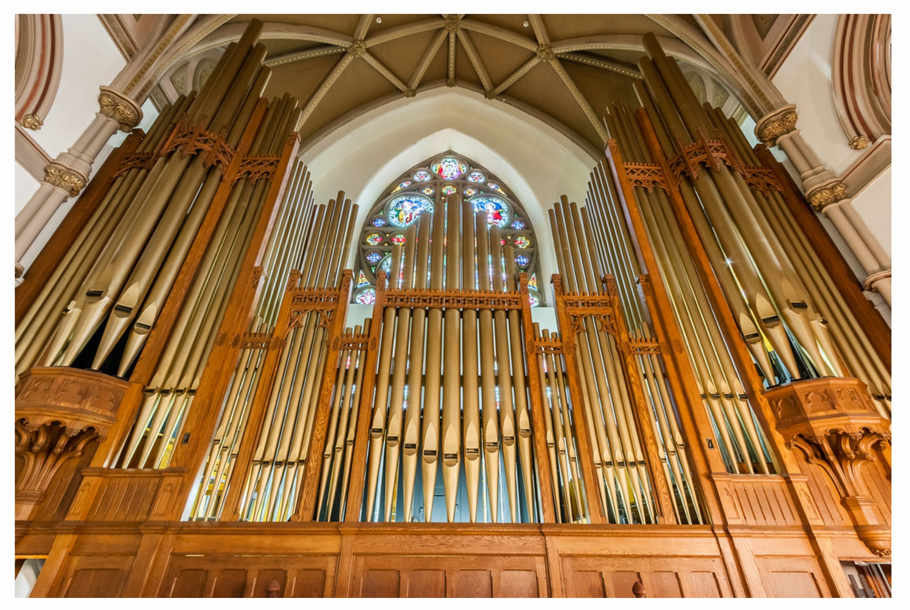
Church of the Assumption Organ

The Church was designed by architect Patrick Charles Keely of Brooklyn, New York, the leading church architect of his day. Between 1847 and 1892, Mr. Keely designed sixteen Catholic Cathedrals including the ones in Chicago, Boston, and Hartford; he also designed between 500 and 700 churches. Mr. Keely’s churches are often called “preaching churches” since they are as broad as they are long. The church was built by J. M. Wheeler of Ansonia, under the supervision of James Houghton, Patrick Keely’s son- in-law. The first stone was laid on September 16, 1889; and two years later, on Sunday, September 6, 1891, the cornerstone was put into place by Very Rev. James Hughes, V.G., acting for Bishop Lawrence McMahon, who was in Europe at the time. From the time of the ground-breaking (1889) until the time of its completion (1907), the new church took eighteen years to build.

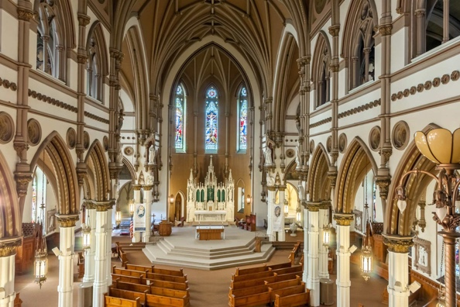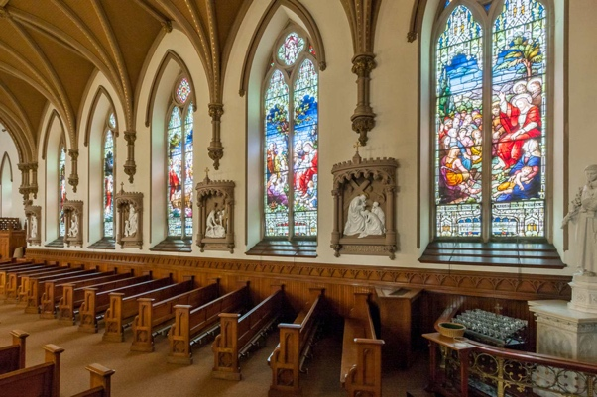

Organist’s View Stained Glass Renovations

