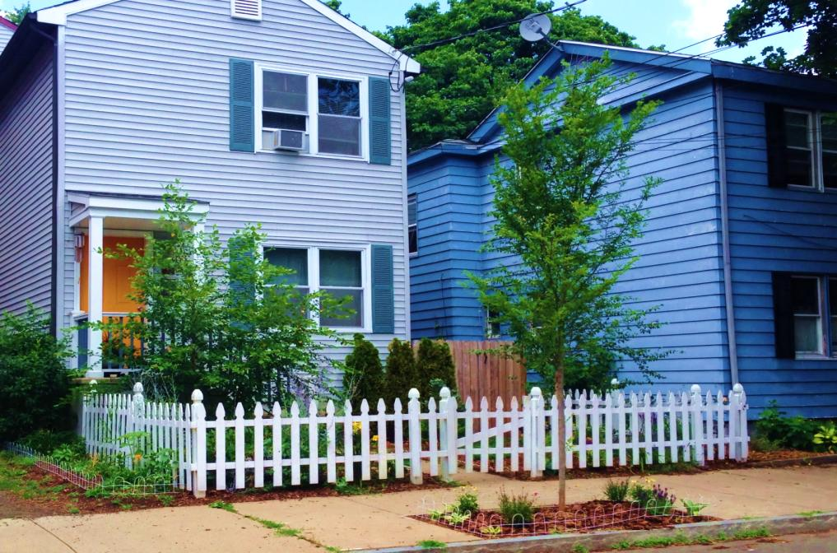

**Now is the time to request a free street tree for your home!** Thanks to a partnership between the City of New Haven’s Department of Parks, Recreation, and Trees and the Urban Resources Initiative, you can request a tree to be planted for free, as long as you commit to watering the tree to ensure it survives and thrives.

Planting a tree not only helps to shade, beautify, and add value to the street, but it also provides paid work experience to local high school students and adults with barriers to employment. Our tree experts will work with you to plant a tree that thrives at your location and fits your interests.

The fall planting season is only a few weeks away, so request your tree today! To make a request, visit our [website](http://uri.yale.edu/get-involved/request-free-tree). For more information, contact us at [uri@yale.edu](mailto:uri@yale.edu) or 203-432-6189.